The Oahu Metropolitan Planning Organization (Oahu MPO) Activity-Based Model

Model Framework and Detailed Technical Specifications

Prepared by

Caliper Corporation

February 26, 2024





Contents

1 Introduction 6

2 ABM Framework 7

3 Data collection 9

4 Model specifications 10

4.1 Long-term choices 10

4.1.1 The driver license model 10

4.1.2 The auto ownership model 11

4.1.3 The worker category model 12

4.1.4 The work attendance model 13

4.1.5 The remote work percentage model 14

4.1.6 The pre-K/daycare status model 14

4.1.7 The school status model 15

4.1.8 The college/university status model 15

4.1.9 The work location choice model 16

4.1.10 The university location choice model 17

4.1.11 The school location choice model 18

4.2 Short-term decisions 19

4.3 Mandatory tour decisions 20

4.3.1 The work tour frequency model 20

4.3.2 The university tour frequency model 21

4.3.3 Work duration model (full-time workers) 22

4.3.4 Work duration model (part-time workers) 22

4.3.5 University duration model 22

4.3.6 School duration model 23

4.3.7 Work activity start time model (full-time workers) 23

4.3.8 Work activity start time model (part-time workers) 24

4.3.9 University activity start time model 24

4.3.10 School activity start time model 25

4.3.11 Mode choice considerations 25

4.3.12 The work mode choice model 26

4.3.13 The university mode choice model 29

4.3.14 The school mode choice model 31

4.4 Mandatory tour scheduling logic 32

4.5 The Time Manager 33

4.6 Non-mandatory decisions 33

4.7 Mandatory tour intermediate stops 35

4.7.1 Mandatory tour intermediate stop frequency on work tours 35

4.7.2 Mandatory tour intermediate stop frequency on university tours 36

4.7.3 Mandatory tour intermediate stop destination 37

4.7.4 Mandatory tour intermediate stop duration 38

4.8 Work-based sub-tours 39

4.8.1 Work-based tour frequency 40

4.8.2 Work-based tour destination 40

4.8.3 Work-based activity duration 41

4.8.4 Work-based activity start time 42

4.8.5 Work-based tour mode 43

4.9 Non-mandatory tour pattern choice 44

4.10 Non-mandatory joint tour decisions 45

4.10.1 Joint tour purpose and frequency 45

4.10.2 Joint HBO tour composition 46

4.10.3 Joint HB Shop tour composition 47

4.10.4 Joint HBO tour participation 48

4.10.5 Joint HBO tour destination 49

4.10.6 Joint HB Shop tour destination 50

4.10.7 Joint HBO activity duration 51

4.10.8 Joint HB Shop activity duration 51

4.10.9 Joint HBO activity start time 52

4.10.10 Joint HB Shop activity start time 53

4.10.11 Joint HBO tour mode 55

4.10.12 Joint HB Shop tour mode 56

4.10.13 Joint tour intermediate stop frequency 56

4.10.14 Joint tour intermediate stop destination 57

4.10.15 Joint tour intermediate stop duration 59

4.11 Non-mandatory solo tour decisions 59

4.11.1 Solo tour purpose and frequency 59

4.11.2 Solo HBO tour destination 61

4.11.3 Solo HB Shop tour destination 62

4.11.4 Solo HBO activity duration 63

4.11.5 Solo HB Shop activity duration 64

4.11.6 Solo HBO activity start time 64

4.11.7 Solo HB Shop activity start time 65

4.11.8 Solo tour scheduling 66

4.11.9 Solo HBO tour mode 67

4.11.10 Solo HB Shop tour mode 68

4.11.11 Solo tour intermediate stop frequency 69

4.11.12 Solo tour intermediate stop destination 71

4.11.13 Solo tour intermediate stop duration 72

4.11.14 Solo tour intermediate stop scheduling 73

5 Conclusion 74

6 Appendix A: Calibration 75

6.1 Long-Term 75

6.1.1 Auto Ownership 75

6.1.2 Daycare Status 75

6.1.3 Driver’s License 75

6.1.4 University Status 75

6.1.5 Worker Category 75

6.2 Mandatory Tours 76

6.2.1 Full Time Work Duration 76

6.2.2 Full Time Work Start 77

6.2.3 Part Time Work Duration 77

6.2.4 Part Time Work Start 78

6.2.5 School Duration 78

6.2.6 School Forward Mode Choice 79

6.2.7 School Return Mode Choice 79

6.2.8 School Start 79

6.2.9 University Mode Choice 79

6.2.10 University Duration 80

6.2.11 University Start 80

6.2.12 University Tour Frequency 80

6.2.13 Work Mode Choice 81

6.2.14 Work Tour Frequency 81

6.3 Mandatory Stops 81

6.3.1 University Stops Duration 81

6.3.2 University Stops Frequency 81

6.3.3 Work Stops Duration 82

6.3.4 Work Stops Frequency 82

6.4 Subtours 82

6.4.1 Subtour Duration 82

6.4.2 Subtour Frequency 82

6.4.3 Subtour Mode 83

6.4.4 Subtour Start 83

6.5 Joint Tours 83

6.5.1 Joint Tours Composition (Other) 83

6.5.2 Joint Tours Composition (Shop) 83

6.5.3 Joint Tours Duration (Other) 84

6.5.4 Joint Tours Duration (Shop) 84

6.5.5 Joint Tours Frequency 84

6.5.6 Joint Tours Mode Choice (Other) 84

6.5.7 Joint Tours Mode Choice (Shop) 85

6.5.8 Joint Tours Participation Adult Other 85

6.5.9 Joint Tours Participation Adult Shop 85

6.5.10 Joint Tours Participation Child Other 85

6.5.11 Joint Tours Participation Child Shop 85

6.5.12 Joint Tours Start Time Other 86

6.5.13 Joint Tours Start Time Shop 86

7 Appendix B: Highway Validation 87

# Introduction

The term Activity-Based Model (ABM) generally refers to the module within a travel demand model that predicts the demand for travel (by forecasting the demand for people’s requirement to participate in various activities). This demand component, when connected to a traffic assignment model with feedback interactions between travel demand and network supply, constitutes the travel demand model. The assignment helps determine the feasibility of the demand predictions and the feedback allows the simulated residents to re-evaluate some of their choices in the context of the congestion information now available to them by travel mode.

In the Oahu MPO model flowchart, the ABM is contained within the ABM Core step:

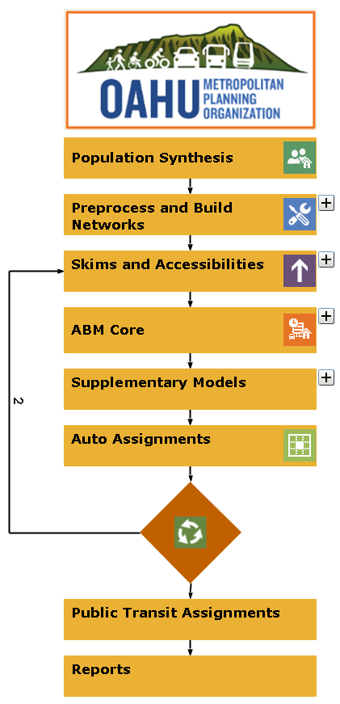

Figure 1 illustrates the ABM model stream. Initial steps include the generation of a synthetic population and the calculation of all necessary skim matrices. The person and household tables from the population synthesis, together with the skims, are the inputs to the ABM module (indicated by the dashed box) that predicts the origin, destination, departure time, travel mode, activity duration and household member participation for each activity undertaken by the residents of the region. This detailed picture of the demand side of desired activity participation needs to be reduced to its constituent trips and combined with other demand estimates related to visitors, trucks, and cross-border (i.e. external) trips. The total demand can then be assigned by (highway) mode to predict network congestion and levels of service (LOS).

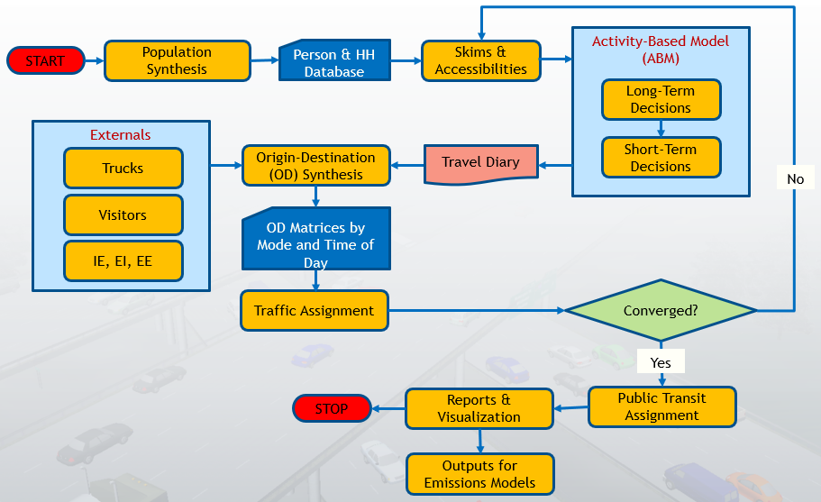

**Figure 1: Overall ABM Framework**

If convergence metrics are not satisfied, the networks must be re-skimmed and the ABM executed to revise the demand picture. Upon convergence, the results of the model are available for a final public transit assignment and other post-processing, visualization, reporting and off-model assessment.

This document serves as a detailed description of the demand models comprising the Oahu ABM. They assume the following core inputs from upstream steps:

* A table of synthetic households from a source external to the ABM (this is usually obtained from a population synthesis step)
* A table of synthetic persons, with a field indicating their household ID consistent with the synthetic household table.
* A set of skim matrices to cover the variables used in the ABM specifications.

The household table contains income data for each household. The person table contains age, gender, long-term worker status, and work industry (if applicable) data for each person.

# ABM Framework

In keeping with the original goals of this project, the ABM framework and model specifications have been transferred from another region in the US in lieu of one estimated from local data. Any additional extensions to these models can be undertaken at a later phase after a household travel survey and/or other data become available.

The ABM is comprised of a series of models that predict various household- and person-level decisions made by the residents of the study region. These decisions can be broadly classified into long-term and short-term decisions. Long-term decisions are made on a relatively infrequent basis, their outcomes remaining fixed for some duration. The key long-term decisions are:

* Driver license ownership
* Auto ownership
* Worker models
  + Worker category (full-time or part-time)
  + Work attendance (number of work days per week)
  + Remote work percentage (by work industry)
* Other mandatory participation
  + Daycare status
  + School status
  + University status
* Location decisions
  + Work
  + University
  + School
  + Daycare

Short-term decisions on the other hand can vary more frequently and even from day to day. The key short-term decisions in the ABM are:

* Mandatory tour decisions
  + Frequency
  + Activity durations
  + Activity start times
  + Tour mode
  + Tour scheduling
  + Intermediate stops
    - Frequency
    - Destination
    - Stop activity duration
* Work-based sub-tours
  + Frequency
  + Destination
  + Activity duration
  + Activity start time
  + Mode
* Non-mandatory activity pattern choice
* Joint non-mandatory tours
  + Frequency
  + Tour party composition and participation
  + Destination
  + Activity duration
  + Activity start time
  + Mode
  + Intermediate stops
    - Frequency
    - Destinations
    - Stop activity durations
  + Joint non-mandatory tour scheduling
* Solo non-mandatory tours
  + Frequency
  + Destinations
  + Activity durations
  + Activity start times
  + Mode
  + Intermediate stops
    - Frequency
    - Destinations
    - Stop activity durations
  + Solo non-mandatory tour scheduling

The above list illustrates the complexity of managing these numerous decisions so that the outcomes are coherent, logical, and plausible. Highly involved logical checks and constraints must also be put in place to ensure that the results from so many models remain consistent without the need for post-process adjustments. The ABM employs these to ensure that the model can be calibrated to match the observed survey data, or other relevant data obtained from third-party sources.

The available data, detailed model specifications, and other decision logic encapsulated in the ABM are described in the remainder of this document.

# Data collection

An ABM traditionally requires a household travel survey on which a majority of the component models would be estimated. In the absence of such a dataset, the model structure (including its constituent model specifications) may be borrowed from another region for which such data were available, and where these models had already been estimated. This process may accelerate the development of the model but requires careful review and calibration to align the borrowed model to local conditions.

Since a household travel survey was available for Oahu, the critical mode and destination choice components of the model were estimated from Oahu data and plugged back into Caliper’s ABM framework. All model steps were then calibrated to match local target shares and Big Data estimates (where relevant).

The model specifications section of this document summarizes the details of Caliper’s ABM, and reflect the calibration to Oahu target shares. Detailed estimation results are included where model components were also re-estimated with Oahu survey data.

# Model specifications

This section is split into logical sub-sections pertaining to long-term choices, mandatory tour decisions and non-mandatory tour decisions. Each sub-section illustrates the sequence of modeled decisions through a flowchart and complements the same with detailed specifications contained therein. Where applicable, other logic supporting the calculation of constraints and other quantities are outlines.

Each model description contains the type of model, the population segment that it is applied to, the choice tree structure and final utility specification. A brief analysis of the role played by each variable in the model is also provided.

## Long-term choices

The long-term choices in the ABM are illustrated in Figure 2:

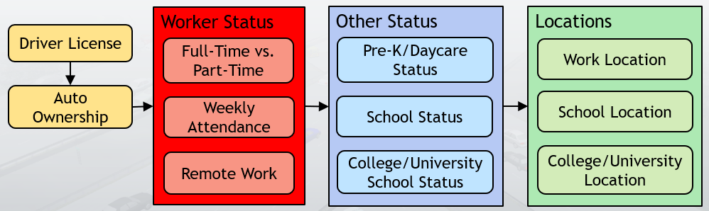

**Figure 2: Long-Term Choices**

### The driver license model

The **driver license model** captures an individual’s decision to own a driver license. It is applied to all individuals at least 16 years of age, given that children as young as 16 can drive to school in the region.

*Model type:* Binary Logit (BL)

*Applied to:* All individuals 16 years or older

*Tree structure:*

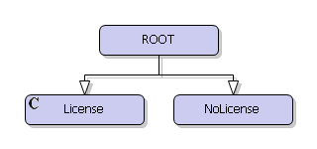

*Utility specification:*

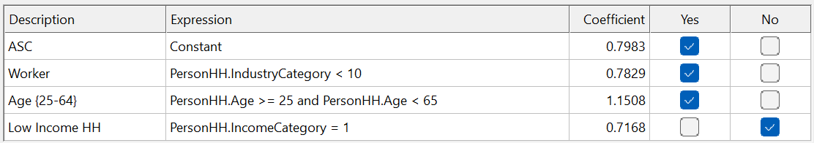

Workers and persons between 25 and 64 years of age (many of whom will be workers) are more likely to be licensed to drive. Persons in low-income households are less likely to have a driver license.

### The auto ownership model

The **auto ownership model** predicts the number of vehicles available to members of each household. It is applied to all households, and deeply impacts various downstream mode- and destination-related choices.

*Model type:* Multinomial Logit (MNL)

*Applied to:* All households

*Tree structure:*

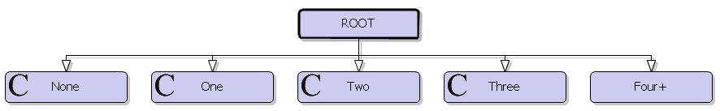

*Utility specification:*

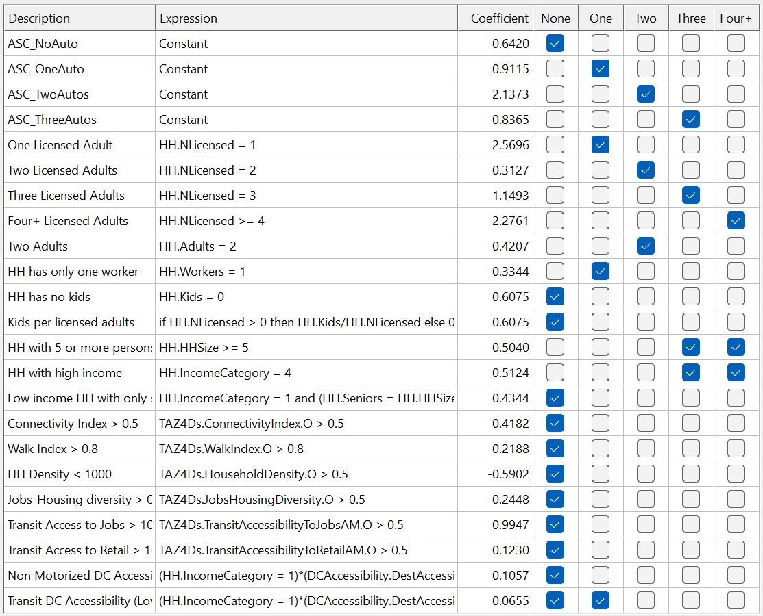

Vehicle ownership tracks the number of licensed drivers in the household. The absence of kids and low income both increase the chance of not owning any vehicles. A variety of accessibility effects involving walk, bike and public transit also increase the probability of not owning vehicles, as expected.

### The worker category model

The **worker category model** predicts whether a worker is full-time or part-time. This model’s output will feed into the next decision of the number of days a week the individual worked.

*Model type:* Binary Logit (BL)

*Applied to:* All workers

*Tree structure:*

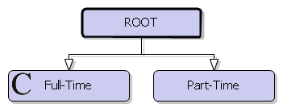

*Utility specification:*

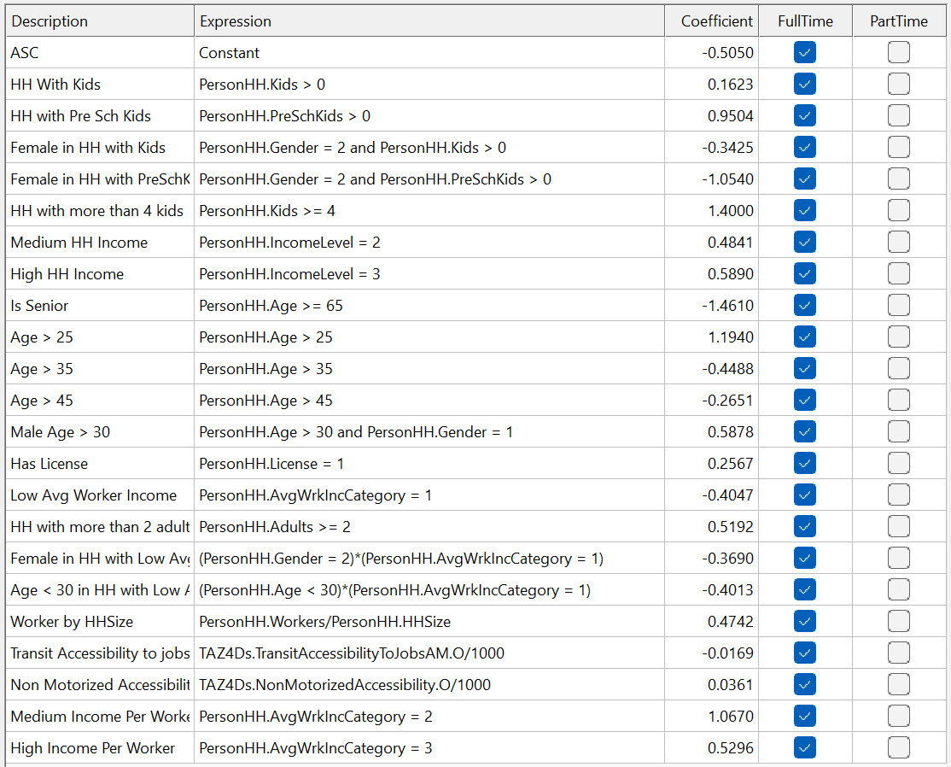

The presence of kids in the household tends workers toward full-time employment, though the effect is temped for female workers. Higher income levels are also associated with full-time status. As transit accessibility to jobs rises, there is a tendency toward part-time work, perhaps due to schedule flexibility without having to rely on driving.

### The work attendance model

The **work attendance model** captures the number of weeks that individuals may work on a regular basis. These numbers are derived from a travel survey and are used to simulate if a worker works on the given day.

*Model type:* Look-up table

*Applied to:* All workers

*Table values:*

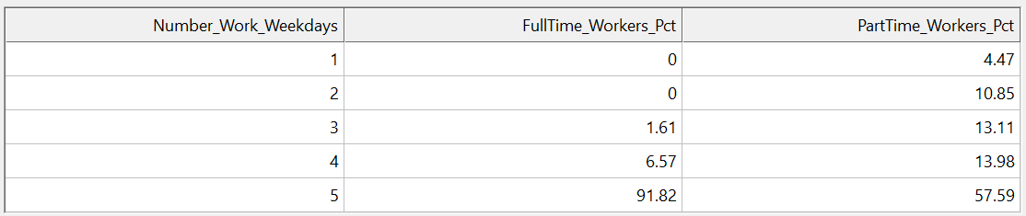

Full-time workers skew heavily toward the five-day work week while part-time workers are distributed more across all possibilities.

### The remote work percentage model

The **remote work percentage model** captures the tendency of workers to work from home. This effect has been accentuated during and post pandemic and plays a major role in determining travel patterns as well as free time for other (non-mandatory) activities. One outcome of remote work is the potential substitution of separate non-mandatory tour(s) in place of intermediate stops.

*Model type:* Look-up table

*Applied to:* All workers

*Table values:*

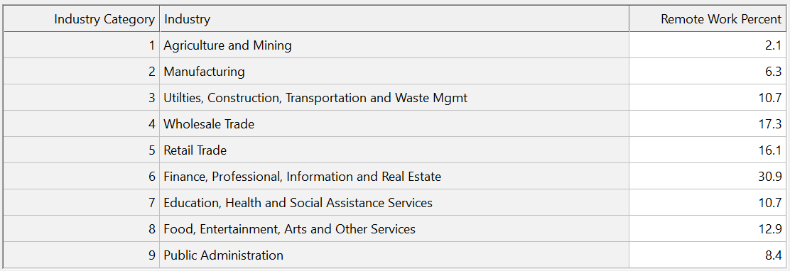

The feasibility of remote work varies by work industry. These values are derived from Bureau of Labor Statistics (BLS) national estimates.

### The pre-K/daycare status model

The **pre-K/daycare status model** predicts whether a child of age five years or younger will attend a pre-kindergarten or daycare facility on the given day.

*Model type:* Binary Logit (BL)

*Applied to:* All children aged five years or younger

*Tree structure:*

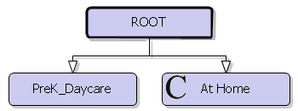

*Utility specification:*

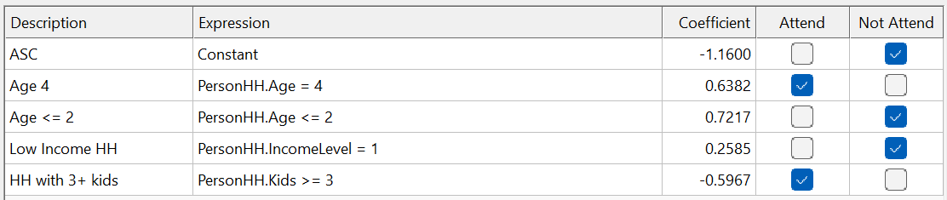

Children aged 4 years are more likely to attend pre-kindergarten or daycare, while children two years or younger tend to stay at home. Low-income households prefer to keep the daycare-age children at home. If there are three or more children in the household, the daycare-age children have a higher chance of attending daycare.

### The school status model

A large share of school-age kids typically tends to attend school. A fixed share suffices to adequately capture this behavior and is set to 88.5%. This also serves as the school tour frequency model, as children who attend school are assumed to make one school tour per day.

### The college/university status model

The **college/university status model** predicts whether an adult will attend college/university on the given day.

*Model type:* Binary Logit (BL)

*Applied to:* All persons aged 19 years or older

*Tree structure:*

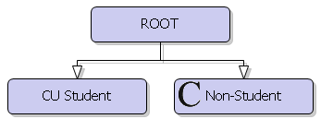

*Utility specification:*

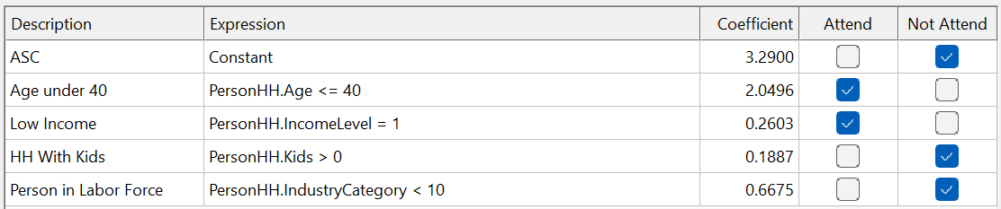

Adults in low-income households and those aged 40 or younger are more likely to attend college/university. Full-time workers and adults with children are less likely to be students.

### The work location choice model

The **work location choice model** predicts the habitual zones for people’s work activity participation. Due to the sparsity of zone representation in the estimation dataset, the work location choice models were estimated at the block group level (a higher-level geography with enhanced survey coverage). During model application, the models are run first to predict the block group. A zone within the simulated block group is then sampled based on distance criteria.

*Model type:* Multinomial Logit (MNL)

*Applied to:* All workers

*Tree structure:* All zones with relevant employment available

*Estimated utility specification:*

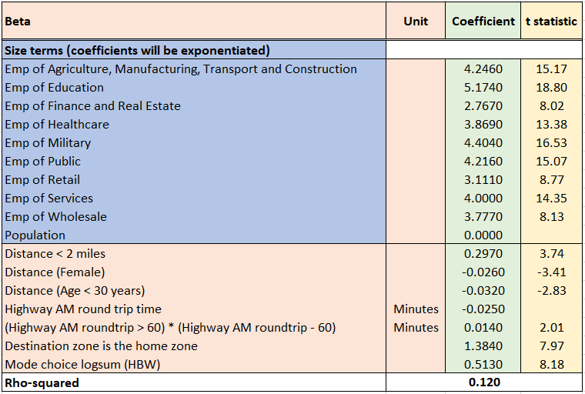

The model has coefficients with appropriate signs. The highway travel time and distance coefficients are negative, indicating that farther destinations are less likely to be chosen in general, though high employment numbers in those block groups could still overcome this impedance effect. Note that destinations significantly far away from the origin are penalized a little less, though the net effect is still negative. Intra-zonal work activities are strongly indicated. The positive mode choice logsum coefficient indicates that the destinations more accessible by different modes are preferred.

Shadow pricing may be turned on in the interface, so that an iterative, zone-level adjustment is carried out to close the gap between the model output and the employment totals. Once these prices are computed, subsequent runs may simply use these final values without re-computing them. You may re-compute these if a scenario is deemed to have changed significantly from the prior model run.

The Size variable serves as an attraction ‘constraint’ by increasing the selection probability of locations with larger employment levels. The models are applied with the appropriate size variables by each person’s work industry type to ensure that work activities are destined to zones that contain the appropriate category of employees:

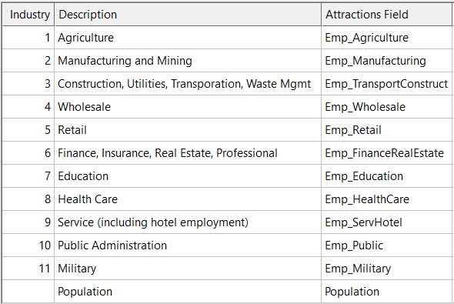

### The university location choice model

The **university location choice model** predicts the habitual zones for people’s college and university activity participation.

*Model type:* Multinomial Logit (MNL)

*Applied to:* All college/university students

*Tree structure:* All zones with education enrollment available

*Estimated utility specification:*

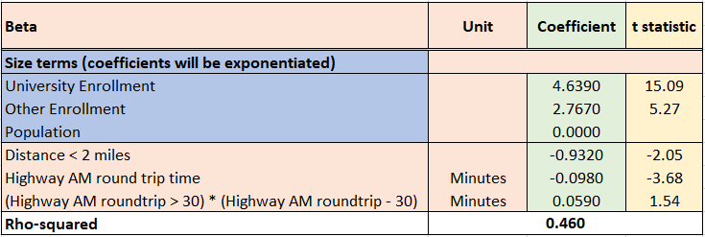

The highway travel time coefficient is negative, indicating that farther destinations are less likely to be chosen in general, though high college/university enrollment numbers in those zones could still overcome this impedance effect. Note that destinations significantly far away from the origin are penalized a little less, though the net effect is still negative.

Shadow pricing may be turned on in the interface, so that an iterative, zone-level adjustment is carried out to close the gap between the model output and the enrollment totals. Once these prices are computed, subsequent runs may simply use these final values without re-computing them. You may re-compute these if a scenario is deemed to have changed significantly from the prior model run.

The Size variable serves as an attraction ‘constraint’ by increasing the selection probability of locations with larger student enrollment levels.

### The school location choice model

The **school location choice model** predicts the habitual zones for children’s school activity participation.

*Model type:* Multinomial Logit (MNL)

*Applied to:* All persons with age between 5 and 18 years

*Tree structure:* All zones with school enrollment available

*Estimated utility specification:*

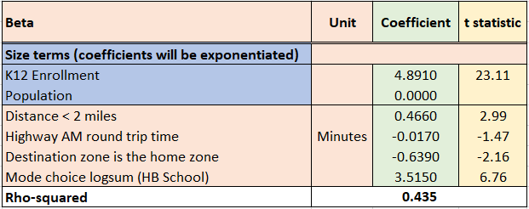

The highway travel time coefficient is negative, indicating that farther school locations are less likely to be chosen in general, though high levels of enrollment in those zones could still overcome this impedance effect. The short-distance and intra-zonal effects interact to indicate the higher preference for school locations closer to home. The positive mode choice logsum coefficient indicates that the destinations more accessible by different modes are preferred.

Shadow pricing may be turned on in the interface, so that an iterative, zone-level adjustment is carried out to close the gap between the model output and the employment totals. Once these prices are computed, subsequent runs may simply use these final values without re-computing them. You may re-compute these if a scenario is deemed to have changed significantly from the prior model run.

The Size variable serves as an attraction ‘constraint’ by increasing the selection probability of locations with larger student enrollment levels.

## Short-term decisions

The ABM predicts various short-term decisions made by the residents of the region. These decisions fall into the basic categories of mandatory and non-mandatory choices. Mandatory choices are those that are generally not optional, and are typically related to work, school and college/university purposes. Non-mandatory (or discretionary) choices are those that may be perceived as being optional, or at least not performed with the regularity/frequency of mandatory activities. These include shopping, leisure and maintenance activities that are integral to life but have a level of flexibility in terms of activity frequency and scheduling. Non-mandatory activities may appear in a daily schedule either as separate tours, or via intermediate stops along any mandatory or non-mandatory tour.

Figure 3 highlights the numerous steps included in the ABM’s short-term decisions. Subsequent sections will focus in turn on the mandatory and non-mandatory components of this flowchart and provide a detailed summary of their inner workings.

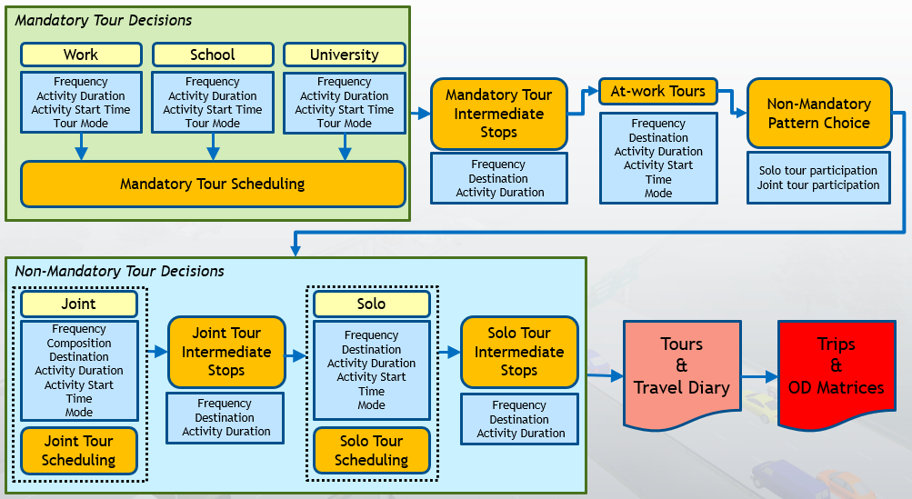

**Figure 3: Mandatory and Non-Mandatory ABM steps**

## Mandatory tour decisions

People’s mandatory decisions are anchored on work, school and college/university status. The worker status is a day-to-day model that predicts is a worker actually works on the given day. This model captures variations in personal situations that can result in working fewer hours than usual or taking the day off for any number of unobserved reasons.

After worker status is determined, the mode for various mandatory tours is predicted. Subsequent models fill in the details about tour frequency and scheduling.

The mandatory decisions described in this section are highlighted with the red box in Figure 4, and cover the following models:

* Various dimensions of work, school and university tours:
  + Tour frequency
  + Activity duration
  + Activity start time
  + Tour mode

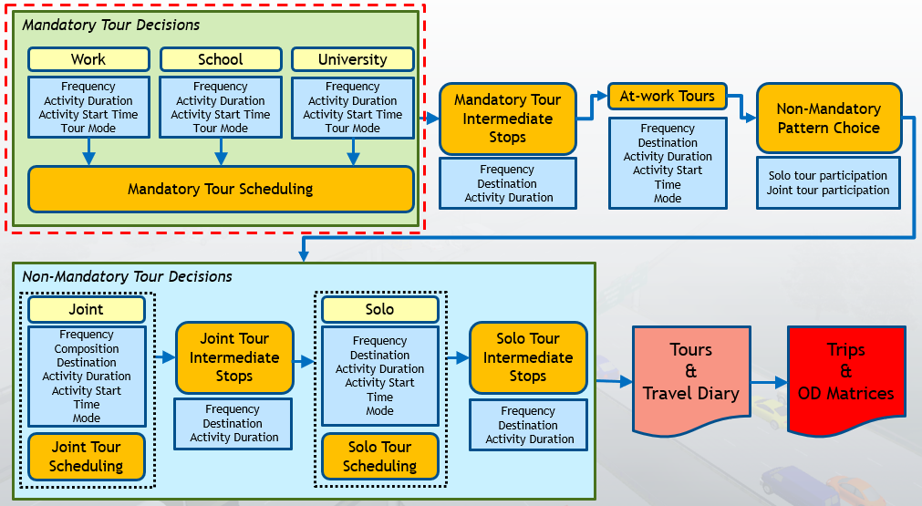

**Figure 4: Highlighting the ABM’s Mandatory Decisions steps**

### The work tour frequency model

The **work tour frequency model** predicts the number of work tours made by each worker, subject to a maximum of two tours. All workers who chose to work on the day (and are not working remotely) are assumed to make at least one work tour.

*Model type:* Binary Logit (BL)

*Applied to:* All workers

*Tree structure:* One tour, or two tours

*Utility specification:*

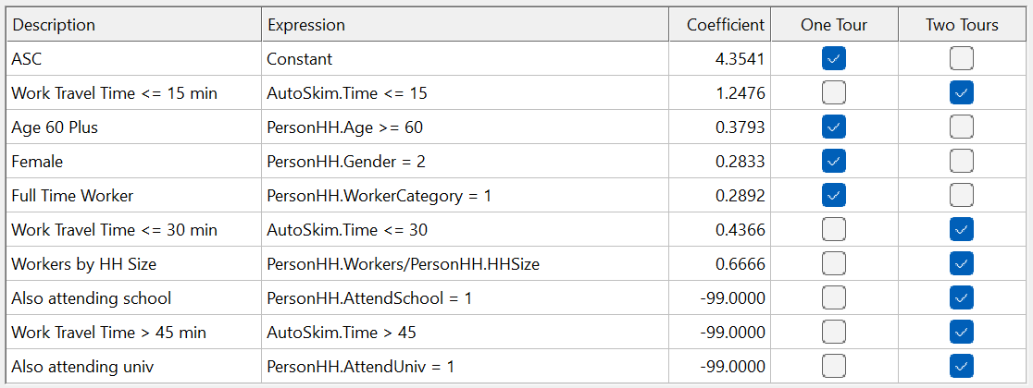

Work locations closer to home induce more work tours. Workers who are also students are restricted to one work tour. Seniors, full-time and female workers are more likely to make a single work tour.

### The university tour frequency model

The **university tour frequency model** predicts the number of college/university tours made by those tagged as university students in the synthetic population.

*Model type:* Binary Logit (BL)

*Applied to:* All higher education students

*Tree structure:* One tour, or two tours

*Utility specification:*

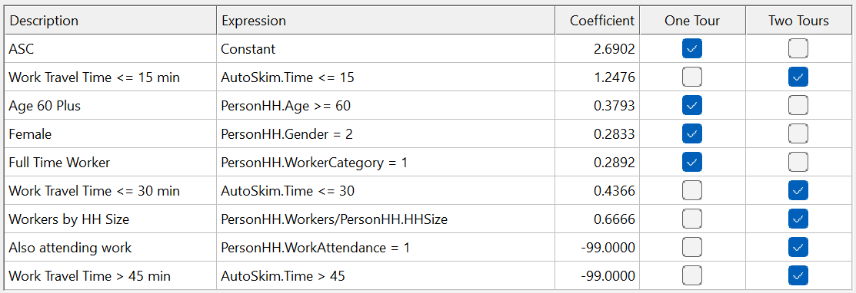

University locations closer to home induce more study tours. Students who are also workers are restricted to one school tour. Seniors, full-time and female workers are more likely to make a single study tour.

### Work duration model (full-time workers)

The **work duration model** for full-time workers predicts the temporal duration of work activities. The model predicts the duration of the work activity to the hour.

*Model type:* Multinomial Logit (MNL)

*Applied to:* All full-time workers and part-time college/university students

*Tree structure:* All hours from 1 to 16, plus the sub-hour alternative

*Utility specification:*

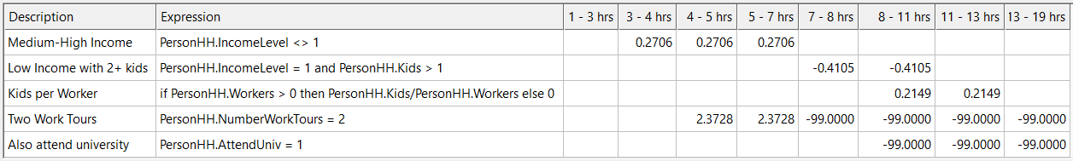

Medium- and high-income households tend to be associated with shorter work durations. Low-income households with two or more children similarly prefer shorter work durations (due to the negative sign on the corresponding coefficient), perhaps due to additional childcare responsibilities. When each worker supports more children in the household, the tendency is to work longer hours. Those who make two or more work tours must necessarily reduce the duration of each work activity so as to maintain a feasible daily schedule.

### Work duration model (part-time workers)

The **work duration model** for part-time workers predicts the temporal duration of work activities. The model predicts the duration of the work activity to the hour.

*Model type:* Multinomial Logit (MNL)

*Applied to:* All part-time workers and part-time college/university students

*Tree structure:* All hours from 1 to 12

*Utility specification:*

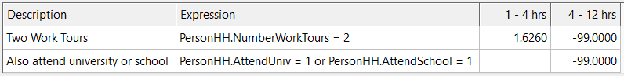

Those making 2 work tours are more likely to work fewer hours. Workers who also study are restricted to shorter work hours in order to accommodate schedules.

### University duration model

The **university duration model** predicts the temporal duration of higher education activities. The model predicts the duration of the university activity to the hour.

*Model type:* Multinomial Logit (MNL)

*Applied to:* All students 18 years or older

*Tree structure:* All hours from 1 to 12, plus the sub-hour alternative

*Utility specification:*

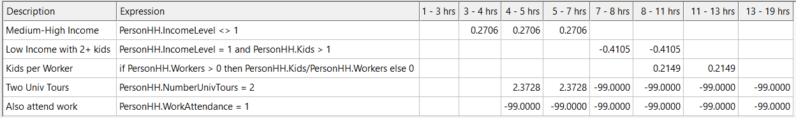

Students from medium- and high-income households tend to participate in shorter study activities. Students who make two study tours and/or also work, are restricted to much shorter study activity durations.

### School duration model

The **school duration model** predicts the temporal duration of school activities. The model predicts the duration of the school activity to the hour.

*Model type:* Multinomial Logit (MNL)

*Applied to:* All children between the ages of 5 and 19

*Tree structure:* All hours from 1 to 10, plus the sub-hour alternative

*Utility specification:*

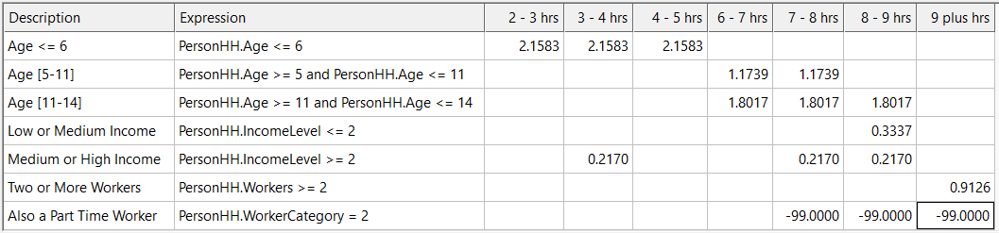

Children 6 years of age or younger are more likely to be in school for 2 to 5 hours on a given day. This is generally associated with pre-school and part-time daycare attendance. Children of primary and secondary school age tend to attend school full-time. If there are two or more workers in the household, the children have a higher tendency to attend more than 9 hours of school. This is likely to correlate with before- and after-school care to accommodate both parents’ worker status.

### Work activity start time model (full-time workers)

The **work activity start time model** for full-time workers predicts the hour during which the work activity begins.

*Model type:* Multinomial Logit (MNL)

*Applied to:* All full-time workers

*Tree structure:* All hours from 4:00 AM to 9:00 PM (exact departure times to the minute will be simulated subsequently based on observed within-hour profiles)

*Utility specification:*

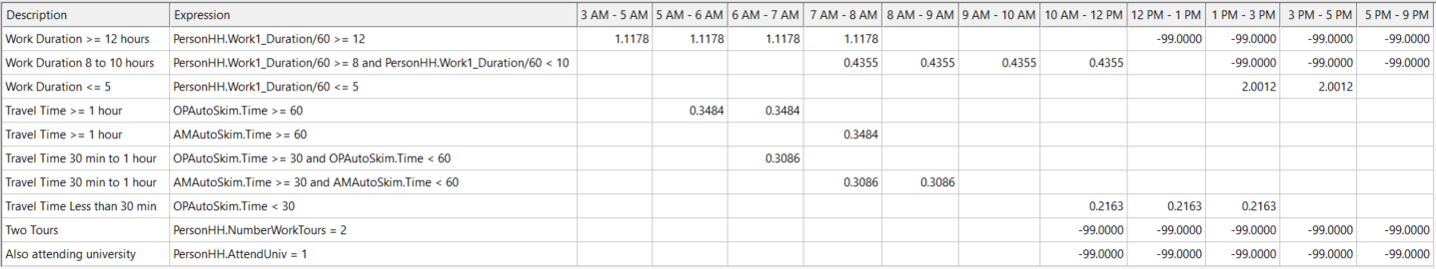

Longer work durations tend to prefer earlier start times in order to ensure within-day schedule feasibility. Consequently, shorter work durations (within 5 hours) increase the chance of later work start options. Drive times to the work location follow a similar trend: longer commutes require earlier work starts and vice versa.

### Work activity start time model (part-time workers)

The **work activity start time model** for part-time workers predicts the hour during which the work activity begins.

*Model type:* Multinomial Logit (MNL)

*Applied to:* All part-time workers

*Tree structure:* All hours from 4:00 AM to 7:00 PM (exact departure times to the minute will be simulated subsequently based on observed within-hour profiles)

*Utility specification:*

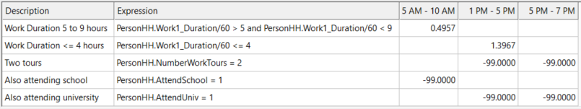

Part-time workers work fewer hours than full-time workers in general. Nevertheless, there is a distinct effect of shorter versus longer work durations. Those working between 5 and 9 hours are more likely to start work earlier in the day. Those working 4 or fewer hours have elevated probabilities of starting between 1:00 PM and 5:00 PM.

### University activity start time model

The **university activity start time model** predicts the hour during which higher education activities begin.

*Model type:* Multinomial Logit (MNL)

*Applied to:* All higher education students

*Tree structure:* All hours between 8 AM and 10 PM

*Utility specification:*

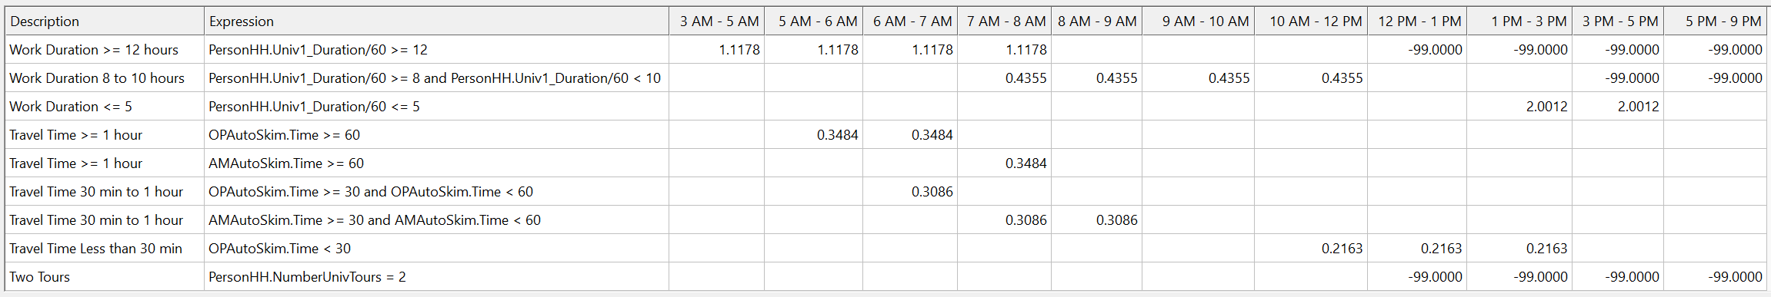

Longer work durations cause earlier university start times, and vice versa. Longer travel times to the university skew slightly toward an earlier start time, and vice versa.

### School activity start time model

The **school activity start time model** predicts the hour during which students’ school activities begin.

*Model type:* Multinomial Logit (MNL)

*Applied to:* All primary and secondary school students

*Tree structure:* All hours between 6 AM and 9 AM, plus a single alternative for the period 9:00 AM – 6:00 PM.

*Utility specification:*

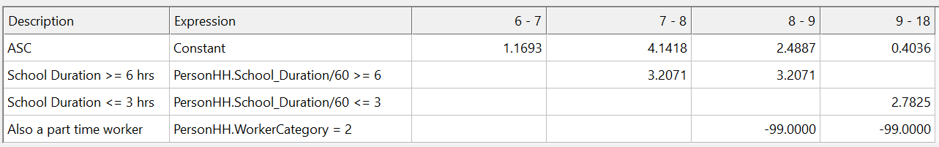

Students attending school on a full-time basis (i.e. for 6 hours or more) tend to start school between 7:00 AM and 9:00 AM. Those with part-time attendance may start later.

### Mode choice considerations

Mode choice is applied in four tiers, in decreasing priority order. Full-time workers are processed first, followed by part-time workers, college/university students and school students. The process flow is illustrated in Figure 5:

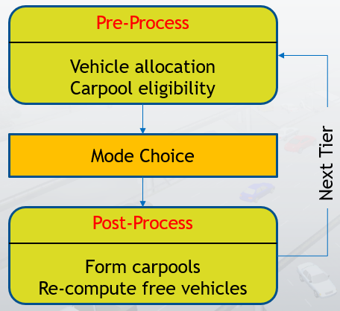

**Figure 5: Tiered Mode Choice Model Flow**

Each tier goes through the following steps:

1. Vehicles are allocated to people with driver licenses based on the priority order
2. Carpool eligibility is determined based on proximity of work locations and work activity start and end times, ensuring that each group has at least one licensed driver
3. The mode choice model is applied to the current tier
4. Simulated outcomes for the tier are post-processed to:
   1. Release any unused vehicles for lower tiers
   2. Form carpool groups where appropriate
   3. For school students who chose Carpool, qualified adult(s) are assigned Pick-Up/Drop-Off (PUDO) responsibilities:
      1. First preference is given to non-working adults with a driver license
      2. Next, working adults are scanned for those who have free time during PUDO hours (to make separate PUDO tours)
      3. If the above two options are infeasible, PUDO is performed as intermediate stops
      4. When all else fails, the student is shifted to the School Bus mode

### The work mode choice model

The **work mode choice model** predicts the travel mode to and from work.

*Model type:* Nested Logit (NL)

*Applied to:* All workers

*Estimated utility specification:*

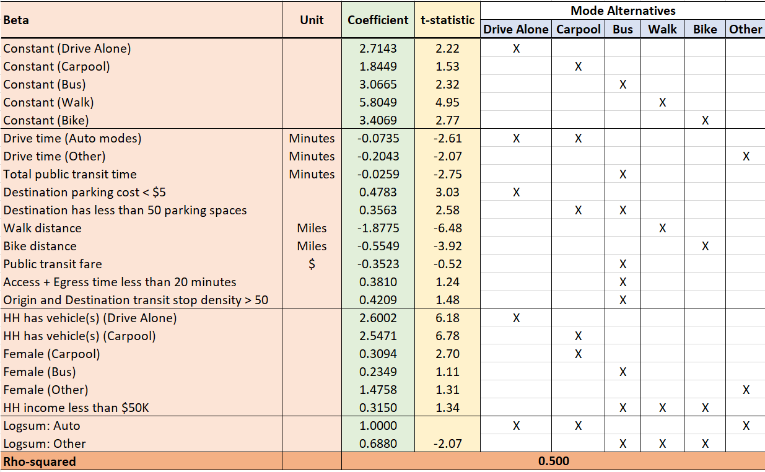

The Other mode includes Transportation Network Companies (e.g. Uber and Lyft).

Travel time plays a critical role in mode choice determinations. The above specification indicates that highway time affects the utilities of the Drive Alone, Carpool and Other modes. Walk and Bike are influenced largely by distance. The respective distance coefficients absorb the speed effect of either mode. The Bus mode is impacted not only by the total public transit time and fare, but also by lack of parking at the destination zone, stop density close to home and work, and shorter access/egress times.

Gender and relative lack of parking spaces impact the chance of Carpool as the chosen work mode. Females are generally somewhat more likely to use Carpool, Bus and Other modes for work tours. Low-income households increase the probability of using the Bus and non-motorized modes. Not surprisingly, the presence of autos in the household fosters the Drive Alone and Carpool modes.

One of the two nest coefficients is different from 1, so that the model is sufficiently different from the simpler Multinomial Logit (MNL) specification.

*Tree structure:*

While the survey allows the estimation of only a single Bus mode, the model must include a broader set of public transit sub-modes. The estimated Bus utility was therefore used for transit sub-modes covering different access modes: Walk access, Park-and-Ride (PnR) and Kiss-and-Ride (KnR). Each of these three access types is further divided into Bus and Rail alternatives. An expanded nested structure was also asserted:

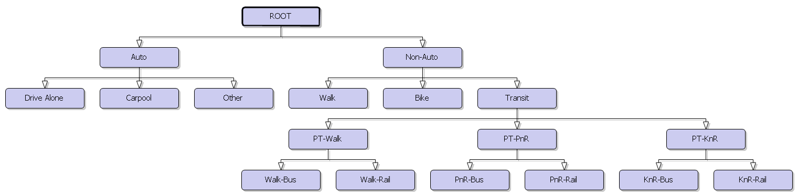

*Mode availability:*

The following conditions are applied to each mode to determine availability:

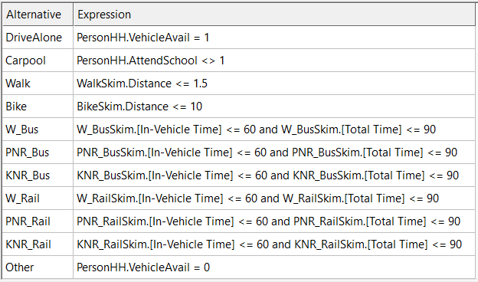

*Final nest coefficients:*

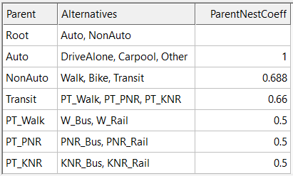

*Calibrated mode constants:*

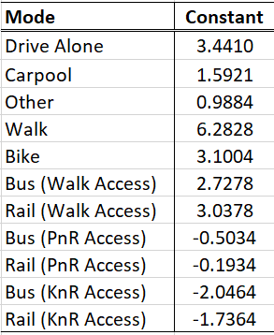

### The university mode choice model

The **university mode choice model** predicts the travel mode to and from college and university.

*Model type:* Nested Logit (NL)

*Applied to:* All college/university students

*Estimated utility specification:*

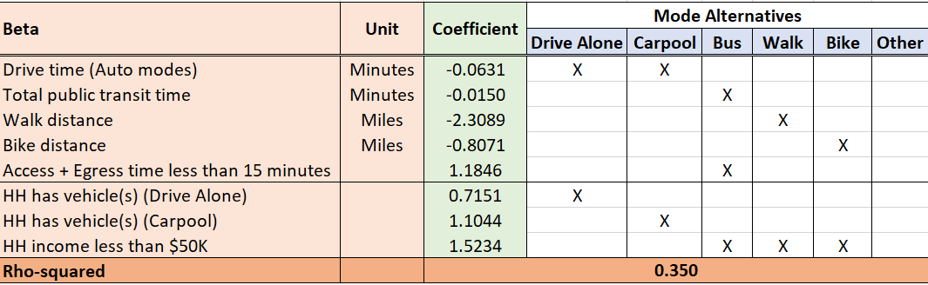

The presence of vehicle(s) in the household boosts the possibility of driving to college/university. Distance and time have the expected negative impacts on the relevant modes. Lower access/egress times favor the bus mode. Low household income is associated with higher utilization of bus, walk and bike modes.

*Tree structure:*

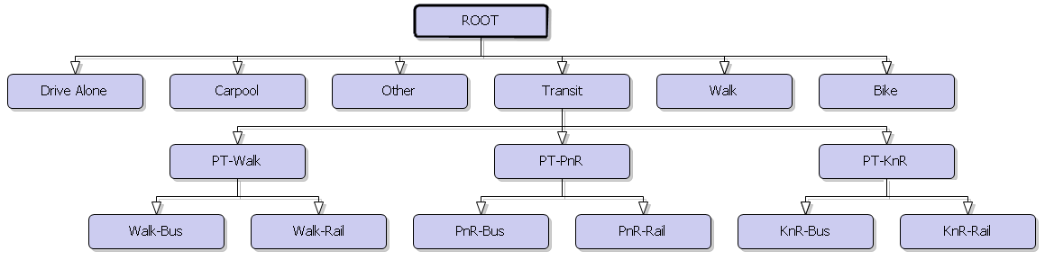

*Mode availability:*

The following conditions are applied to each mode to determine availability:

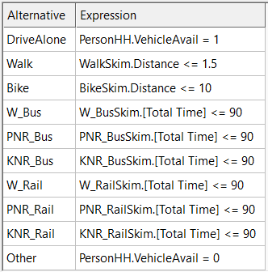

*Calibrated mode constants:*

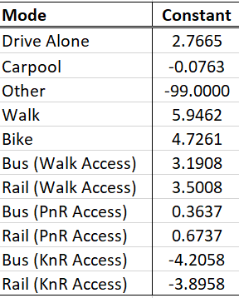

### The school mode choice model

The **school mode choice model** predicts the travel mode of students to and from school.

*Model type:* Nested Logit (NL)

*Applied to:* All primary and secondary school students

*Estimated utility specification:*

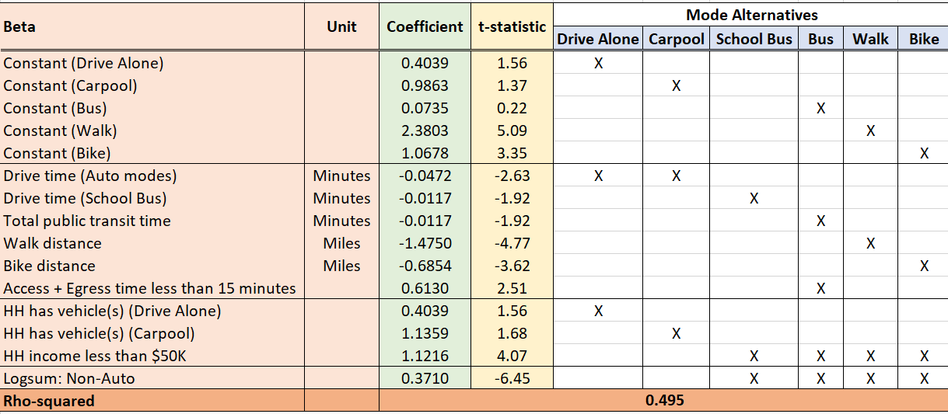

Time and distance affect the relevant modes negatively. Children from low-income households have a higher tendency to ride a bus or choose a non-motorized mode. The presence of vehicle(s) in the household increases the chance of driving or getting escorted. Lower values of access/egress times increase the chance of riding the bus.

The Non-Auto nest’s logsum coefficient is significantly different from 1, justifying the choice of a nested structure.

*Tree structure:*

The Carpool mode indicates pick-up/drop-off (PUDO) by a household member. A new mode, Non-Household Auto, was asserted to capture the expected propensity to share rides with friends and neighbors:

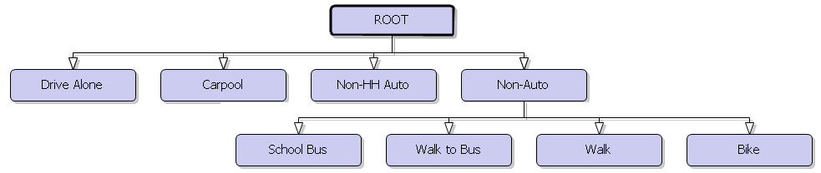

*Mode availability for forward journey:*

The following conditions are applied to each mode to determine availability:

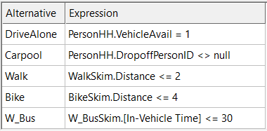

*Mode availability for return journey:*

The following conditions are applied to each mode to determine availability:

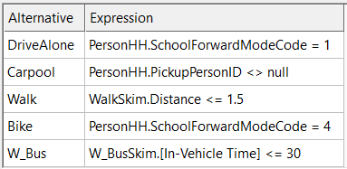

The carpool mode is only available when an adult has been allocated as a potential driver for the journey. The bike mode is automatically set for the return journey if bike was chosen for the forward journey. Consequently, the bike mode is not available on the return journey if it was not chosen for the forward journey.

*Calibrated mode constants:*

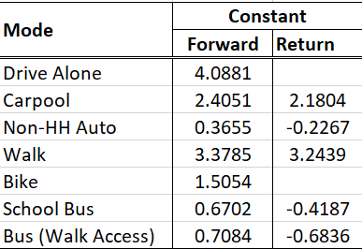

## Mandatory tour scheduling logic

The key scheduling paradigm in the ABM is that the mandatory tours takes precedence over non-mandatory activities. Further, school tours get priority over part-time workers’ schedules. The mandatory tours fall into three scheduling regimes:

* Separate tours: These are free from carpool and school pick-up/drop-off (PUDO)
  + If there are intermediate stops on the forward journey, the departure time from home is advanced as long as other tours are not impacted.
  + Persons may arrive late to work/college/university if they must make stops.
  + If there are intermediate stops on the return journey, persons can arrive late at home as long as other tours are not impacted. Otherwise, persons leave work early.
  + Post-processing removes intermediate stops if the work duration is significantly curtailed due to the stops.
  + School children do not make intermediate stops.
* Carpool tours: Two or more household members are on the tour
  + Drop-off and pick-up order are based on activity start and end times.
  + If there are intermediate stops, they happen before the first drop-off and after the last pick-up.
    - Arriving late/departing early are handled similar to separate tours.
* PUDO
  + Drop-off and pick-up based on school start and end times.
  + If there are intermediate stops, they happen after the last school drop-off and before the first school pick-up.
  + Intermediate stops
    - On the forward journey: School start times are fixed. Persons can be late arriving at work after making intermediate stops.
    - On the return journey: School end times are fixed. Persons may leave work early to accommodate the intermediate stops.

## The Time Manager

The ABM’s Time manager object keeps track of used (and hence available) time at the person and household levels and is the repository of all time slot status information. This is stored at the resolution of 15-minute intervals throughout the day. The time manager is regularly updated as decisions are made by the ABM. Efficient software modules are built around the manager to support querying of various kinds. Some examples are:

* Total time and free time slots for a person
* Common time available across all household members
* Maximum contiguous free time window available per person
* Confirm if a person’s proposed tour will fit into a candidate time window

The time manager is used to calculate variables such as Common Free Time and Average Free Time that will appear in some of the model specifications in subsequent sections of this document.

## Non-mandatory decisions

People’s non-mandatory decisions are typically anchored on the availability of free time after accounting for mandatory activities. The first level of non-mandatory decisions is made via intermediate stops along mandatory tours. Other sub-tours (to run errands, shop, or eat) may start and end within the work activity’s time window, and are also referred to as at-work tours. Subsequent decisions about dedicated non-mandatory tours are made at the household level, where members collectively choose to participate in any joint and solo tours. This latter decision is encapsulated in the pattern choice step in the ABM.

Households that choose to make solo and/or joint tours must then fill out the details of these tours. The non-mandatory decisions described in this section are highlighted with the red box in Figure 6, and cover the following models:

* Mandatory tour intermediate stops on work and university tours
  + Stop frequency
  + Stop destination
  + Stop activity duration
* Details pertaining to work-based (or at-work) tours:
  + Tour frequency
  + Tour destinations
  + Activity durations
  + Activity start times
  + Tour mode
* Household pattern choice
* Various dimensions of joint tours:
  + Tour frequency
  + Tour composition/participation (i.e. household members comprising the tour party)
  + Tour destinations
  + Activity durations
  + Activity start times
  + Tour mode
* Various dimensions of solo tours:
  + Tour frequency
  + Tour destinations
  + Activity durations
  + Activity start times
  + Tour mode
* Details pertaining to intermediate stops:
  + Stop frequency
  + Stop destinations
  + Stop activity durations

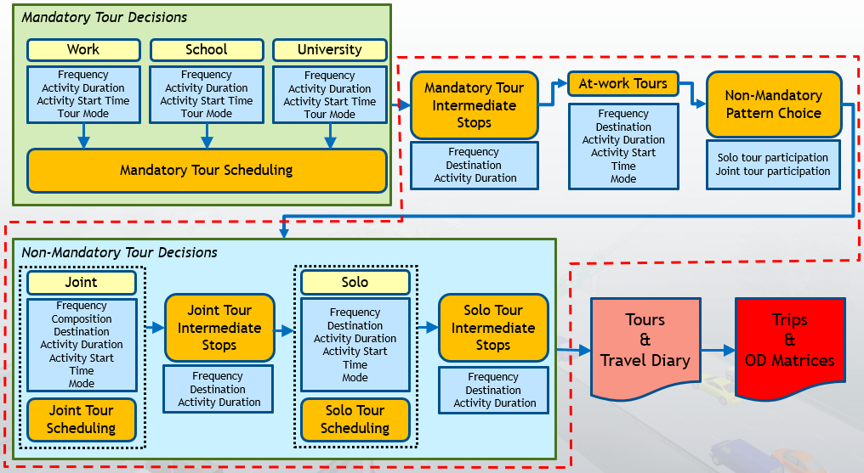

**Figure 6: Highlighting the ABM’s Non-Mandatory Decisions steps**

## Mandatory tour intermediate stops

### Mandatory tour intermediate stop frequency on work tours

The **mandatory tour intermediate stop frequency model for work tours** jointly predicts the presence of a stop on both forward and return legs of a work tour.

*Model type:* Multinomial Logit (MNL)

*Applied to:* All workers

*Tree structure:*

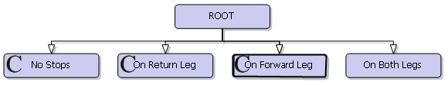

The alternatives are coded in the F_R format, with F (forward) and R (return) each taking on a value of either 0 or 1. A value of 0 means the absence of stops on that leg, while a value of 1 indicates one or more stop(s) on that leg.

*Utility specification:*

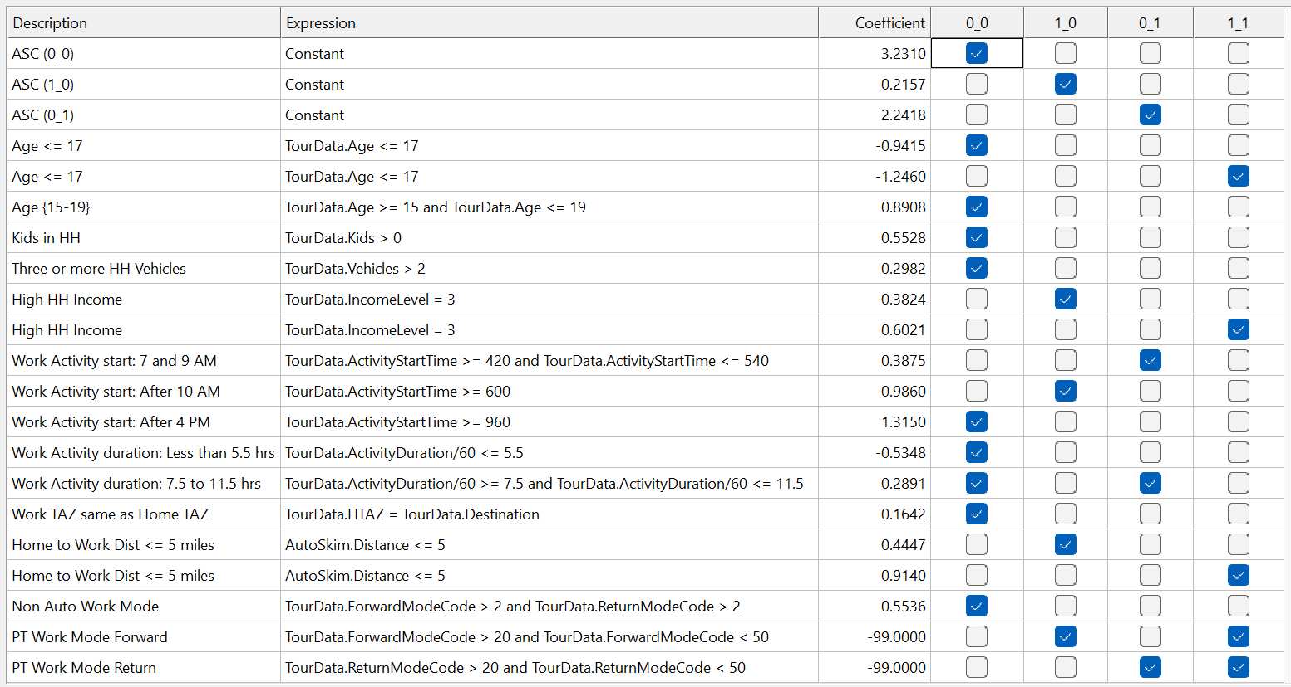

High-income persons are more likely to make one or two stops. The presence of children in the household reduces the probability of stopping. If the worker/college student is of age 17 or below, they are more likely to make one stop than two or no stops. Workers who start work between 7:00 AM and 9:00 AM tend to prefer stops on the way back, while those working after 10:00 prefer to stop on the way in to work. Work starts after 4:00 PM tend to be associated with no stops. Short work durations tend to favor no stops, perhaps because there will be time to make separate non-mandatory tours. When the work location is farther away from home, stops become more attractive. Intra-zonal work tours and non-auto modes favor not making stops, owing to very short distances and perhaps lower travel speeds. An auto-sufficient household tends to prefer no stops, since non-mandatory purposes can be served by separate tours.

In addition to the above, two parameters are used to determine if an intermediate stop happens before school drop-off and before school pick-up, if such a school activity is part of the work tour. These probabilities are set to 0.25 and 0.20 respectively, and can be modified via the flowchart interface.

### Mandatory tour intermediate stop frequency on university tours

The **mandatory tour intermediate stop frequency model for university tours** jointly predicts the presence of a stop on both forward and return legs of a college/university tour.

*Model type:* Multinomial Logit (MNL)

*Applied to:* All higher education students

*Tree structure:*



The alternatives are coded in the F_R format, with F (forward) and R (return) each taking on a value of either 0 or 1. A value of 0 means the absence of stops on that leg, while a value of 1 indicates one or more stop(s) on that leg.

*Utility specification:*

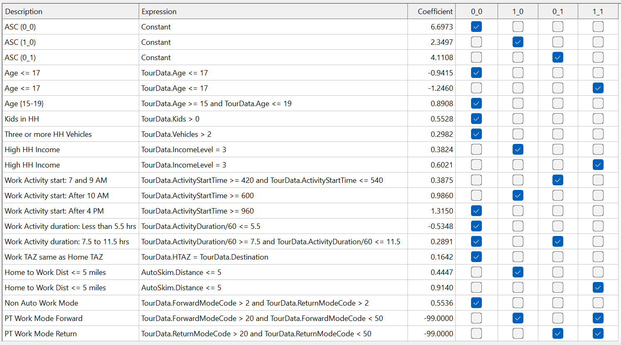

High-income persons are more likely to make one or two stops. The presence of children in the household reduces the probability of stopping. If the worker/college student is of age 17 or below, they are more likely to make one stop than two or no stops. Students who start university activities between 7:00 AM and 9:00 AM tend to prefer stops on the way back, while those studying after 10:00 prefer to stop on the way in. University activity start times after 4:00 PM tend to be associated with no stops. Short activity durations tend to favor no stops, perhaps because there will be time to make separate non-mandatory tours. When the study location is farther away from home, stops become more attractive. Intra-zonal study tours and non-auto modes favor not making stops, owing to very short distances and perhaps lower travel speeds. An auto-sufficient household tends to prefer no stops, since non-mandatory purposes can be served by separate tours.

### Mandatory tour intermediate stop destination

The **mandatory tour intermediate stop destination model** predicts the destination zone of a stop.

*Model type:* Multinomial Logit (MNL)

*Applied to:* Persons who make mandatory tours and choose to make one or two intermediate stop(s)

*Tree structure:* All zones are available.

*Utility specification:*

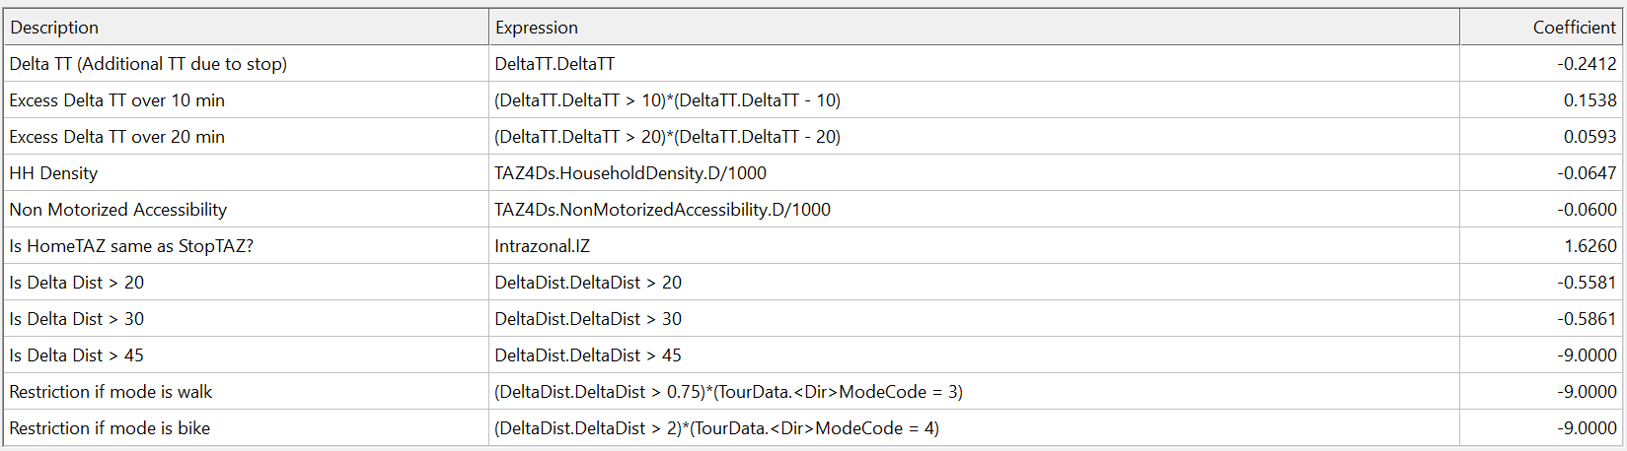

The detour duration (in minutes) serves as a deterrent to selecting stops too far away from the direct route connecting home to work/university. Stops that involve detours of more than 20, 30 and 45 miles are penalized. Priority is given to stops that coincide with either the home or the mandatory tour destination zone, and more so for bike/walk tours.

*Size variable*:

The size value for each candidate destination zone is calculated from the table below. The coefficients are exponentiated before being multiplied by the corresponding variable:

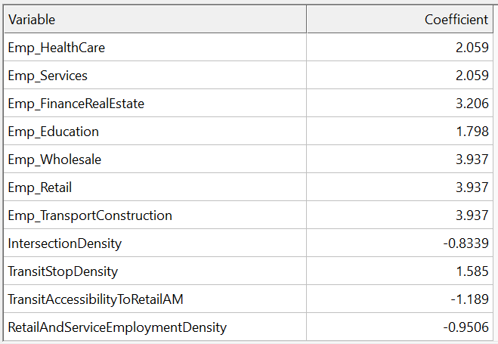

### Mandatory tour intermediate stop duration

The **mandatory tour intermediate stop duration models** predict the duration of an intermediate stop activity along a work/university tour.

*Model type:* Multinomial Logit (MNL)

*Applied to:* Persons who make mandatory tours and choose to make one or two intermediate stop(s)

*Tree structure:*



*Alternative availability:*

The longer stop durations are only available when the main activity duration is low, according to the following table:

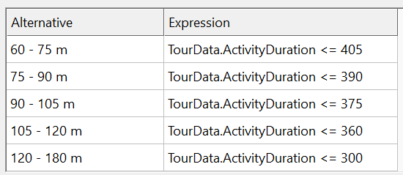

*Utility specification for work tour stops:*

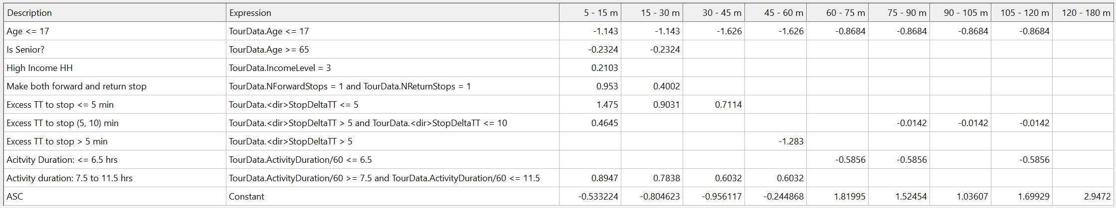

*Utility specification for university tour stops:*

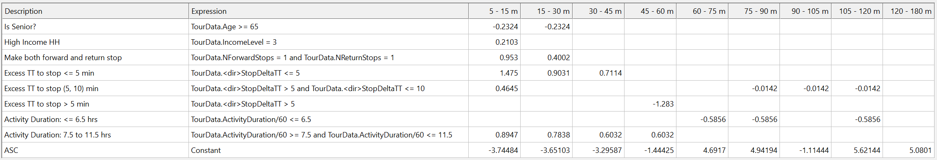

Persons from high-income households are more likely to make very short intermediate stops, perhaps for shopping or other errands. Children are prone to participate in longer stop activities. Seniors prefer longer stops. Mandatory activities that take 6.5 to 11.5 hours tend to favor shorter stops that can be fit into a busy workday. Short detour distances foster quick stops en-route to and from work. All else being equal, stops between 15-30 minutes and 60-75 minutes are more likely.

## Work-based sub-tours

Work-based (or at-work) sub-tours start and end at the work location. They capture tours that are made in the middle of the work duration, and can be for various purposes such as shopping, lunch, maintenance and even work. The following models describe the sequence of decisions behind the handling of work-based sub-tours within the ABM.

### Work-based tour frequency

The **work-based tour frequency model** predicts whether a worker makes a sub-tour during the middle of their work activity.

*Model type:* Binary Logit (BL)

*Applied to:* Persons that made work tour(s) with work activity of at least 90 minutes, and work activity starting and ending within the 7:00 AM – 7:00 PM window.

*Tree structure:*

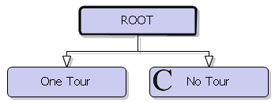

*Utility specification:*

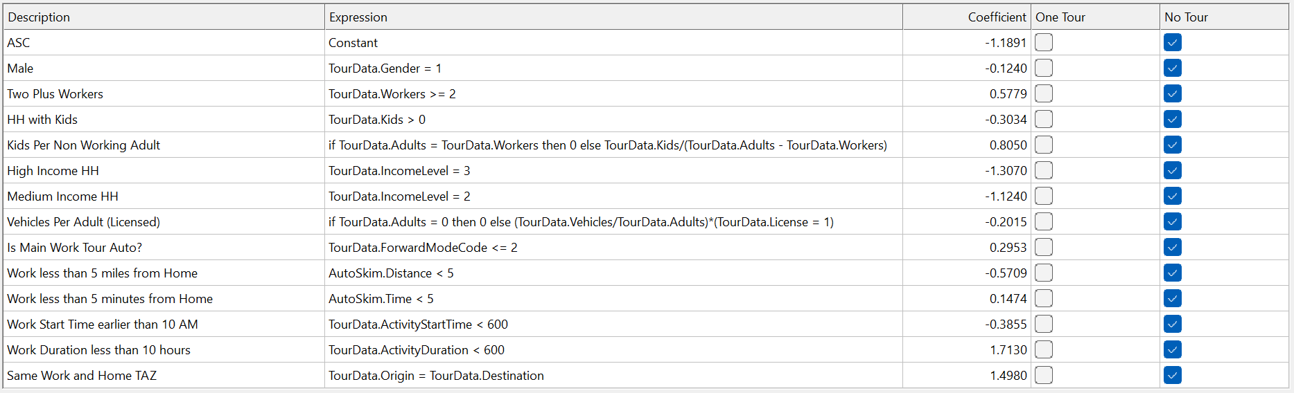

Workers with children make sub-tours, perhaps to preserve time later in the day for child-related commitments. Workers from high-and medium-income households are more likely to make sub-tours. The availability of a vehicle increases the chance of a sub-tour. If the work location is close to home, the tendency is to not make subtours since other travel needs may be met via separate non-mandatory tours.

### Work-based tour destination

The **work-based tour destination model** predicts the zonal location for each work-based tour made by a worker.

*Model type:* Multinomial Logit (MNL)

*Applied to:* Persons that made work tour(s)

*Tree structure:* All zones

*Utility specification:*

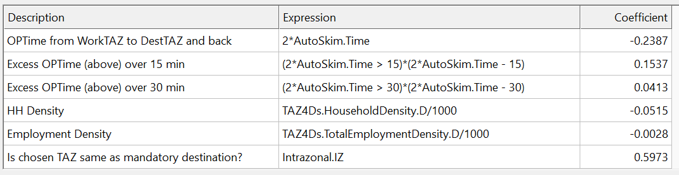

Intrazonal sub-tours are preferred more, owing to their potentially quick nature that minimizes disruptions to the main work activity. Destinations with higher household density are less attractive due to the lower opportunity for relevant activities. Travel time plays the expected role of reducing the attractiveness of farther locations.

*Size variable:*

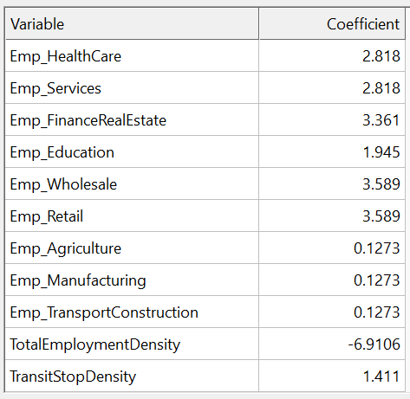

### Work-based activity duration

The **work-based activity duration model** predicts the temporal duration for each work-based activity performed by a worker.

*Model type:* Multinomial Logit (MNL)

*Applied to:* Persons that made work tour(s)

*Tree structure:*

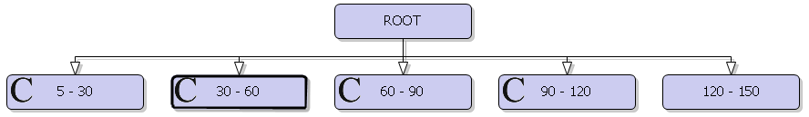

*Alternative availability:*

The longer at-work tour activity durations are only available when the main work activity is sufficiently long, as per the following table:

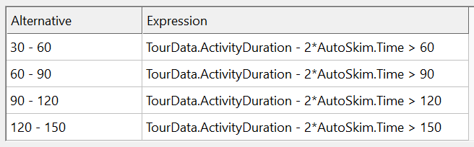

*Utility specification:*

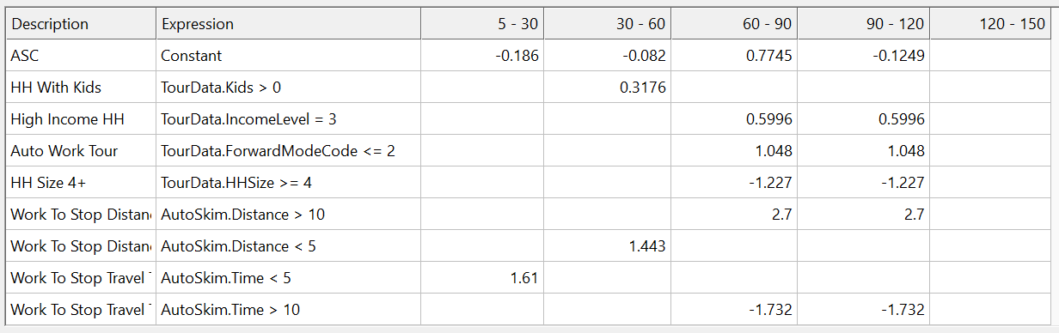

Workers with children make shorter-duration at-work tours. Workers from high-income households and those who drove to work prefer longer durations for their at-work tours. This could be a combined effect of access to the car, and the possibility of work-related sub-tours. Sub-tours to destinations close to work entail shorter sub-tours, perhaps because of quick outings for lunch or grocery shopping.

### Work-based activity start time

The **work-based activity start model** predicts the temporal beginning of each work-based activity performed by a worker.

*Model type:* Multinomial Logit (MNL)

*Applied to:* Persons that made work tour(s)

*Tree structure:* Every hour from 8:00 AM to 7:00 PM

*Utility specification:*

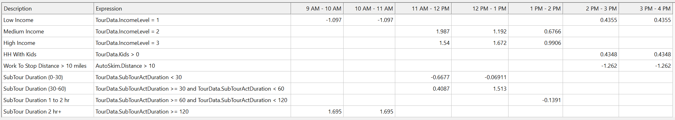

Workers from medium- and high-income households tend to prefer the middle of the day for at-work tours, perhaps coinciding with lunch breaks. Workers with children opt for mid-day sub-tours perhaps due to other child-related commitments later in the day. Longer-duration subtours are done earlier in the day, perhaps to complete them without disrupting work-related tasks.

*Alternative-Specific Constants (ASC):*

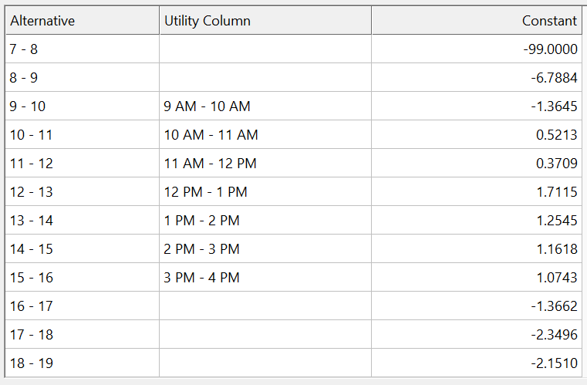

### Work-based tour mode

The **work-based tour mode choice model** predicts the travel mode for each work-based activity performed by a worker.

*Model type:* Multinomial Logit (MNL)

*Applied to:* Persons that made work tour(s)

*Tree structure:*

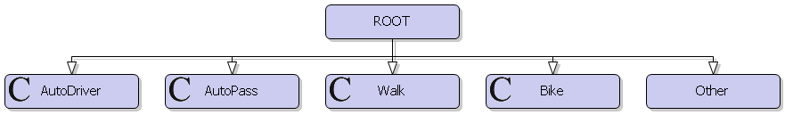

*Utility specification:*

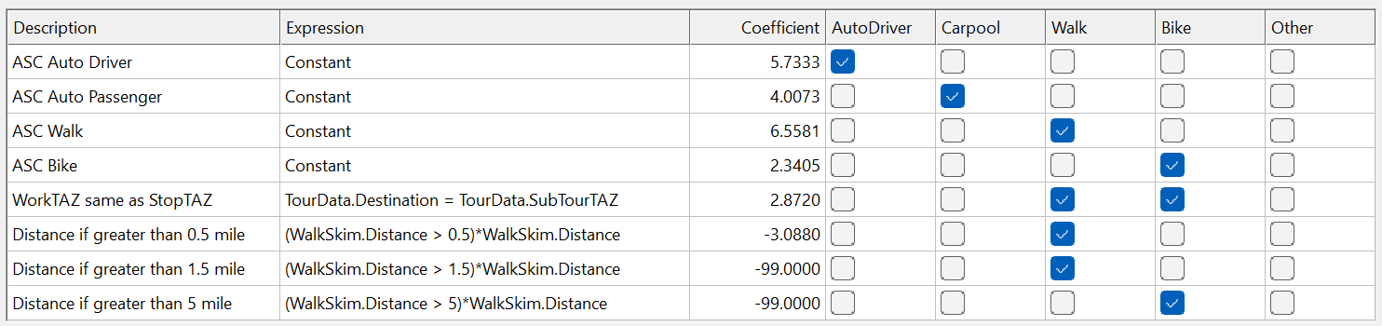

Intrazonal work tours increase the tendency to make walk/sub-tours, potentially in the vicinity of the work location. Distances greater than half a mile away deter the use of active modes. All else being equal, at-work tours are made predominantly by drive-alone and walk modes, reflecting the availability of the car if it was used as the work tour mode, and the tendency to not use the car for very short and quick sub-tours.

## Non-mandatory tour pattern choice

While the decisions around mandatory activities (work, school, college/university) are well-structured and potentially repeat with high frequency during the week, the non-mandatory activities are discretionary in nature and hence may or may not happen on a given day. These decisions can be performed by individuals alone (solo), or by multiple household members in a group (joint).

Discretionary activity participation (even those of the solo kind) can be viewed as household-level decisions that must be made together rather than independently by individuals. These activities can be classified into the following four categories:

1. No discretionary activities
2. Only solo tours
3. Only joint tours
4. Combination of solo and joint tours

Each of the above possibilities (together with the previously determined mandatory tour decisions) is a pattern that describes the behavior of a household on the given day..

*Model type:* Multinomial Logit (MNL)

*Applied to:* All households

*Tree structure:*

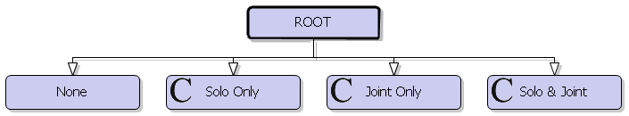

The ‘Joint Only’ and ‘Solo & Joint’ alternatives are only available for households with at least two members.

*Utility specification:*

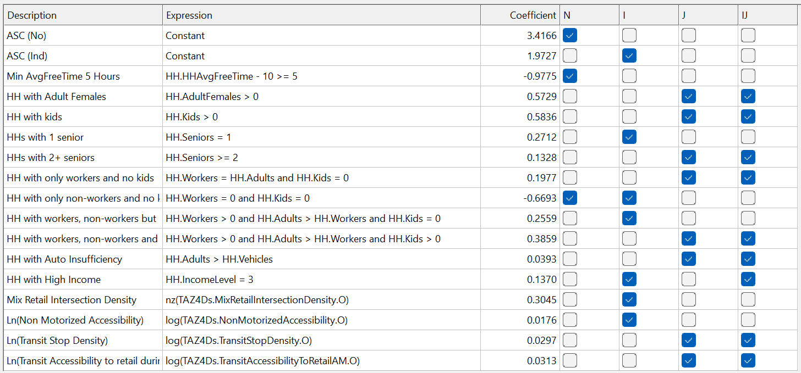

Households with an average free time of at least 5 hours are more likely to make non-mandatory tours of any kind. The presence of females, kids and seniors impacts this decision. Auto insufficiency pushes households toward joint tours. High-income households have a tendency toward solo tours.

## Non-mandatory joint tour decisions

### Joint tour purpose and frequency

The **joint tour purpose and frequency choice model** foretells a household’s collective decision to participate in joint discretionary activities.

*Model type:* Multinomial Logit (MNL)

*Applied to:* Households that chose joint tour(s) in their daily pattern

*Tree structure:*

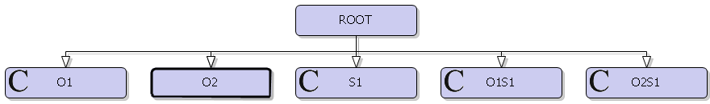

In the above choice tree, O refers to the Other purpose while S denotes the Shop purpose. The numbers indicate the tour counts of the relevant purposes. For example, O2S1 corresponds to a household’s decision to make two Other joint tours and one Shop joint tour.

*Utility specification:*

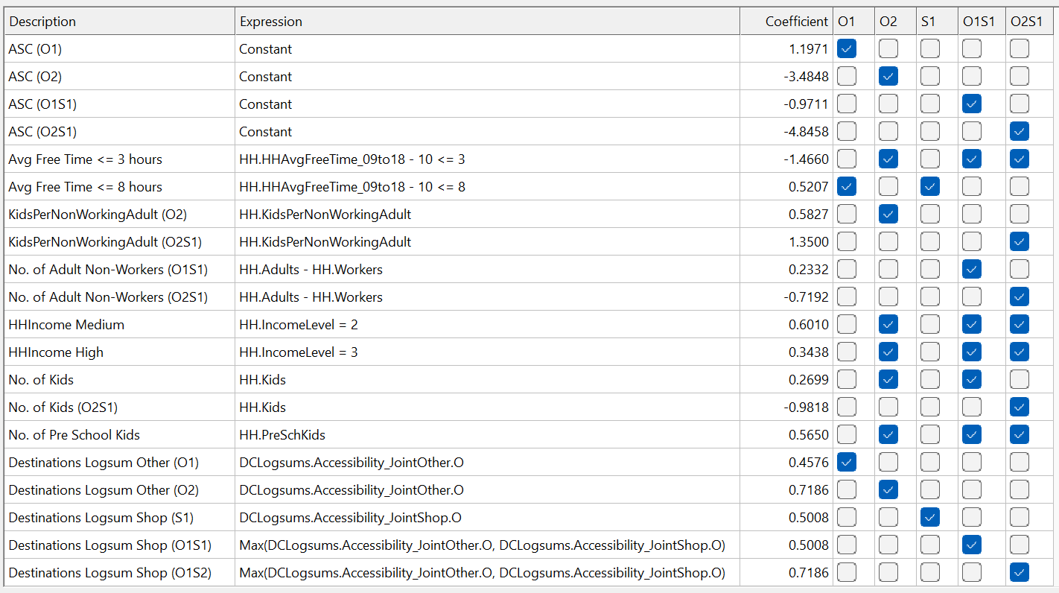

Less available free time favors fewer tours. More children in the household increases the chance of two tours but penalizes three tours. Non-working adults and those from high-income households are more likely to make two tours with a mix of Other and Shop purposes, and less likely to make three tours. The presence of children and non-working adults increases the probability of making two or more discretionary tours.

### Joint HBO tour composition

The **joint HBO tour composition model** predicts the party composition (comprised of the number of adults and kids from the household) who participate in a joint Other activity.

*Model type:* Multinomial Logit (MNL)

*Applied to:* All joint Other tours

*Tree structure:*

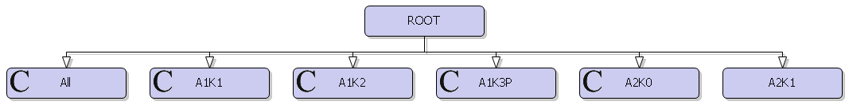

In the above choice tree, A refers to adults while K denotes kids. The numbers indicate the count of household members of the relevant type. For example, A1K2 corresponds to a joint Other tour with one adult and 2 kids.

*Utility specification:*

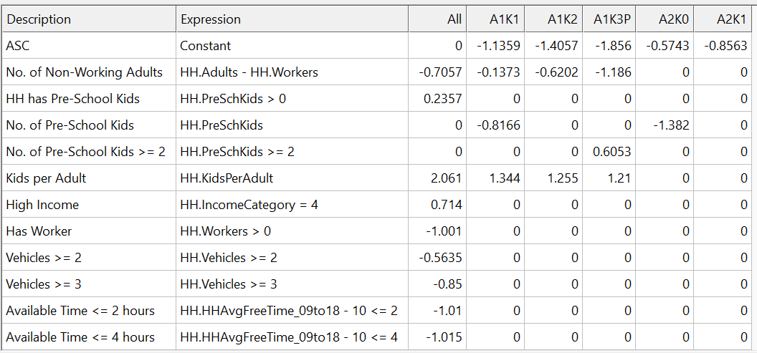

As the number of workers, adults and vehicles in the household increase, the chance of the entire household participating in joint Other tours decreases. This is logical considering the need for a range of maintenance activities that may not all appeal to (or be relevant to) the entire household. Low levels of available free time also dissuade joint Other travel, while high income correlates with the opposite effect. As the number of children per non-working adult increases, the joint tours involving one adult and multiple kids is elevated.

### Joint HB Shop tour composition

The **joint HB Shop tour composition model** predicts the party composition (comprised of the number of adults and kids from the household) who participate in a joint Shop activity.

*Model type:* Multinomial Logit (MNL)

*Applied to:* All joint Shop tours

*Tree structure:*

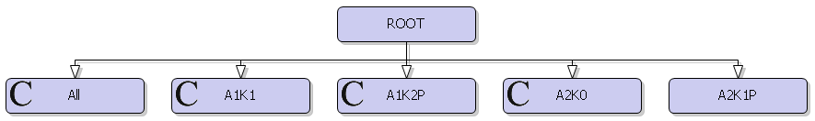

In the above choice tree, A refers to adults while K denotes kids. The numbers indicate the count of household members of the relevant type. For example, A1K2P corresponds to a joint Shop tour with one adult and 2+ (i.e. 2 or more) kids.

*Utility specification:*

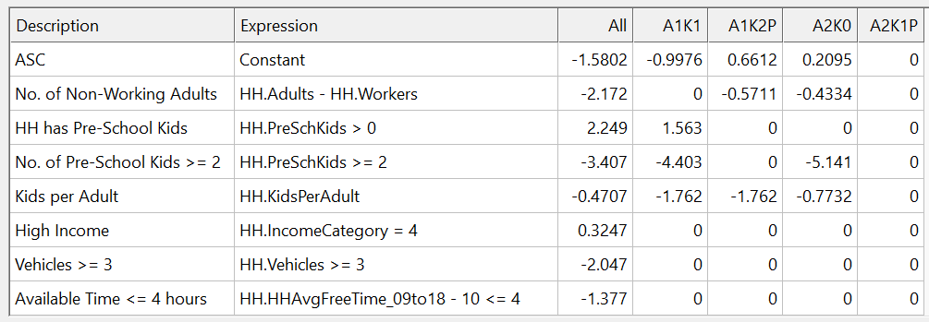

The presence of pre-K age children increases the formation of joint tours that involve more of the kids. More vehicles and less free time in the household also reduce the chance of full-household tours. A higher number of children per non-working adult causes a push towards larger joint shopping tour party sizes. More adults on the tour appears to favor multiple shopping tours with subsets of household members.

### Joint HBO tour participation

The **joint HB Other tour participation models** predict the exact individuals from the household that form the tour party.

*Model type:* Multinomial Logit (MNL)

*Applied to:* All joint Other tours

*Alternatives:* Yes and No

*Utility specification for adults:*

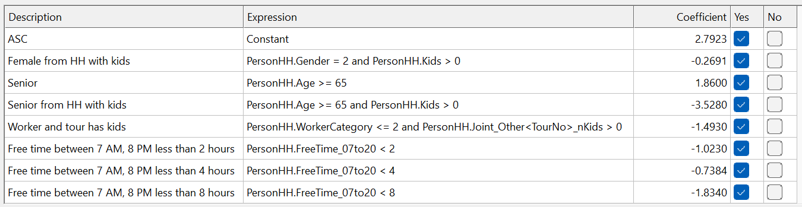

Seniors are more likely to participate, while the presence of kids suppresses the tendency of adults to take part in joint tours. Lower free time availability also reduces the chance of participation.

*Utility specification for kids:*

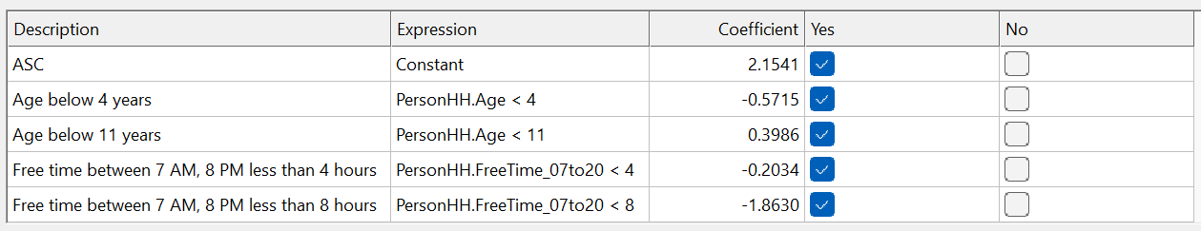

Older kids are more likely to participate. Lesser amounts of free time also tend kids toward not participating.

### Joint HBO tour destination

The **joint HBO tour destination model** predicts the zonal location for a joint Other tour.

*Model type:* Multinomial Logit (MNL)

*Applied to:* All joint Other tours

*Tree structure:* All zones

*Utility specification:*

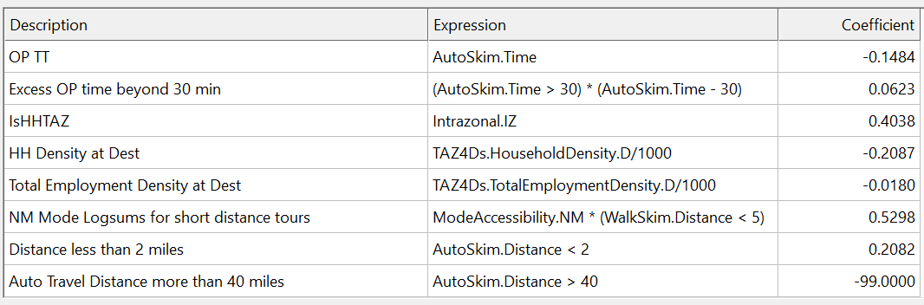

Zones with higher household density are less attractive for Other tours due to the reduced potential for activity participation. A higher total employment density is similarly less attractive, perhaps due to the jobs being in non-service sectors. The intrazonal tour is more favorable. Travel time plays the expected role of discouraging the selection of farther destinations for Other tours.

*Size variable:*

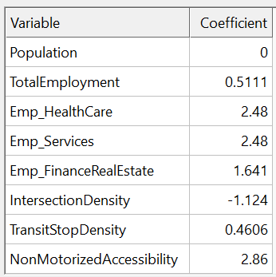

### Joint HB Shop tour destination

The **joint HB Shop tour destination model** predicts the zonal location for a joint Shop tour.

*Model type:* Multinomial Logit (MNL)

*Applied to:* All joint Shop tours

*Tree structure:* All zones

*Utility specification:*

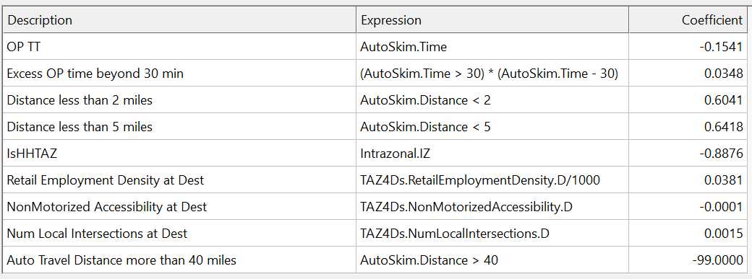

Increased retail employment density boosts the selection of the zone for shopping tours. The home zone is less preferable, perhaps due to its residential character. Travel time attenuates the probability of choosing zones that are farther away. The number of local intersections, which can be viewed as a proxy for walkability, plays a positive role in a zone’s attractiveness for shopping activities.

*Size variable:*

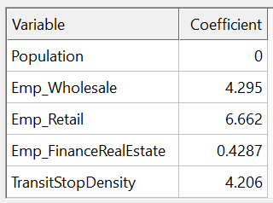

### Joint HBO activity duration

The **joint HBO activity duration model** predicts the temporal length of a joint Other tour.

*Model type:* Multinomial Logit (MNL)

*Applied to:* All joint Other tours

*Tree structure:* All alternatives (in hours) in the columns of the specification table shown below.

*Utility specification:*

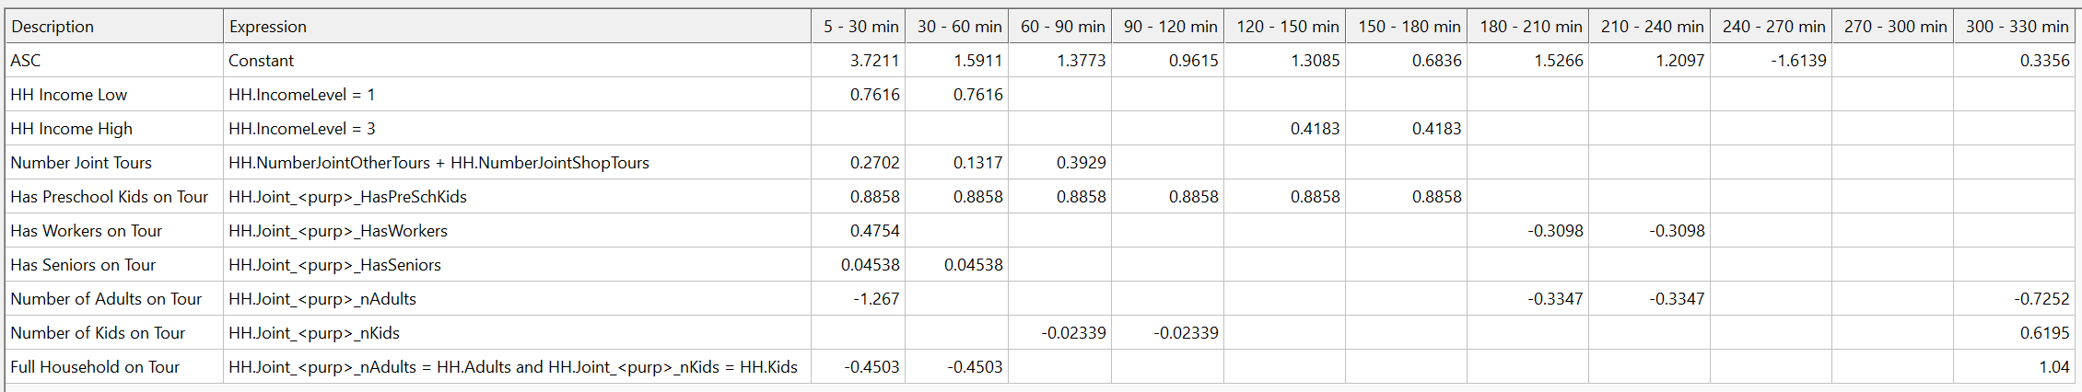

When the entire household participates, the activity durations tend to be longer. Low-income households tend to prefer shorter Other activity durations. More the number of joint tours, shorter the durations of each activity. The presence of pre-K children on the tour increases the chance of activities within 3 hours.

### Joint HB Shop activity duration

The **joint HB Shop activity duration model** predicts the temporal length of a joint Shop tour.

*Model type:* Multinomial Logit (MNL)

*Applied to:* All joint Shop tours

*Tree structure:* All alternatives (in hours) in the columns of the specification table shown below.

*Utility specification:*

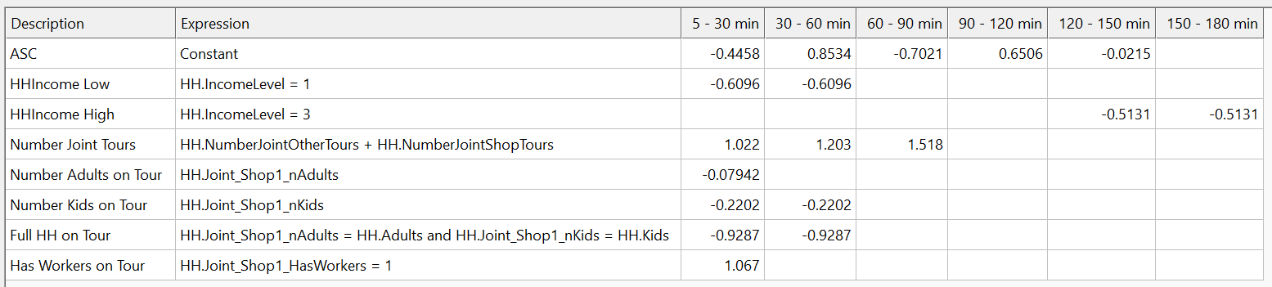

When the entire household participates in a shopping activity, the duration tends to the higher side. As the number of children on the tour increases, the tendency is for higher durations. A similar effect (though not as strong) is observed for the number of adults on the tour. As the number of joint tours increases, the durations tend to reduce to maintain within-day schedule feasibility across multiple household members. Tours with workers are on the shorter side.

### Joint HBO activity start time

The **joint HBO activity start time model** predicts the time of day for the start of a joint Other activity.

*Model type:* Multinomial Logit (MNL)

*Applied to:* All joint Other tours

*Tree structure:* All alternatives in the columns of the specification table shown below.

*Utility specification:*

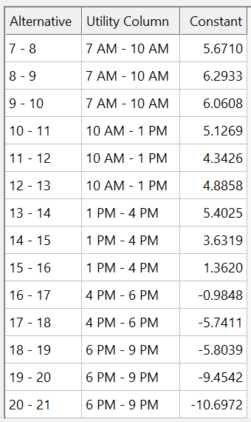

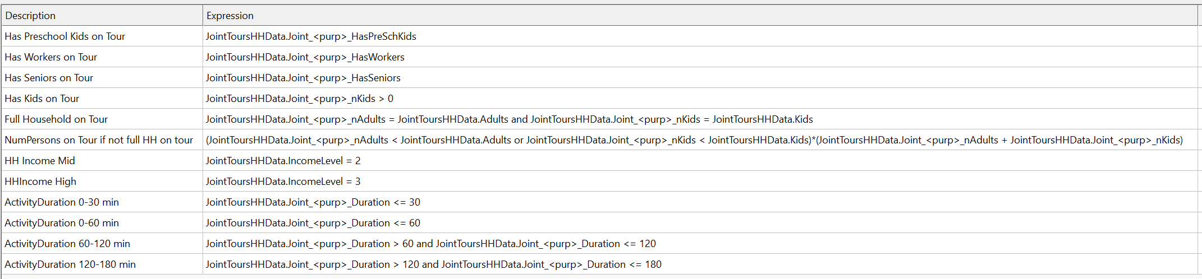

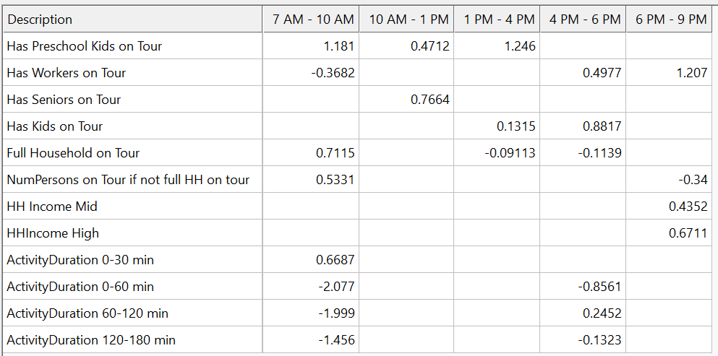

When the full household participates in Other activities, they prefer the earlier part of the day to start the activity. This is logical, given the need for some of the members to subsequently attend to mandatory activities such as work and university. Tours with workers and children tend to start in the evening, which is also along expected lines. Seniors prefer the middle of the day. Very short duration activities are often performed early in the day, with longer durations pushed further out.

### Joint HB Shop activity start time

The **joint HB Shop activity start time model** predicts the time of day for the start of a joint Shop activity.

*Model type:* Multinomial Logit (MNL)

*Applied to:* All joint Shop tours

*Tree structure:* All alternatives in the columns of the specification table shown below.

*Utility specification:*

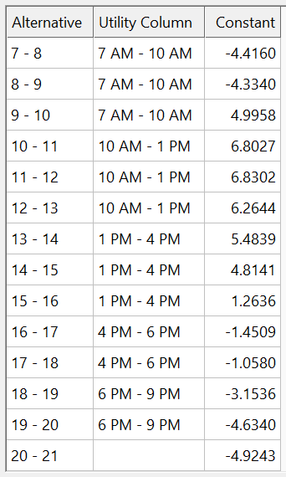



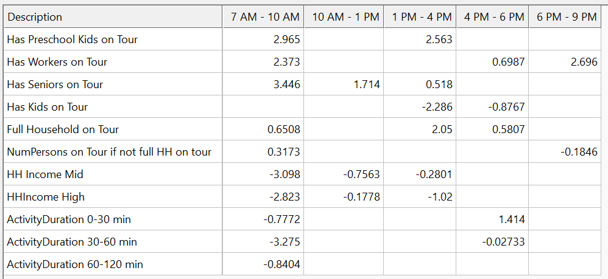

Full-household shopping tours have a high preference for the middle of the day, though the presence of workers in the tour party tends to push the start times into the early or later parts of the day. Seniors prefer the first half of the day. Medium- and high-income groups prefer to shop in the evenings. This may be correlated with those demographics also involving workers who have free time available later in the day.

### Joint HBO tour mode

The **joint HBO tour mode choice model** predicts the travel mode for a joint Other tour.

*Model type:* Multinomial Logit (MNL)

*Applied to:* All joint Other tours

*Tree structure:*

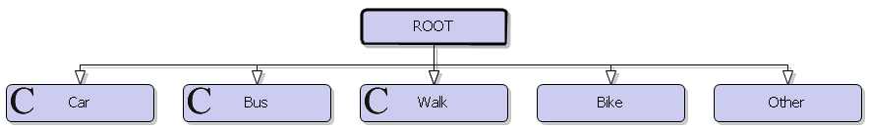

Car represents carpool since these are joint tours. Bus represents public transit with walk access (PTWalk).

*Mode availability:*

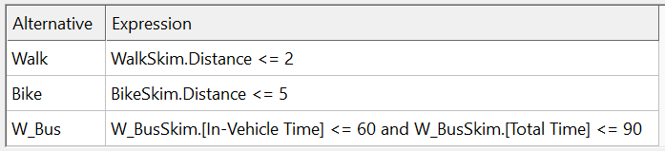

*Utility specification:*

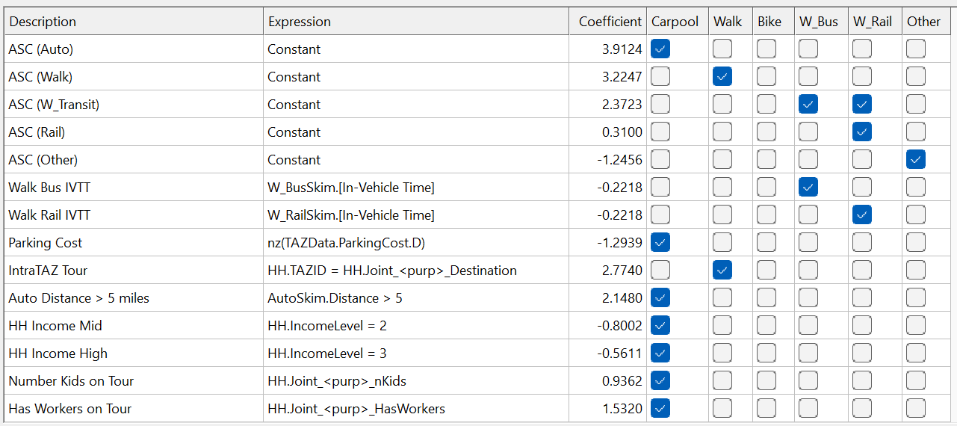

Long distances, higher income levels, large groups and the presence of children, seniors and workers increases the use of the auto mode. Intrazonal tours boost the selection of the walk mode.

### Joint HB Shop tour mode

The **joint HB Shop tour mode choice model** predicts the travel mode for a joint Shop tour.

*Model type:* Binary Logit (BL)

*Applied to:* All joint Shop tours

*Tree structure:*

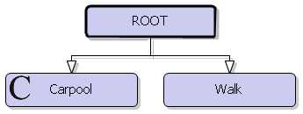

*Utility specification:*

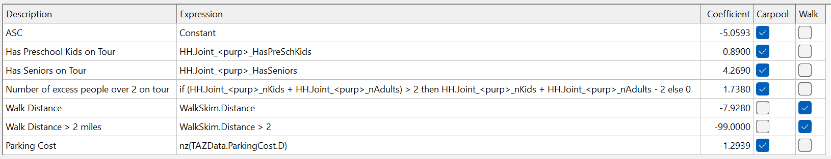

Large groups and the presence of seniors and pre-K children boost the use of the car. Long distances also heavily penalize the walk mode.

### Joint tour intermediate stop frequency

The **joint tour intermediate stop frequency models** predict the number of stops along a joint tour.

*Model type:* Multinomial Logit (MNL)

*Applied to:* All joint tours

*Tree structure:*

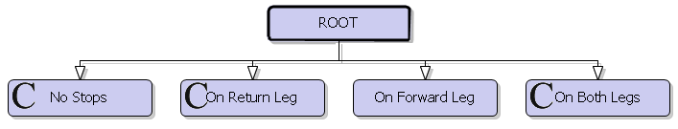

The alternatives are coded in the F_R format, with F (forward) and R (return) each taking on a value of either 0 or 1. A value of 0 means the absence of stops on that leg, while a value of 1 indicates one or more stop(s) on that leg.

*Utility specification for Other joint tours:*

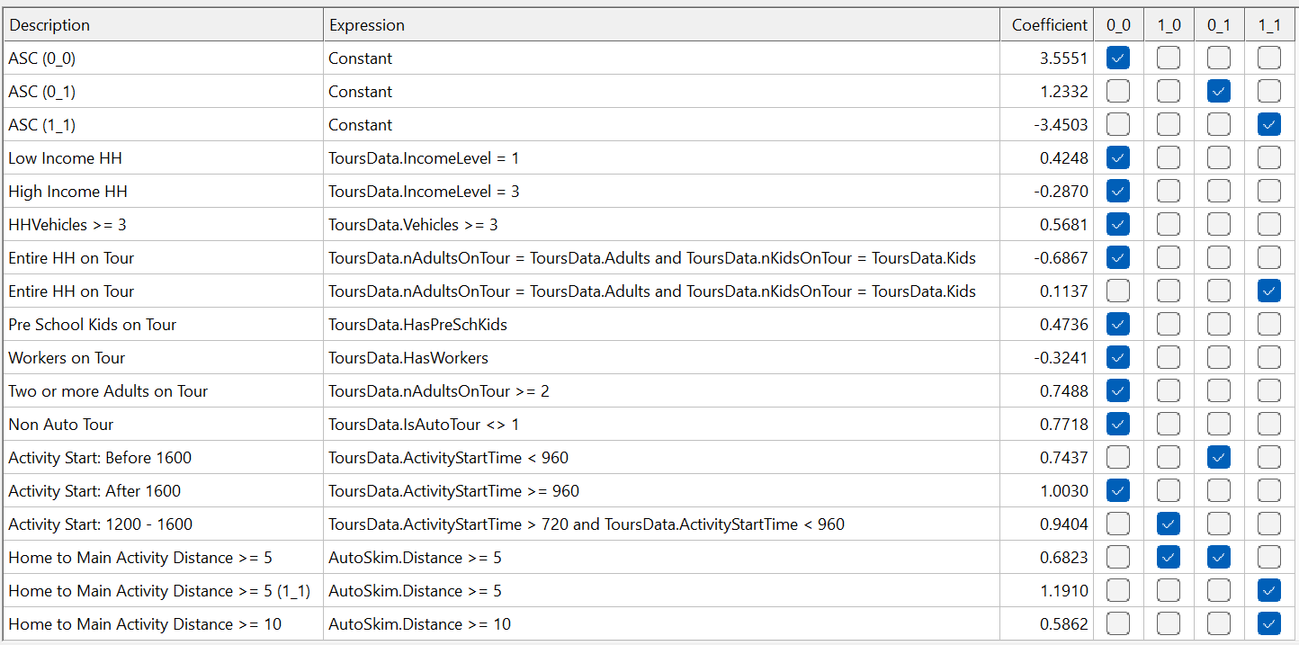

*Utility specification for Shop joint tours:*

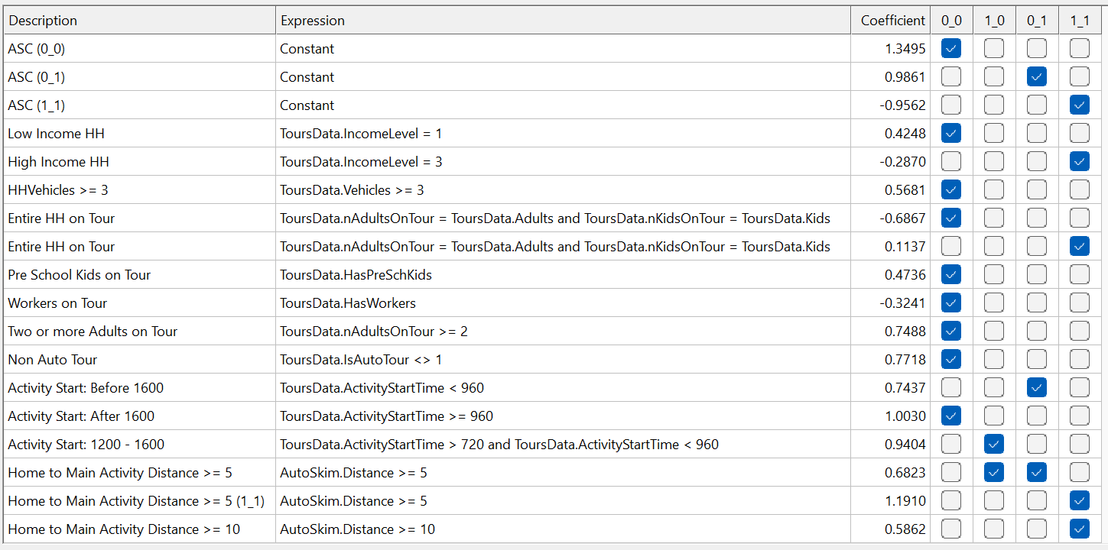

Joint tours that include all household members tend to make intermediate stops. Low-income households may prefer not stopping. The presence of workers induces stops while the presence of pre-K children reduces this effect. Early activity starts foster stops on the return journey and vice versa. Greater distances to the destination engender more stops. More vehicles and more adults in the household will reduce the chance of stops, since there might be a tendency to make more tours instead. Intrazonal tours and the choice of a non-auto mode will boost the chance of not stopping.

### Joint tour intermediate stop destination

The **joint tour intermediate stop destination model** predicts the zonal location for a stop along a joint tour.

*Model type:* Multinomial Logit (MNL)

*Applied to:* All stops along joint tours

*Tree structure:* All zones

*Utility specification:*

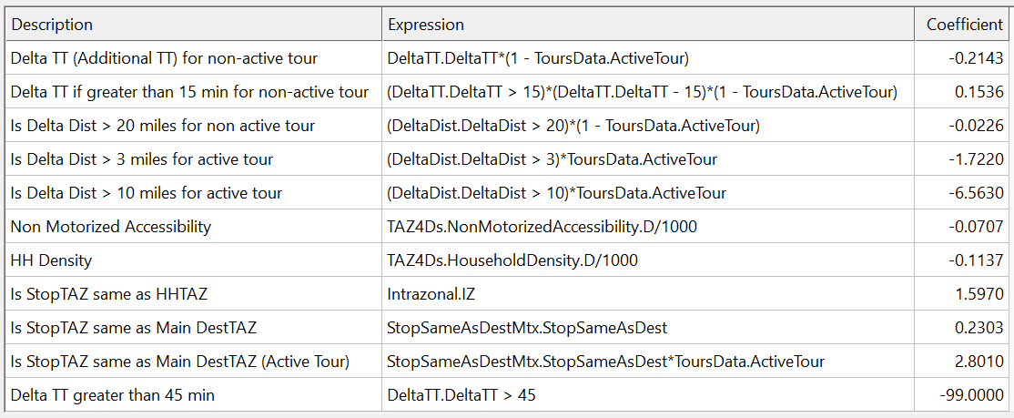

Stop locations that are close to home or the joint tour destination are preferred. Increases in household density are associated with a reduced tendency to make stops, thanks to the reduced opportunity for activity participation at these locations. Travel time and distance temper the attractiveness of stops that are longer detours from the main route.

*Size variable:*

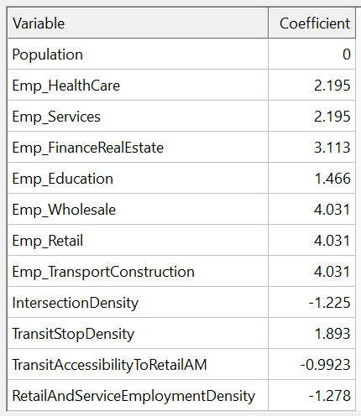

### Joint tour intermediate stop duration

The **joint tour intermediate stop duration model** predicts the temporal length of an activity at an intermediate stop along a joint tour.

*Model type:* Multinomial Logit (MNL)

*Applied to:* All stops along joint tours

*Tree structure:* All alternatives (in hours) in the columns of the specification table shown below.

*Utility specification for Other tours:*

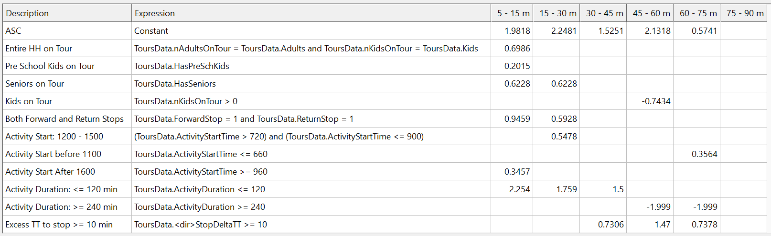

*Utility specification for Shop tours:*

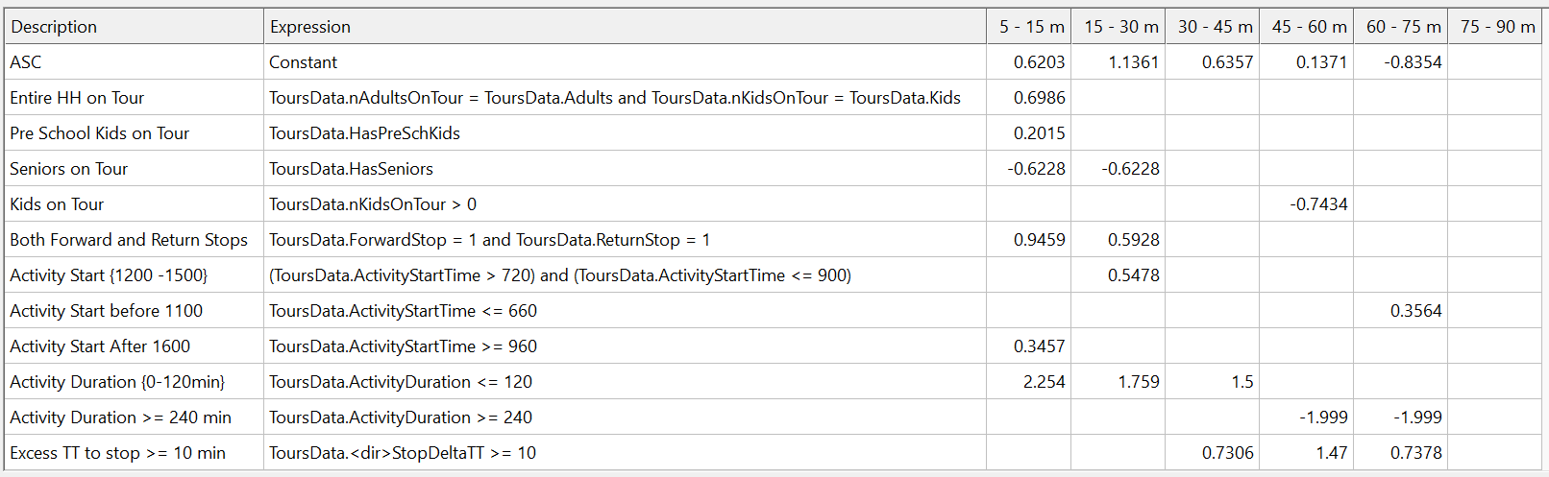

Full-household tours and those with young children tend to make brief stops. Seniors tend to make longer stops. Earlier start times foster longer stops, since the main activity can still be feasibly performed despite the stops. Short joint activity durations are associated with shorter stop durations. Multiple stops imply shorter stop durations. Longer detours favor longer stops, perhaps as a way of justifying the extra travel burden.

## Non-mandatory solo tour decisions

### Solo tour purpose and frequency

The **solo tour purpose and frequency choice model** predicts the occurrence of solo tours by purpose and frequency.

*Model type:* Multinomial Logit (MNL)

*Applied to:* Persons in households that chose a pattern involving solo tour(s)

*Tree structure:*



In the above choice tree, O refers to the Other purpose while S denotes the Shop purpose. The numbers indicate the count of tours of the relevant purpose. For example, O2S1 corresponds to a household’s decision to make two Other solo tours and one Shop solo tour.

*Alternative availability:*

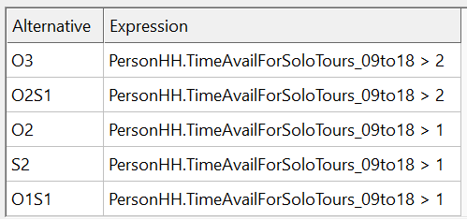

*Utility specification:*

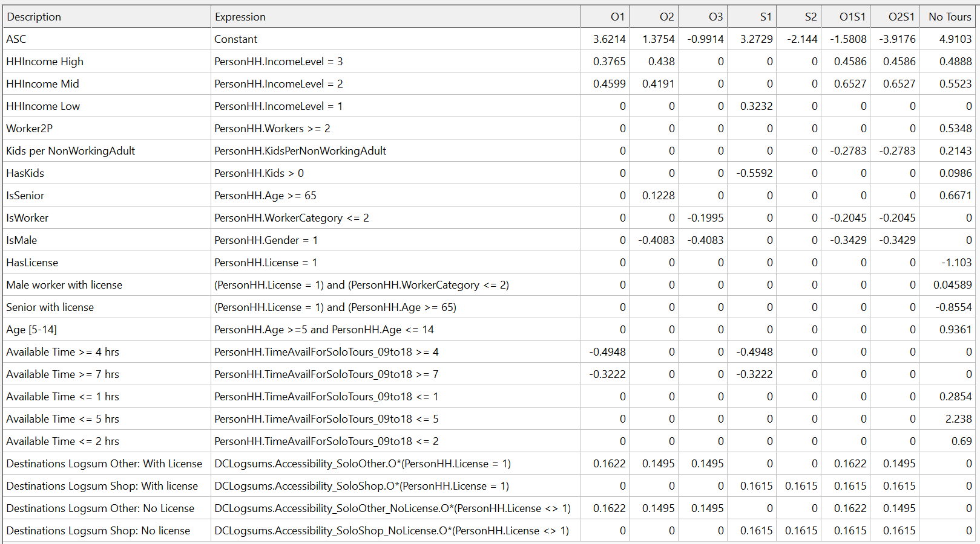

The presence of two or more workers in the household increases the chance for a solo shopping tour. People will more free time are less likely to make just one solo tour. The logsums encapsulating the attractiveness of accessible Shop and Other destinations have a positive correlation with solo tour frequency. Seniors are more likely to stay at home or make Other purpose tours. Seniors with a driver license are less likely to stay at home.

### Solo HBO tour destination

The **solo HBO tour destination choice model** predicts the zonal location for a solo “Other” purpose tour.

*Model type:* Multinomial Logit (MNL)

*Applied to:* Persons that made solo “Other” tour(s)

*Tree structure:* All zones

*Utility specification:*

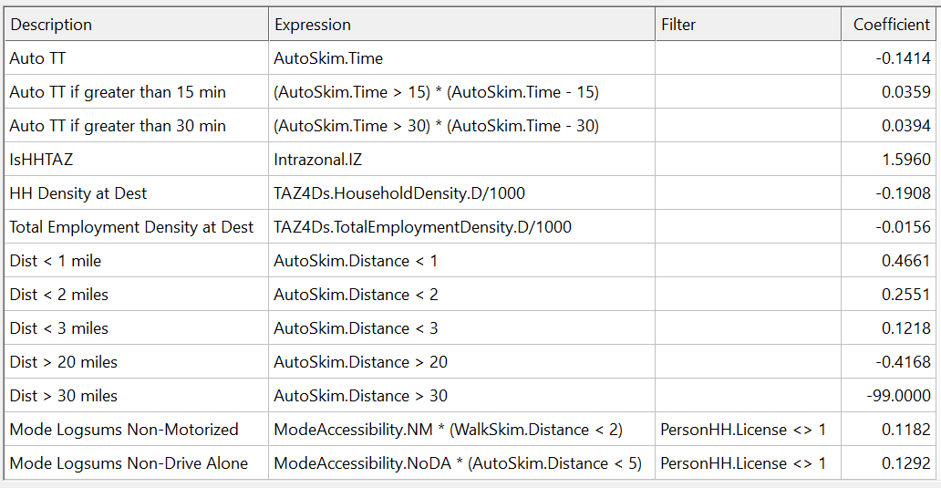

Intrazonal solo Other tours are more likely. Zones with higher household density are less likely to be solo tour destinations since they may have fewer opportunities for activities. Time and distance play the usual role in tempering tours to farther destinations.

*Size variable*:

The size value for each candidate destination zone is calculated from the table below. The coefficients are exponentiated before being multiplied by the corresponding variable.

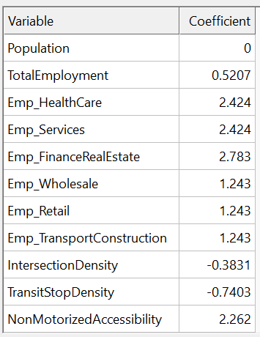

### Solo HB Shop tour destination

The **solo HB Shop tour destination choice model** predicts the zonal location for a solo “Shop” purpose tour.

*Model type:* Multinomial Logit (MNL)

*Applied to:* Persons that made solo Shop tour(s)

*Tree structure:* All zones

*Utility specification:*

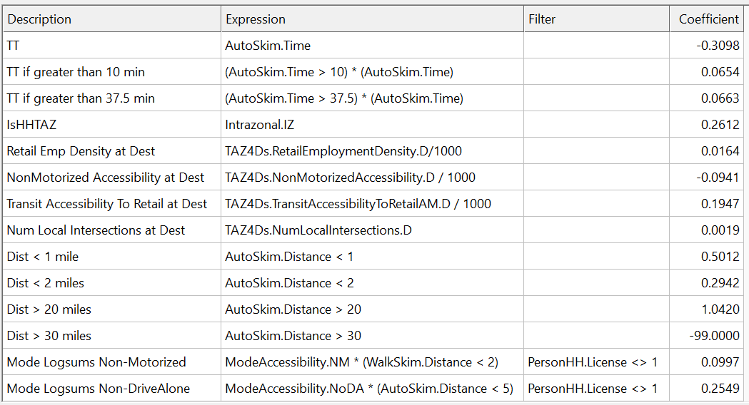

Intrazonal solo Shop tours are more likely. Greater retail employment density and transit accessibility to retail will, as expected, increase the probability of being picked for solo Shop tours. Walkability (correlated with the number of local intersections) and non-motorized accessibility also positively impact solo Shop tours to a location. Time and distance play the usual role in tempering tours to farther destinations.

*Size variable*:

The size value for each candidate destination zone is calculated from the table below. The coefficients are exponentiated before being multiplied by the corresponding variable.

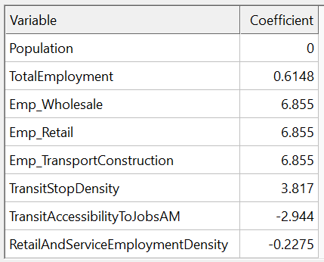

### Solo HBO activity duration

The **solo HBO activity duration choice model** predicts the temporal duration for a solo “Other” purpose tour.

*Model type:* Multinomial Logit (MNL)

*Applied to:* Persons that made solo Other tour(s)

*Tree structure:* Duration bins shown in the columns of the utility specification table below

*Utility specification:*

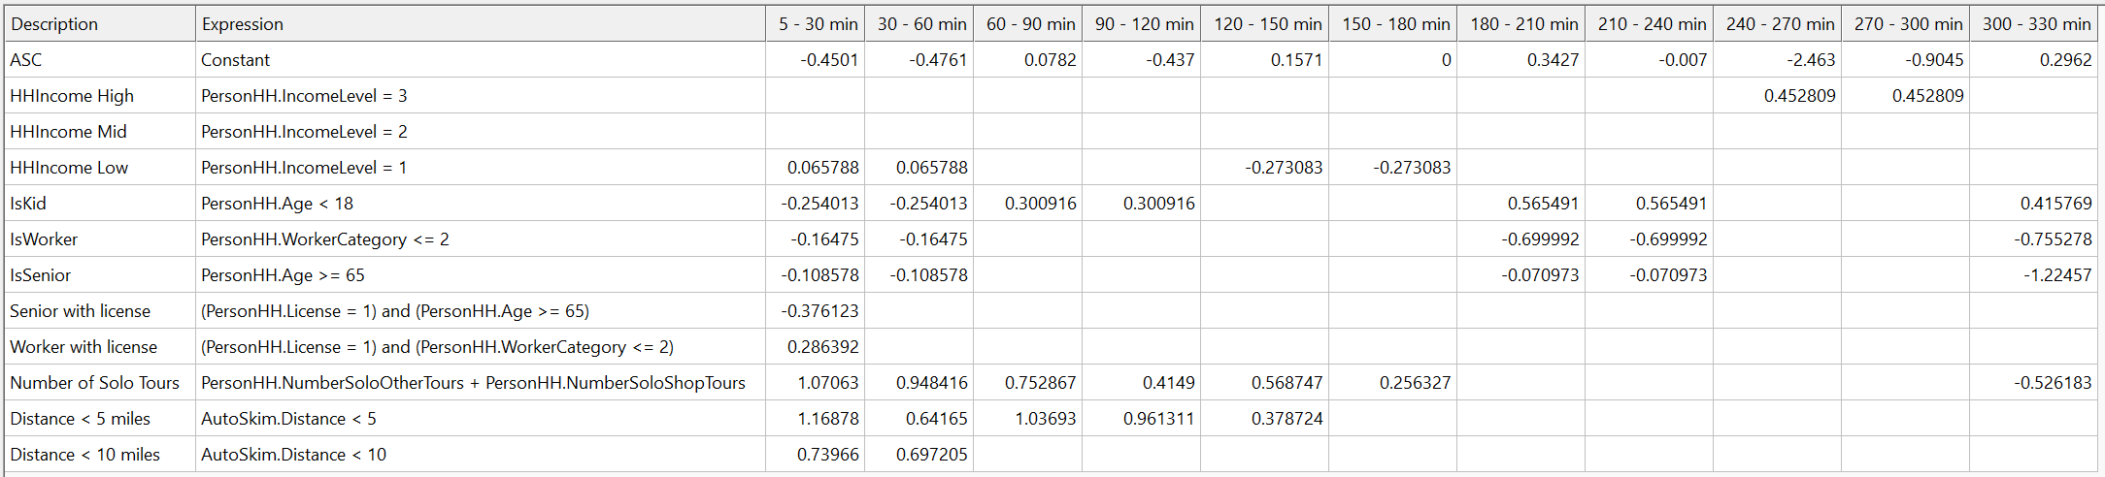

Persons from high-income households tend to prefer longer Other activities. Workers, seniors and low-income individuals prefer shorter Other activity durations. As more solo tours are performed, the durations tend toward the shorter end. Shorter distances from home to activity destination favorably impact a range of durations.

### Solo HB Shop activity duration

The **solo HB Shop activity duration choice model** predicts the temporal duration for a solo “Shop” purpose tour.

*Model type:* Multinomial Logit (MNL)

*Applied to:* Persons that made solo Shop tour(s)

*Tree structure:* Duration bins shown in the columns of the utility specification table below

*Utility specification:*

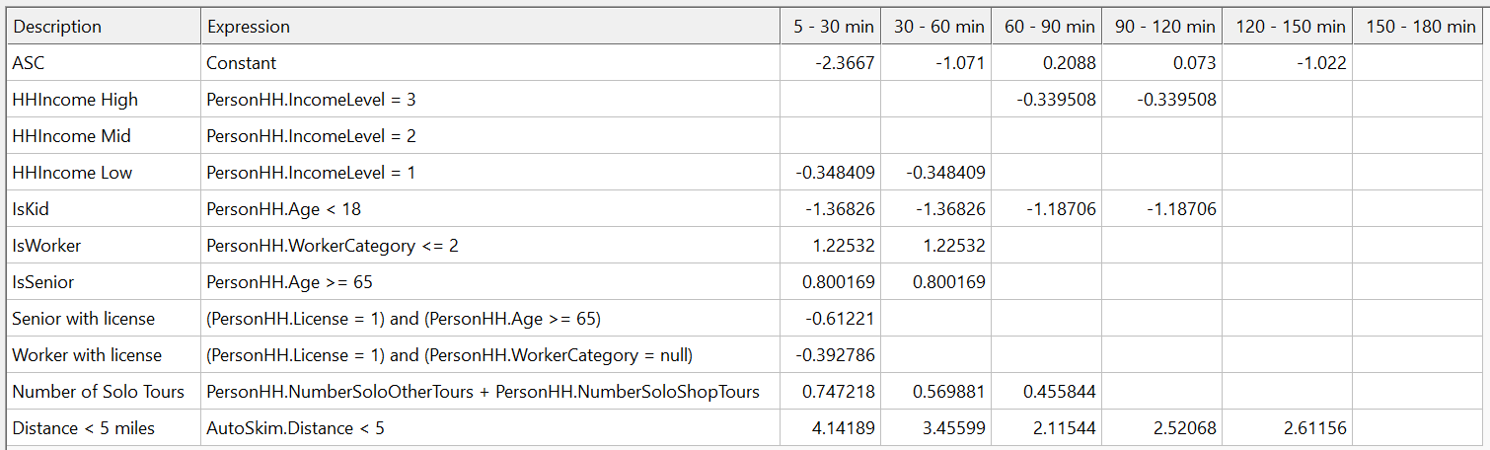

Seniors and workers prefer shorter shopping activities. Greater the number of solo tours performed, shorter the durations of the Shop activities. Children participate in longer shopping tours. Shorter distances from home to activity destination favorably impact a range of durations.

### Solo HBO activity start time

The **solo HB Other activity start time choice model** predicts the temporal start for a solo activity of the “Other” purpose.

*Model type:* Multinomial Logit (MNL)

*Applied to:* Persons that made solo Other tour(s)

*Tree structure:* Start time bins shown in the columns of the utility specification table below

*Utility specification:*

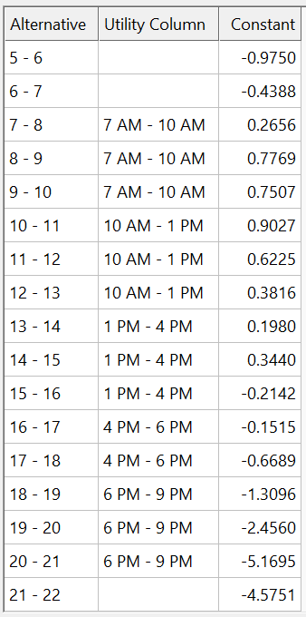

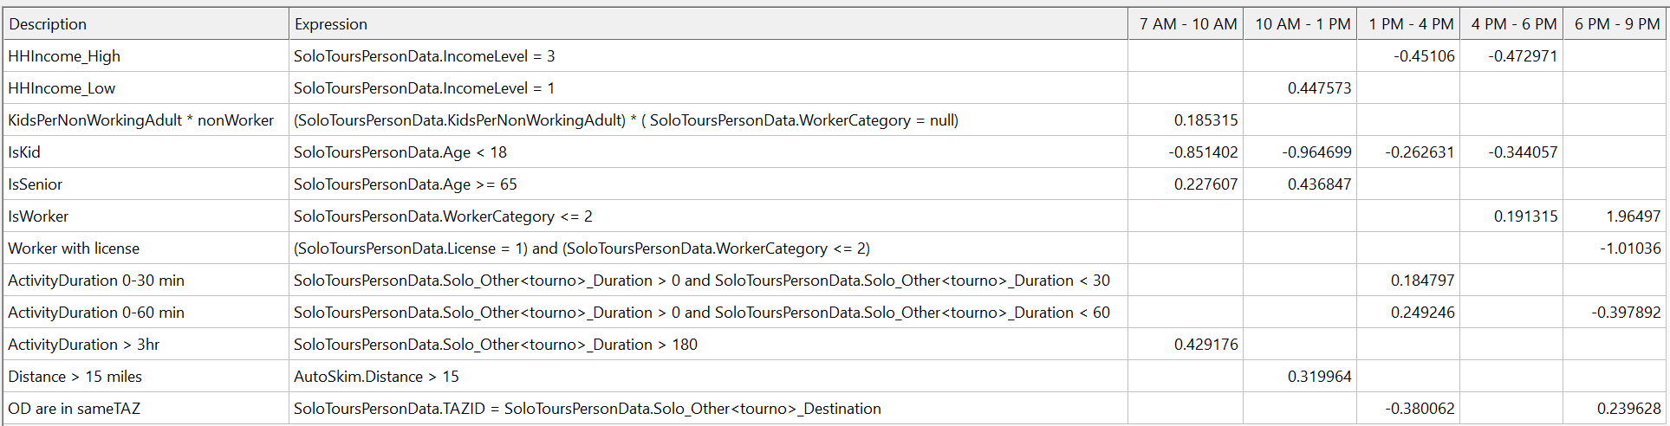

Persons from high-income households do not prefer the middle of the day for Other tours, perhaps due to work commitments. Children tend to participate in Other tours in the evenings, which is consistent with school hours and working parents. Seniors prefer the early part of the day while workers prefer the later part of the day, as expected. Longer activities tend to start earlier in the day compared to shorter activities.

### Solo HB Shop activity start time

The **solo HB Shop activity start time choice model** predicts the temporal start for a solo activity of the “Shop” purpose.

*Model type:* Multinomial Logit (MNL)

*Applied to:* Persons that made solo Shop tour(s)

*Tree structure:* Start time bins shown in the columns of the utility specification table below

*Utility specification:*

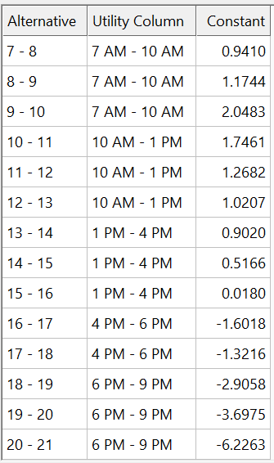

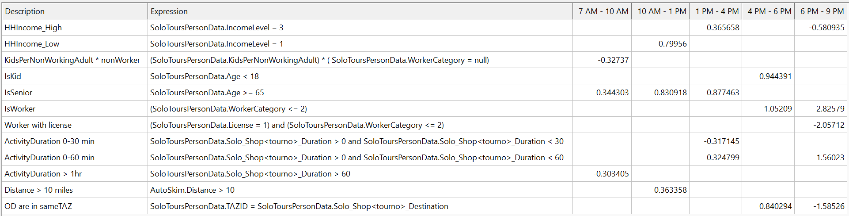

Individuals in high-income households prefer mid-day shopping tours rather than those at the end of the day. This may be explained by short runs to local stores during lunch breaks. Seniors prefer to shop early in the day, while children and workers prefer later hours. Farther distances engender earlier start times, as do longer shopping activity durations.

### Solo tour scheduling

Solo tours are scheduled after all mandatory tours and joint non-mandatory tours are scheduled and finalized.

Once the frequency of solo tours is determined, the tours for each person are scheduled sequentially. The time manager is queried to schedule each tour, and used times are updated as the tours are processed. The time manager ensures that time availabilities for subsequent tours implicitly ensure feasibility.

### Solo HBO tour mode

The **solo HBO tour mode choice model** predicts the travel mode for a solo activity of the “Other” purpose.

*Model type:* Multinomial Logit (MNL)

*Applied to:* Persons that made solo Other tour(s)

*Tree structure:*

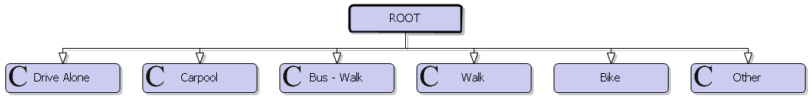

*Mode availability:*

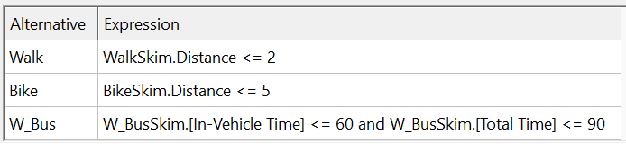

*Utility specification:*

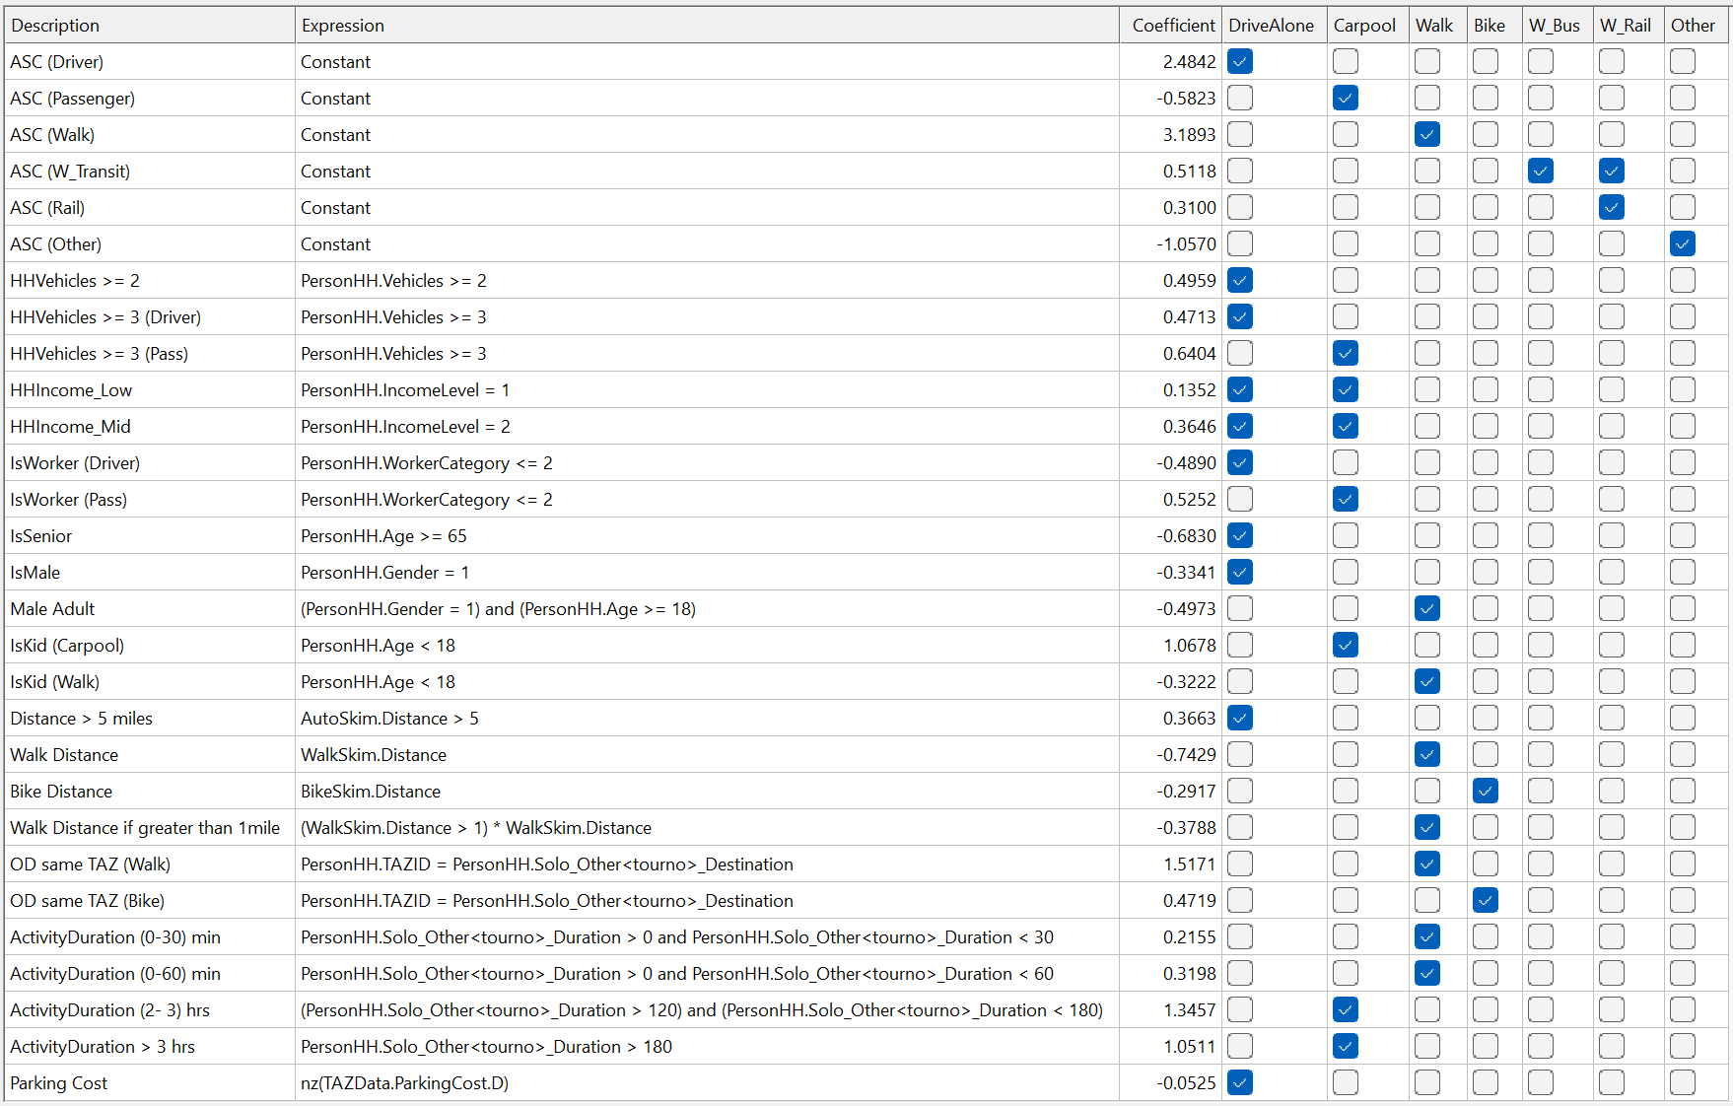

Increased household auto ownership levels raise the chance of auto Other tours, both as a driver and as a passenger. Seniors are less likely to drive. Longer distance tours are more likely to be drive tours and less likely to be non-motorized. Intrazonal tours increase the propensity to use active modes. Children are more likely to walk or be a passenger in a car. Shorter activity durations are associated with the walk mode while longer activity durations prefer the car passenger mode.

### Solo HB Shop tour mode

The **solo HB Shop tour mode choice model** predicts the travel mode for a solo activity of the “Shop” purpose.

*Model type:* Multinomial Logit (MNL)

*Applied to:* Persons that made solo Shop tour(s)

*Tree structure:*



*Mode availability:*

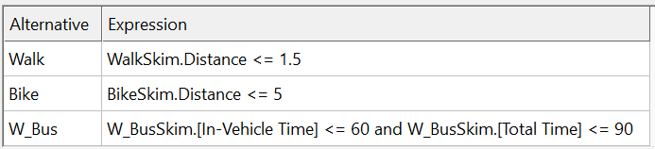

*Utility specification:*

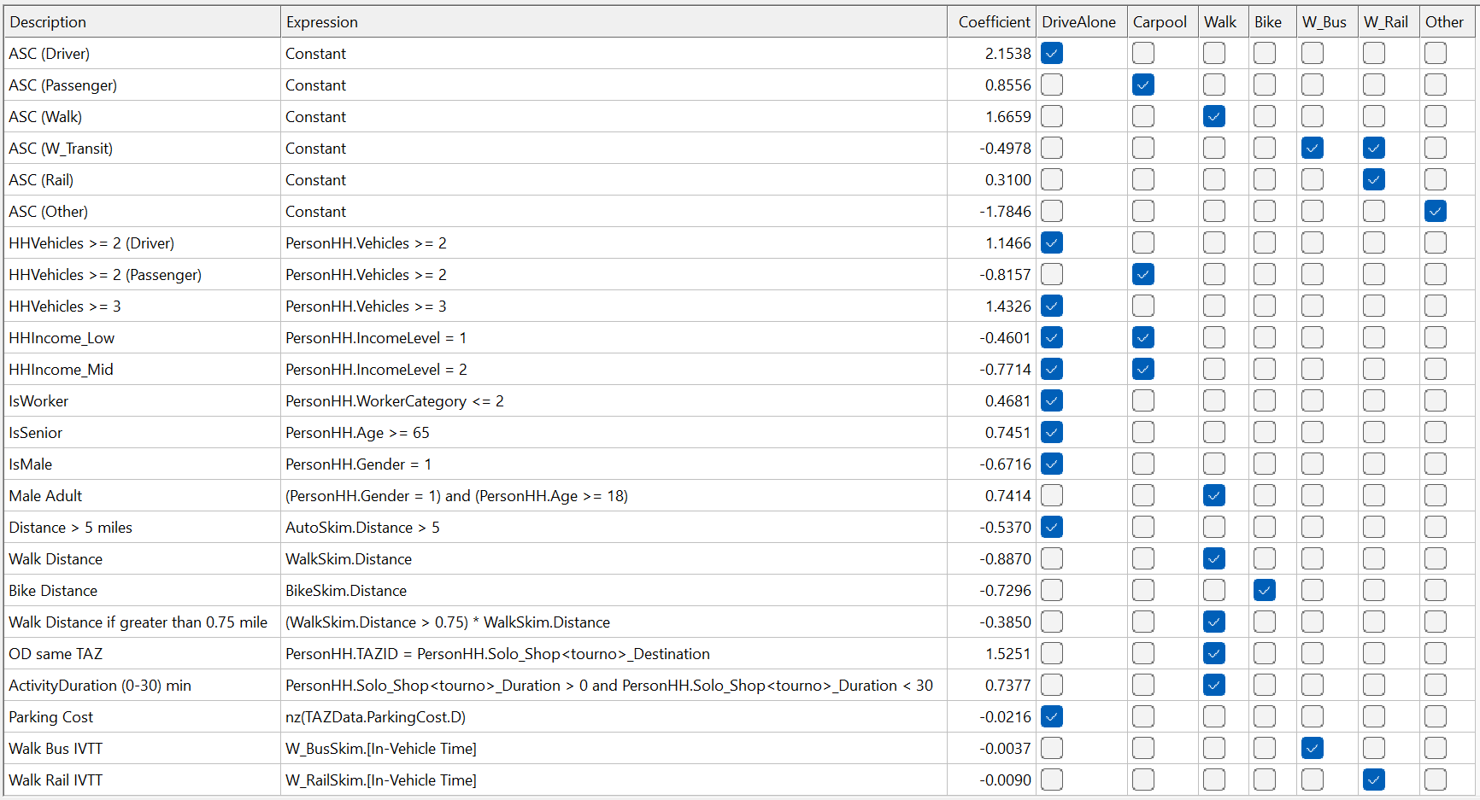

Increased household auto ownership levels raise the chance of auto Other tours, both as a driver and as a passenger. However, auto sufficiency engenders drive-alone shopping tours. Low- and medium-income households tend to use non-car modes for shopping. Greater distances penalize the non-motorized modes. Intrazonal tours and shorter activities increase the selection of the walk mode.

### Solo tour intermediate stop frequency

The **solo tour intermediate stop frequency choice models** predict the number of solo tour legs that will feature stop(s).

*Model type:* Multinomial Logit (MNL)

*Applied to:* Persons that made solo tour(s)

*Tree structure:*

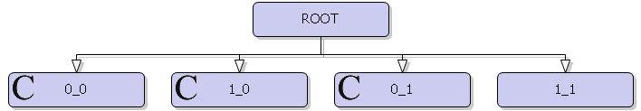

The alternatives are coded in the F_R format, with F (forward) and R (return) each taking on a value of either 0 or 1. A value of 0 means the absence of stops on that leg, while a value of 1 indicates one or more stop(s) on that leg.

*Utility specification for Other tours:*

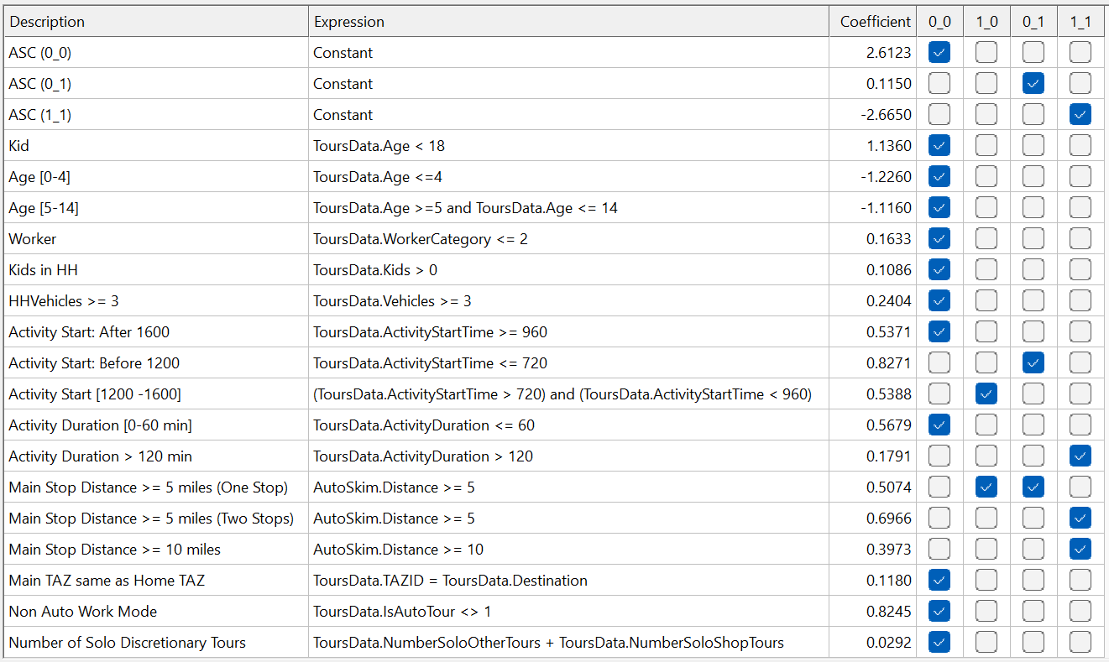

*Utility specification for Shop tours:*

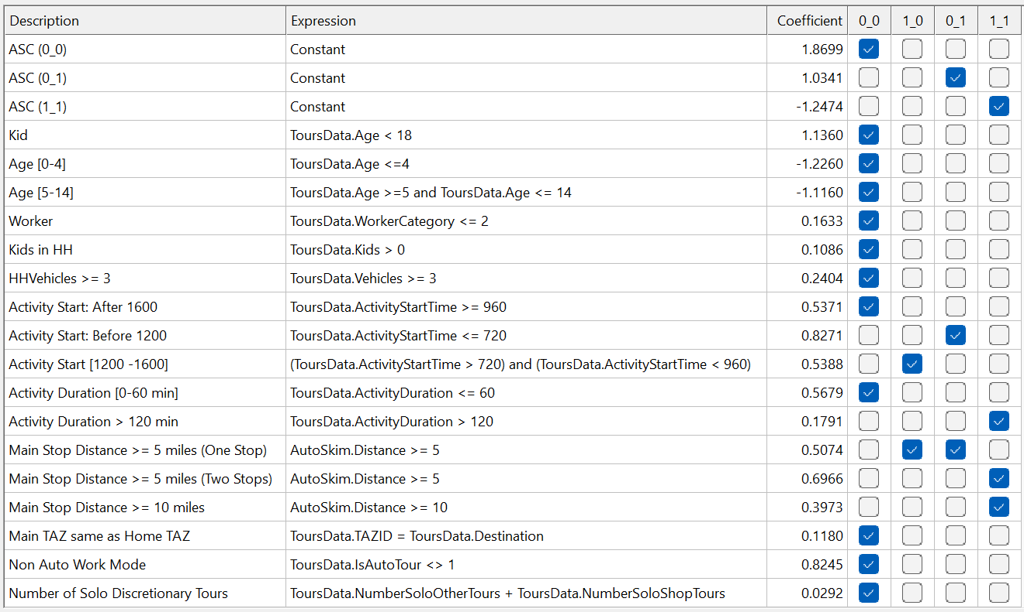

Children and workers tend toward not making stops. Stops are also less likely in households with 3 or more cars, since each driver can go directly to their destination without having to drop off/pick up others. If the main activity starts early, then stops are likely on the way back and vice versa. Stops are more likely on longer tour legs. Intrazonal and non-auto tours are more likely to have no stops, as expected. More tours also translate into fewer stops.

### Solo tour intermediate stop destination

The **solo tour intermediate stop destination choice model** predicts the zonal location for solo tour legs that will feature a stop.

*Model type:* Multinomial Logit (MNL)

*Applied to:* Persons that made solo tour(s)

*Tree structure:* All zones

*Utility specification:*

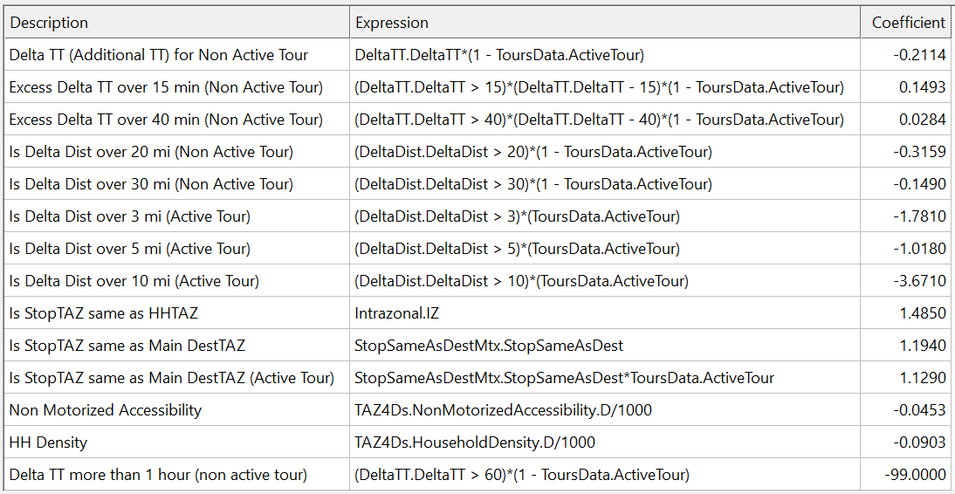

Stops in close proximity to the home or the main destination are preferred, and especially so when the mode is bike or walk. Zones with higher household density are less likely to be picked as a stop, perhaps owing to reduced opportunities for activities. Distance and time perform the expected role of tempering the attractiveness of farther destinations.

*Size variable:*

The size value for each candidate destination zone is calculated from the table below. The coefficients are exponentiated before being multiplied by the corresponding variable.

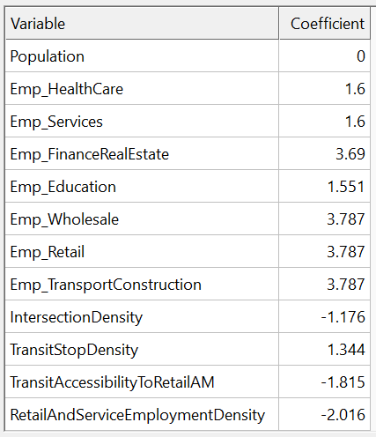

### Solo tour intermediate stop duration

The **solo tour intermediate stop activity duration choice model** predicts the time spent at each solo tour stop.

*Model type:* Multinomial Logit (MNL)

*Applied to:* Persons that made solo tour(s)

*Tree structure:*

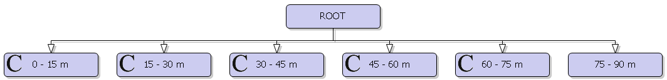

*Utility specification for Other tours:*

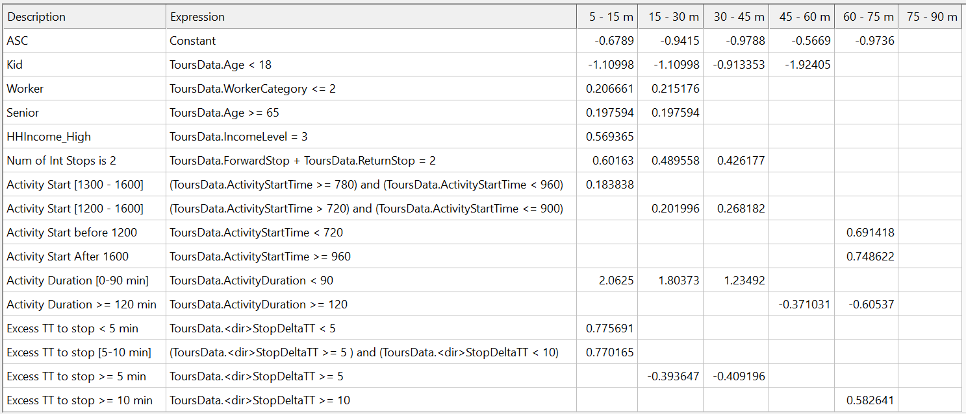

*Utility specification for Shop tours:*

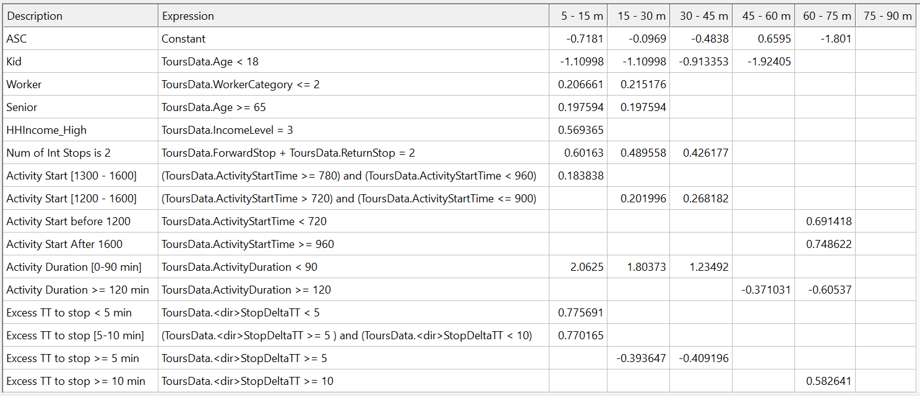

Children prefer longer stops while workers and seniors prefer shorter stops. Persons from high-income households and those who make two tours are more likely to make quick stops. Shorter main activity durations correlate with shorter stop durations, as expected. Longer main activity durations also lead to shorter stops perhaps due to time constraints.

### Solo tour intermediate stop scheduling

Intermediate stop feasibility is determined through a sequence of checks. For stops on the forward journey:

* The departure time from home is adjusted back to account for the excess travel time caused by the stop, and the activity duration at the stop.
* If other tours are impacted by this change, the stop duration is reduced by at most 15 minutes and the overall feasibility is checked again.
* If the stop remains infeasible, it is removed from the schedule.

A similar logic is adopted for stops on the return journey, where the arrival time at home is delayed due to the stop.

# Supporting Datasets

Model development included creation of base year traffic analysis zones (TAZs), socio-economic (SE) data, roadway networks, and transit route systems.

## Traffic Analysis Zones

### Intro

Traffic Analysis Zones (or TAZs) are geographic areas similar to Census blocks and blockgroups. They contain information on residential and commercial land uses that travel models base travel demand predictions on. TAZ creation is one of the first steps in building a new model. The Oahu TAZ system was developed prior to 2012, so a complete rebuild was undertaken using the latest Census data and geographic boundaries.

The new TAZ layer now lives on a GitHub repository maintained (for the moment) by Caliper, and is where the model will be developed.

### Basic Approach

I started with the block and block group layers for the island. Using aerials, network data, census population, topology and other sources, I split block groups up into smaller units. Importantly, this approach means that no TAZ violates block group geography. In addition, modifications were made by assigning entire blocks to new TAZs. As a result, block geography was respected except for some specific situations (as explained below).

**Fast Facts:**

Blocks: 6,851

Block Groups: 772

TAZs after my review: 1,100

TAZs in current model: 780

An example of my review map can be seen below. This map shows where I have split block groups (purple lines) into smaller TAZs (green lines). The light blue lines and dot are the blocks and their populations, respectively.

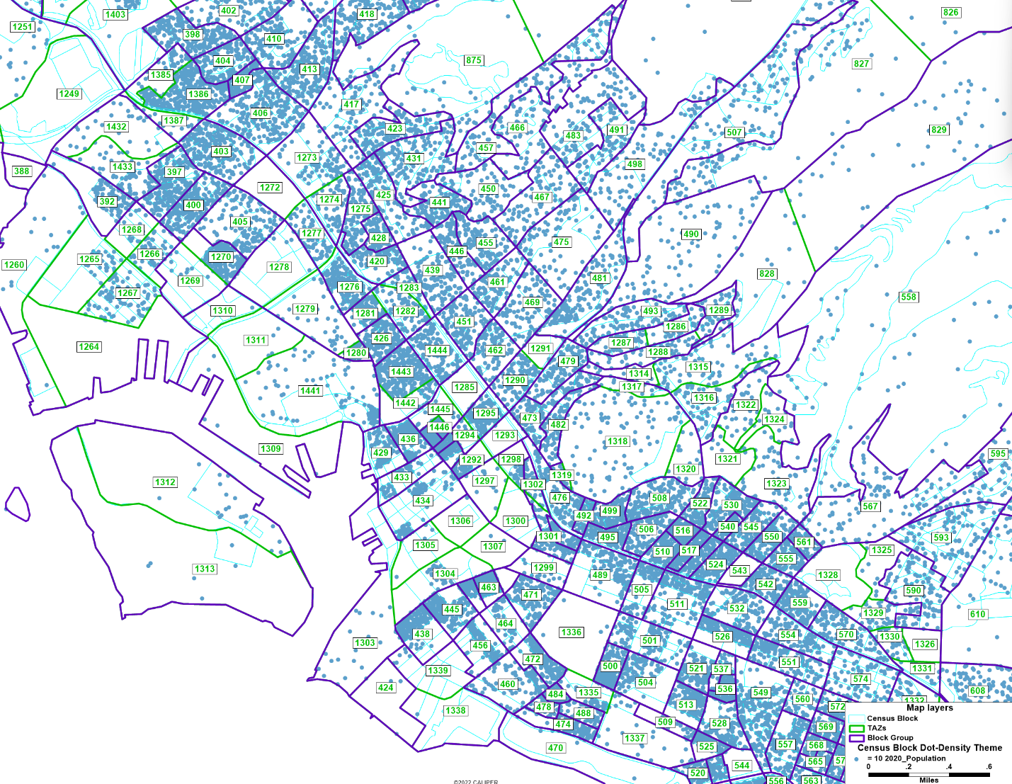

TAZ creation is as much an art as a science, and there are multiple, competing priorities to optimize. For example, smaller zone increase the accuracy of zonal loading. Additionally, smaller zones ensure that demand on the road network is dispersed across multiple loading points rather than concentrated at a few. These benefits diminish beyond a certain point. At the same time, each no zone increases the matrix sizes at an exponential rate (i.e. a 4 zone system has 16 origin-destination matrix cells while a 5 zone system has 25). Because of this, it is important to find a balance of zone size that meets the needs of the model region without going too far.

After my initial pass based purely on geography and loading pattern considerations, I performed a second pass split any remaining zones with high populations. As a result, no zone contains a population of more than 4,000. At the time of this review, no employment data was available, but when it becomes available at a later date, another quick pass will be warranted to limit the number of employees in any one zone.

### Geographic Challenges

The aerial below illustrates a common issue with the Census block group geography: large regions of undeveloped land are included in the same block group as a relatively small area of dense development. This is due to the population minimums enforced by the Census, but causes a problem in travel model when doing common tasks like calculating the density of a zone.

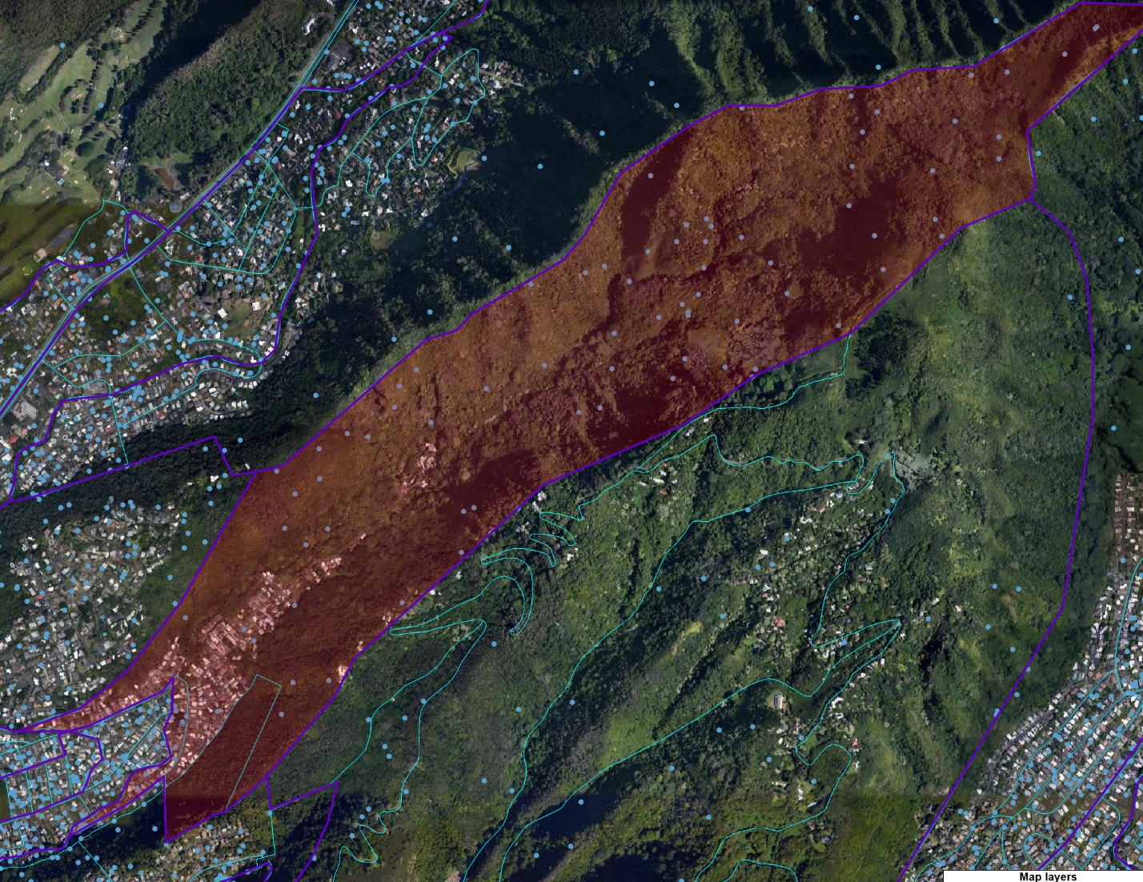

In these cases, I split the block as shown in the map below. Any and all population data from the original block is assumed to be in the new, smaller TAZ (828 in this case).

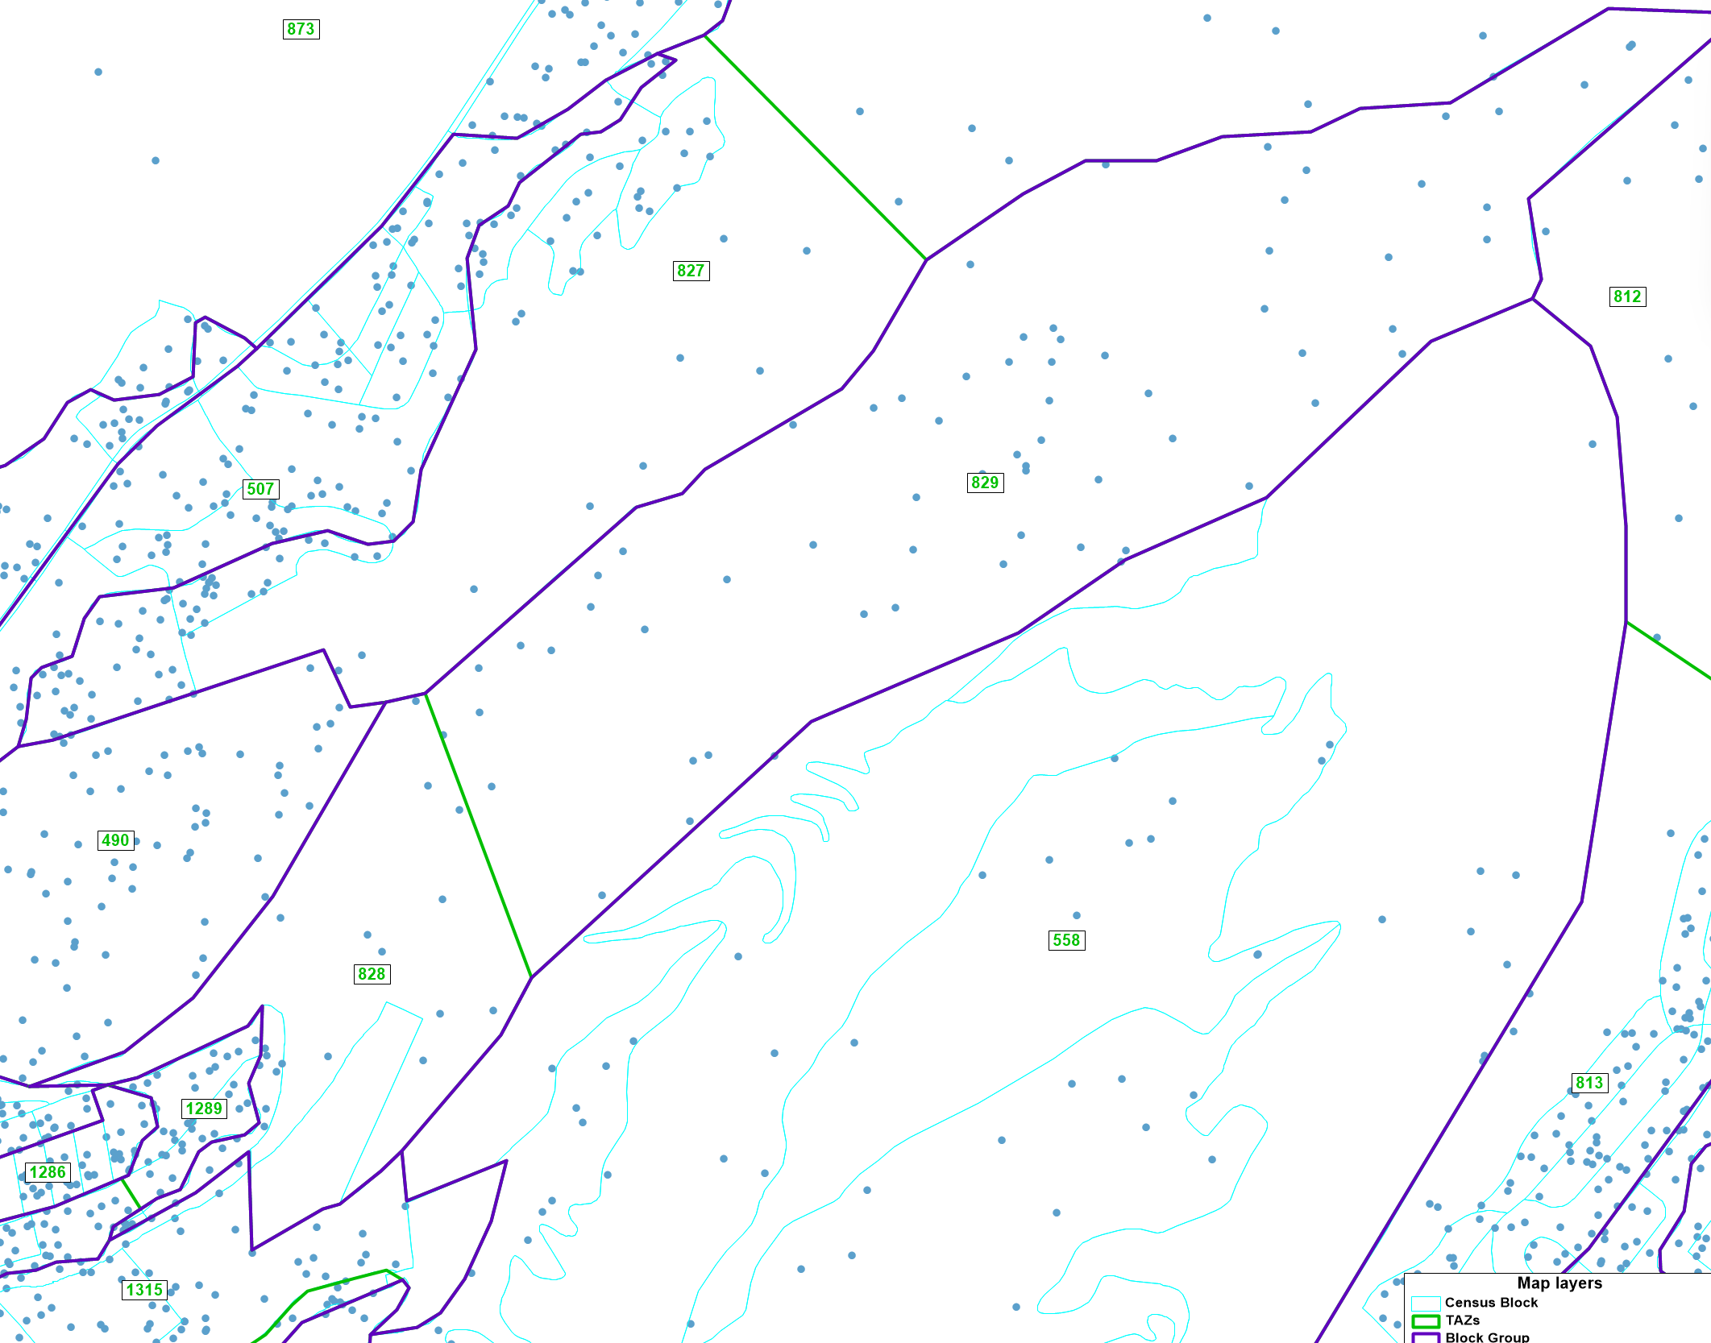

### Parcel Data

Parcel data from the Department of Planning and Permitting was also reviewed. The employment data it contained prompted a few additional TAZ splits, but otherwise conformed well to the zone system already developed.

### Summary

The new zone system is more detailed, which will increase model measurement accuracy for things like travel times but is still a small enough number that model runs should be reasonably fast. Based on the approach taken, the TAZ will work well with Census and parcel data from the City of Honolulu for years to come.

## Socio-economic Data

With the TAZs delineated, they were filled with residential and employment socio-economic data (SE data).

### Residential Data

The TAZ boundaries were sent to the Department of Planning and Permitting, who modified their various procedures to produce residential data at the TAZ level. This included counts of households and population along with income and other metrics required by the model.

For the full list of fields and field definitions, see:

<https://github.com/OahuMPO/OahuTDFM/wiki/3-Model-Inputs#socioeconomic-data>

### Employment Data

The MPO purchased employment data from DataAxle (formerly InfoUSA). This dataset was a point file with counts of employment by NAICS code. These NAICS codes allowed Caliper to translate employment into the various categories (e.g. Agriculture or Service) used by the model.

For the full list of fields and field definitions, see:

<https://github.com/OahuMPO/OahuTDFM/wiki/3-Model-Inputs#socioeconomic-data>

## Road Network

Caliper started with the existing planning network from the previous model. A manual review and conflation process was performed to improve the alignment of the planning links to aerial photography of the actual road network.

Traditionally, model road network do not include all streets but instead only those whose facility type is collector or above. Caliper has begun including all streets for models they develop and did the same here. These additional streets, while not used in highway assignment, provide for more accurate walk (and walk to transit) calculations. They also allow bus routes to more accurately match real world alignments. Because these extra streets are not used in highway assignment, they don’t require attributes and don’t add much burden to the long-term maintenance of the network.

Finally, MPO staff along with Caliper performed final passes and attribute checks. This included a review of median treatments and posted speeds, which were not included in the previous model’s network.

## Transit Route System

The Department of Transportation Services at the City of Honolulu maintains remix files for all transit routes. Caliper was granted access to the Remix website and used it to create the base year route system file. The remix files included headways by time period along with major stop locations. Caliper supplemented these major stops with others to provide access that matched the real world.

# Visitor Model

Visitors are a major travel market for Oahu, and require their own independent set of models. The MPOs last visitor survey was collected in 2011, which is before the arrival of Uber/Lyft to the island. COVID presented another challenge for the visitor model given that all recently observed metrics (e.g. daily arrivals) were still lower than historical averages. For these reasons, the visitor model was developed as an aggregate trip-based model. The MPO is currently planning to collect a new visitor survey in 2024 or 2025 at which point the model will be upgraded to an activity-based treatment matching the resident models.

Caliper took a fresh look at the 2011 visitor survey and processed it to create the datasets used for model estimation. Calibration targets came from the Department of Business, Economic Development, and Tourism (DBEDT). The model uses the 2019 measure of daily visitor on-island of 109,584. This was to ensure that the validation to 2019 counts was not impacted by COVID. As a point of reference, daily visitors on the island in 2020 was only 6,176.

## Lodging

The MPO purchased Transography data from Caliper primarily to have a validation set for visitor travel. However, it was also helpful in determining visitor lodging locations on the island. However, it was not possible to separate personal and business visitor types in the big data set, so the process was also informed by the existing visitor model. When the model runs, the daily visitors are assigned to lodging locations based on the following rates:

* Hotel/Condo occupancy rate: 85%
* Household occupancy rate (e.g. AirBnB): 2%

## Generation

The processed 2011 survey was used to calculate trip rates by purpose separately for business and personal visitors. The trip purposes and rates are given below.

* HBEat: Home-based Eating out
* HBO: Home-based Other
* HBRec: Home-based Recreation
* HBShop: Home-based Shopping
* HBW: Home-based work
* NHB: Non-home-based

|  |  |  |  |  |  |  |
| --- | --- | --- | --- | --- | --- | --- |
| **Visitor Type** | **HBEat** | **HBO** | **HBRec** | **HBShop** | **HBW** | **NHB** |
| Business | 0.64 | 0.03 | 0.56 | 0.27 | 0.66 | 1.12 |
| Personal | 0.88 | 0.12 | 0.79 | 0.39 | 0.00 | 1.40 |

## Destination Choice

Caliper implemented a nested destination choice model for visitors to better-capture their travel on the island. This approach groups adjacent TAZs into larger clusters. Similar to nested mode choice models, visitors first choose a cluster to travel to and then choose which TAZ in that cluster as the second choice. Caliper has demonstrated the value of this approach in the Triangle Regional Model, Central Coast, and other regions. In short, choice models work best with limited choice sets that are different from one another. Choosing a TAZ out of 1000 options is difficult particularly because adjacent TAZs have such similar measures of travel time (and usually employment). The TAZ layer below shows the clusters used.

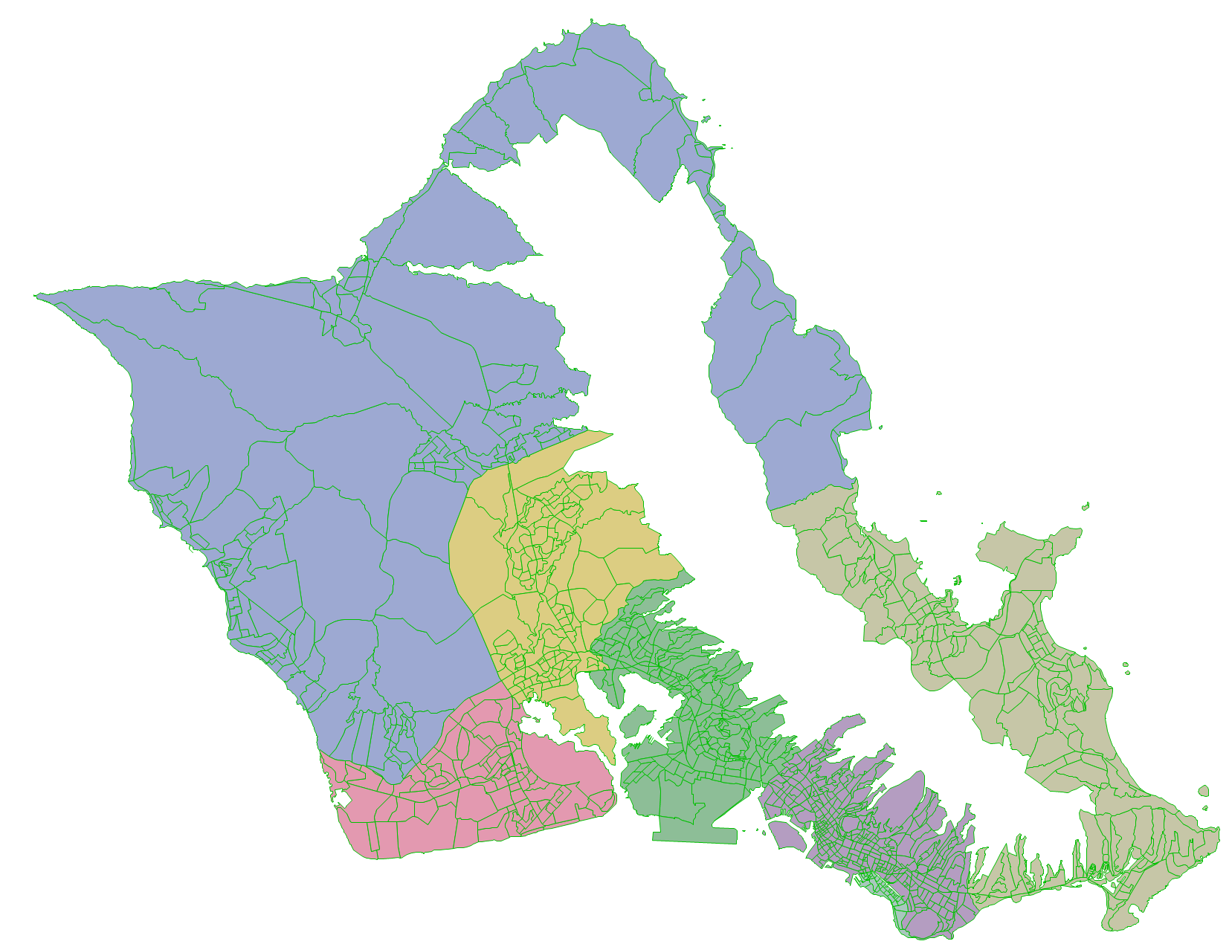

The full list of DC model specs and estimation stats can be found here:

<https://github.com/OahuMPO/OahuTDFM/tree/main/docs/Python/dc>

HBO is included below as an example.

* Nest Coefficients: these are the cluster-based nesting coefficients.
* IC: Intra-cluster effect
* IZ: Intra-zonal effect
* Time: Travel time
* Other: these are the employment categories that make up the size term

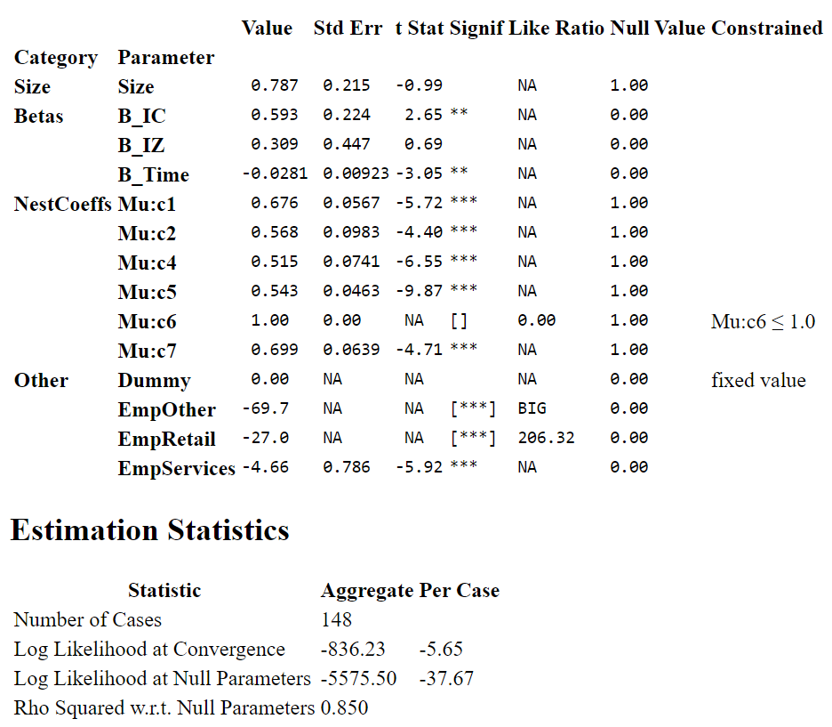

## Mode Choice

Caliper estimated nested mode choice models by trip purpose for mode choice. The alternatives are:

* Auto
* Bus
* TNC (uber/lyft)
* Walk
* Bike
* Rail

Note that rail coefficients were asserted given that there are no rail observations in the 2011 survey. Bus coefficients were used, instead.

Full mode choice estimation results can be found here:

<https://github.com/OahuMPO/OahuTDFM/tree/main/docs/Python>

HBO is included below as an example:

* ACSs: the various alternative-specific constants
* AccessEgressInitWitTimes: time spent outside the vehicle for transit trips
* Time: travel time
* Time_NM: non-motorized time for walk and bike trips

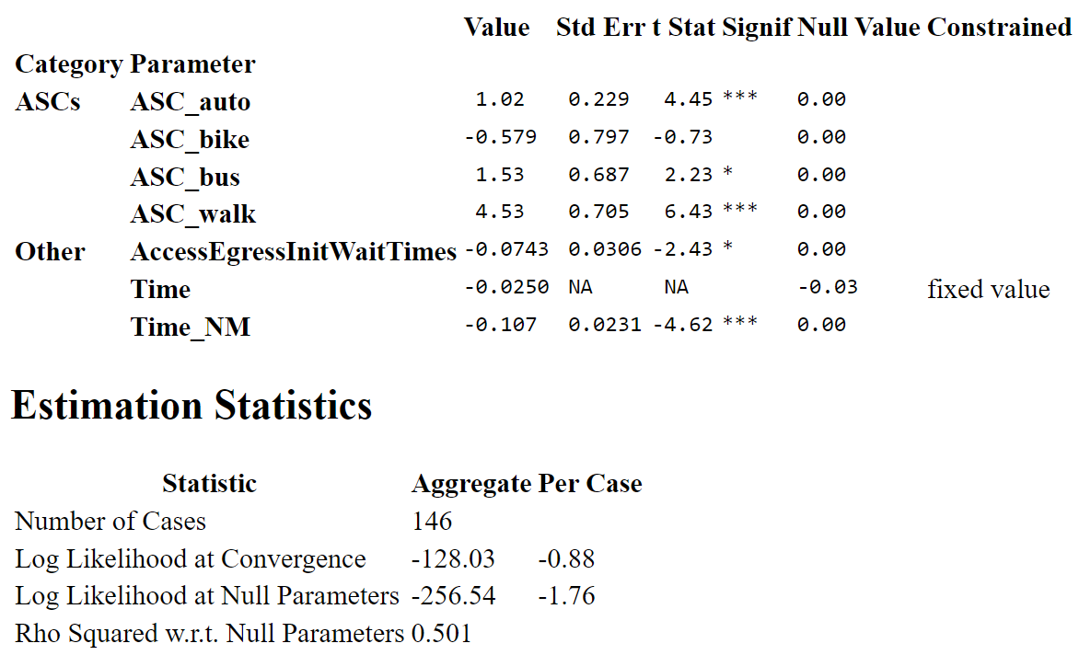

## Time of Day

Time of day factors were calculated from the survey and are shown below:

|  |  |  |
| --- | --- | --- |
| **Trip Purpose** | **TOD** | **Factor** |
| HBEat | AM | 6% |
| HBEat | OP | 67% |
| HBEat | PM | 26% |
| HBO | AM | 19% |
| HBO | OP | 59% |
| HBO | PM | 22% |
| HBRec | AM | 16% |
| HBRec | OP | 58% |
| HBRec | PM | 26% |
| HBShop | AM | 3% |
| HBShop | OP | 69% |
| HBShop | PM | 28% |
| HBW | AM | 32% |
| HBW | OP | 39% |
| HBW | PM | 29% |
| NHB | AM | 2% |
| NHB | OP | 67% |
| NHB | PM | 30% |

## Directionality Factors

These factors are used to convert trips from PA format to OD format and are shown below.

|  |  |  |
| --- | --- | --- |
| **Trip Purpose** | **TOD** | **PA Factor** |
| HBEat | AM | 87% |
| HBEat | OP | 35% |
| HBEat | PM | 73% |
| HBO | AM | 92% |
| HBO | OP | 48% |
| HBO | PM | 38% |
| HBRec | AM | 95% |
| HBRec | OP | 57% |
| HBRec | PM | 29% |
| HBShop | AM | 92% |
| HBShop | OP | 44% |
| HBShop | PM | 34% |
| HBW | AM | 100% |
| HBW | OP | 46% |
| HBW | PM | 13% |
| NHB | AM | 50% |
| NHB | OP | 50% |
| NHB | PM | 50% |

## Occupancy Factors

Occupancy factors are used to convert person trips into vehicle trips and are shown below.

|  |  |  |  |  |
| --- | --- | --- | --- | --- |
| **Trip Purpose** | **TOD** | **%SOV** | **HOV Occ** | **TNC Occ** |
| HBEat | AM | 33% | 4.12 | 4.12 |
| HBEat | OP | 61% | 3.02 | 1.71 |
| HBEat | PM | 56% | 3.21 | 1.24 |
| HBO | AM | 58% | 3 | 1.5 |
| HBO | OP | 76% | 3.82 | 1.5 |
| HBO | PM | 53% | 3.43 | 1.88 |
| HBRec | AM | 67% | 4.07 | 2.16 |
| HBRec | OP | 63% | 3.48 | 2.39 |
| HBRec | PM | 65% | 3.96 | 3.96 |
| HBShop | AM | 33% | 3.5 | 1 |
| HBShop | OP | 55% | 3.93 | 1 |
| HBShop | PM | 58% | 3.33 | 1.33 |
| HBW | AM | 60% | 2.75 | 2.75 |
| HBW | OP | 79% | 2.25 | 2.25 |
| HBW | PM | 71% | 3.5 | 3.5 |
| NHB | AM | 62% | 3.6 | 2 |
| NHB | OP | 56% | 3.29 | 3.29 |
| NHB | PM | 63% | 3.06 | 2.33 |

# Trucks / Commercial Vehicles

Given the lack of any truck/cv data for the island, Caliper opted for a simple approach based on the Quick Response Freight Manual (QRFM). This is an aggregate trip based approach that handles generation, distribution, and time of day.

## Generation

The generation rates for trucks/CVs are shown below.

|  |  |  |  |
| --- | --- | --- | --- |
| **Field** | **CV** | **SUT** | **MUT** |
| Emp_Agriculture | 0.361 | 0.035 | 0.0723 |
| Emp_Manufacturing | 0.1998 | 0.0244 | 0.0539 |
| Emp_Wholesale | 0.1998 | 0.0244 | 0.0539 |
| Emp_Retail | 0.2137 | 0.0235 | 0.0336 |
| Emp_TransportConstruction | 0.361 | 0.035 | 0.0723 |
| Emp_FinanceRealEstate | 0.361 | 0.035 | 0.0723 |
| Emp_Education | 0.1975 | 0.018 | 0.046 |
| Emp_HealthCare | 0.1975 | 0.018 | 0.046 |
| Emp_Services | 0.1975 | 0.018 | 0.046 |
| Emp_Public | 0.361 | 0.035 | 0.0723 |
| Emp_Hotel | 0.361 | 0.035 | 0.0723 |
| Emp_Military | 0.361 | 0.035 | 0.0723 |
| OccupiedHH | 0.218 | 0.086 | 0 |

## Distribution

Distribution is handled by a simple gravity model. The gamma function parameters of which are shown below. As shown by the beta parameters, MUTs will travel the furthest while CVs make the shortest trips.

|  |  |  |  |
| --- | --- | --- | --- |
| **Class** | **a** | **b** | **c** |
| CV | 5 | 1 | 0.1 |
| SUT | 5 | 0.75 | 0.1 |
| MUT | 5 | 0.6 | 0.1 |

## Time of Day

Time of day factors were retained from the previous model given no new information to update them.

|  |  |  |  |
| --- | --- | --- | --- |
| **TOD** | **CV** | **SUT** | **MUT** |
| AM | 9% | 11% | 10% |
| OP | 78% | 75% | 77% |
| MD | 13% | 15% | 13% |

# Airport Trips

Airport trips are specified in the “AirportTrips” field of the SE data file.

Caliper used the Transography big data set to estimate destination choice models for airport travel. Unlike other household models where the households produce trips and employment attracts it, the airport model is reversed. This is because there is only one airport, so the model instead determines where the household side of the trip is located. A simple gravity model was estimated and then applied to both residents and visitors. The gamma function parameters are shown below.

|  |  |  |  |
| --- | --- | --- | --- |
|  | **a** | **b** | **c** |
| Visitors | 1.2082 | -0.2124 | 0.0176 |
| Residents | 1.2082 | -0.2124 | 0.0176 |

The attraction rates are shown below, with residents being attracted to households and visitors attracted to hotels and condos.

|  |  |  |
| --- | --- | --- |
| **Field** | **Visitors** | **Residents** |
| Hotels | 0.000635 | 0 |
| Condos | 0.001428 | 0 |
| Households | 0 | 1 |

Time of day factors were also derived from the Transography dataset.

|  |  |
| --- | --- |
| **TOD** | **Factor** |
| AM | 25% |
| OP | 42% |
| PM | 33% |

# Conclusion

This technical report serves as the detailed specification of the ABM overall framework and demand modeling approach. It presents the chosen model components, their sequence, and their interactions, as well as a microscopic view into its numerous behavioral considerations. The model’s sensitivity to various policy-related factors are indicated by the presence of relevant variables in the choice model utility equations and other input tables. The software implementation of the ABM is faithful to this document. The system, together with other components (trucks, externals and traffic/public transit assignments) represents a complex, yet self-contained ABM fully implemented on a single software platform with a user-friendly graphical interface. Please refer to the model user guide and TransCAD documentation/help files for information on running the model and leveraging the numerous features native to TransCAD.

# Appendix A: Calibration

The following tables provide calibration statistics for the various models. Additionally, this information is included in the model repositories in the base year scenario.

## Long-Term

### Auto Ownership

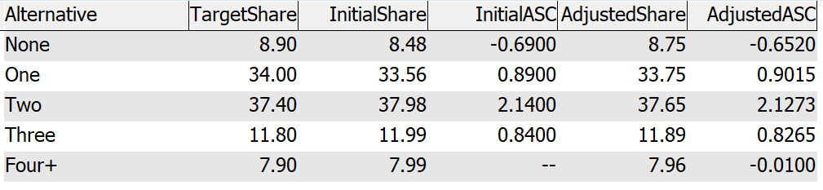

### Daycare Status

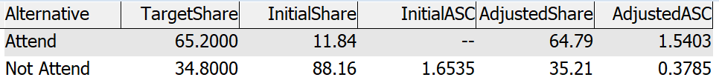

### Driver’s License

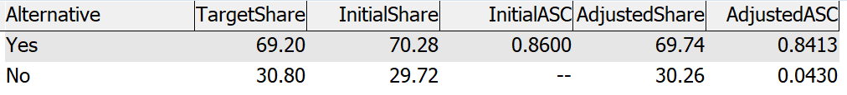

### University Status

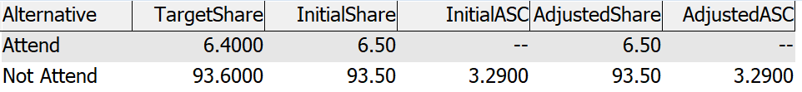

### Worker Category

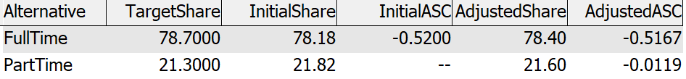

## Mandatory Tours

### Full Time Work Duration

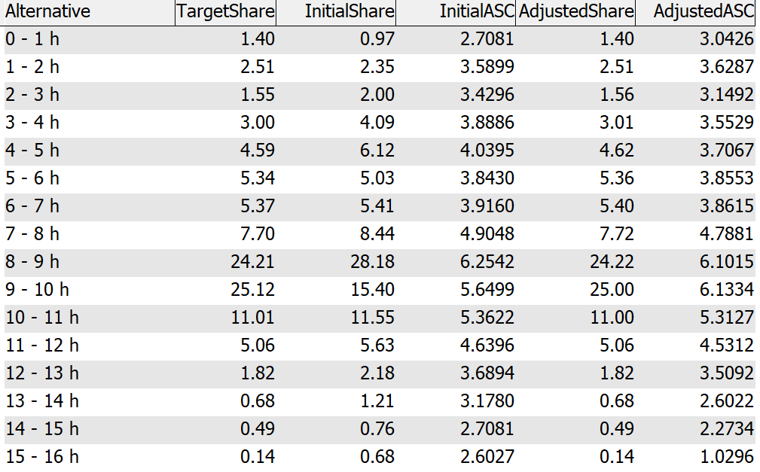

### Full Time Work Start

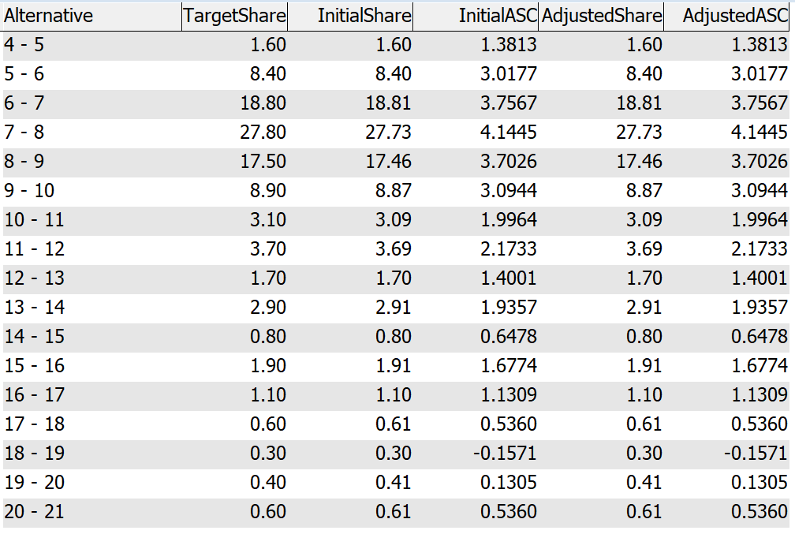

### Part Time Work Duration

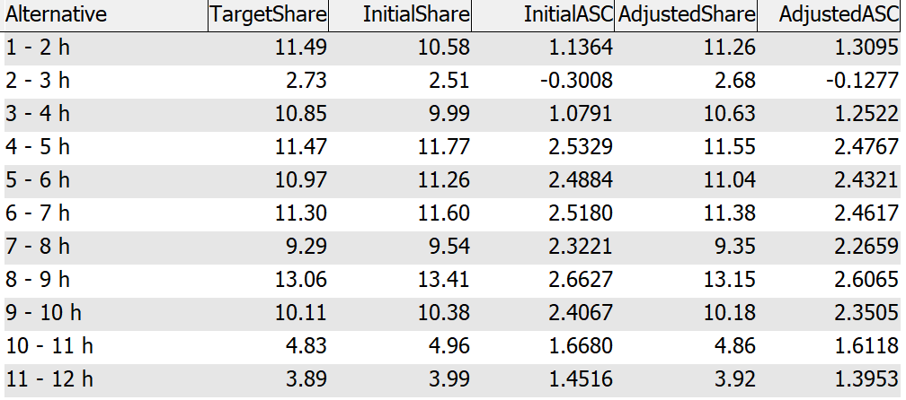

### Part Time Work Start

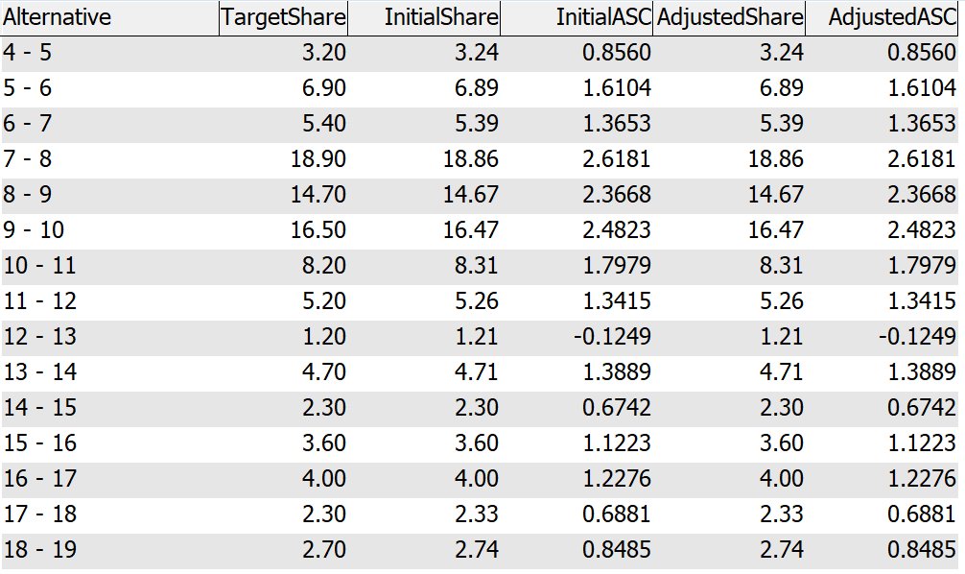

### School Duration

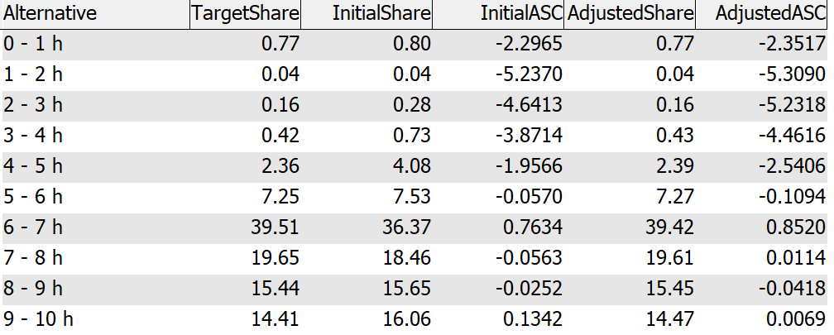

### School Forward Mode Choice

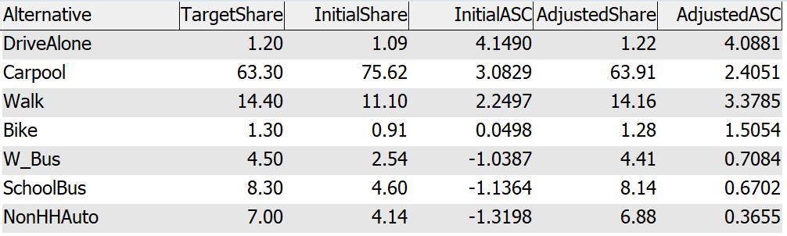

### School Return Mode Choice

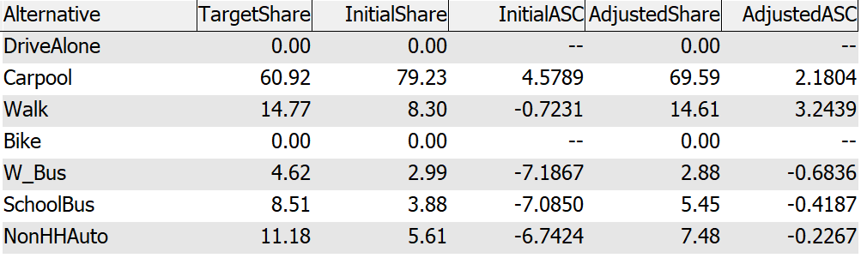

### School Start

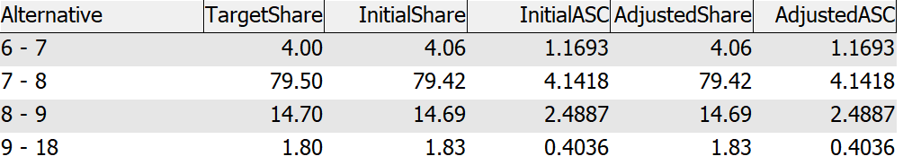

### University Mode Choice

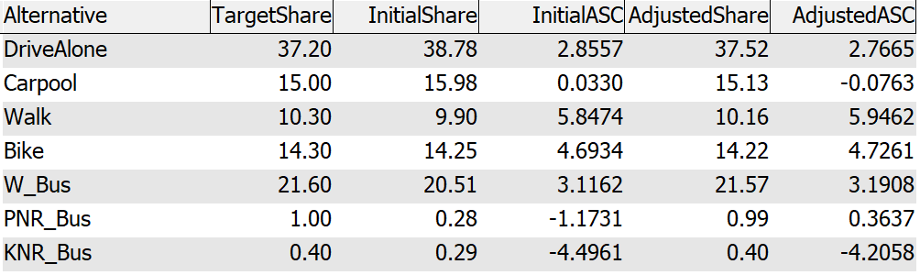

### University Duration

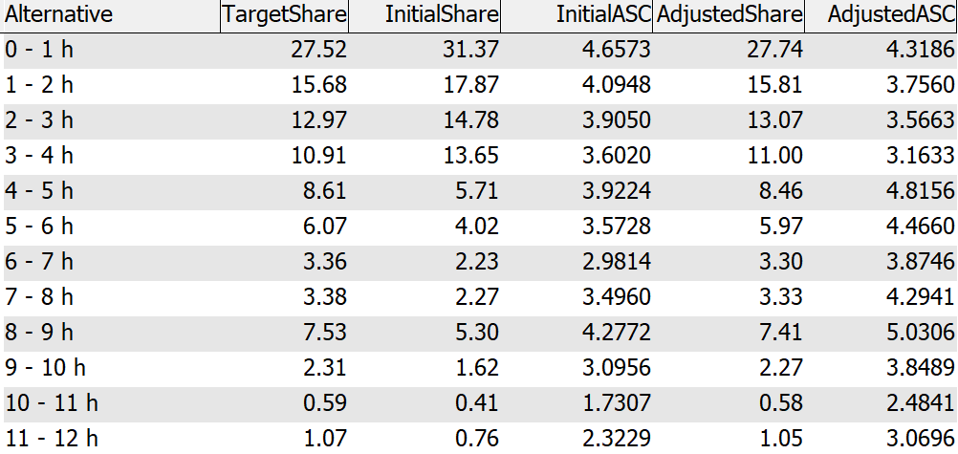

### University Start

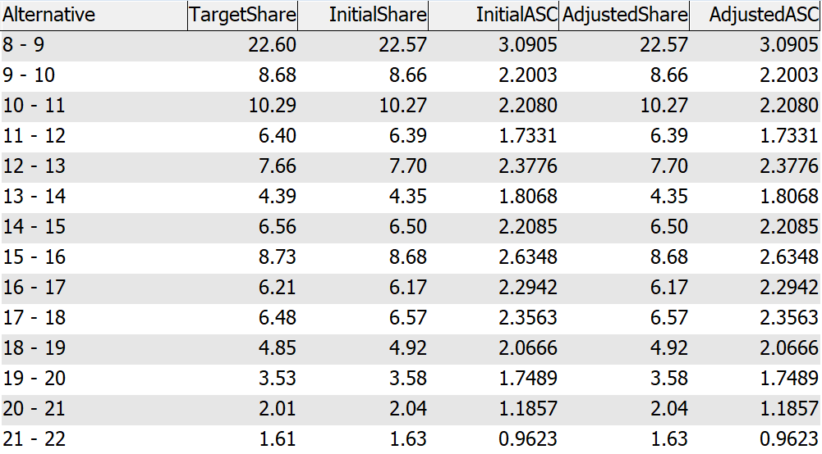

### University Tour Frequency

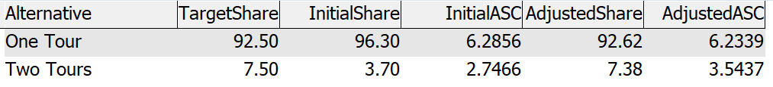

### Work Mode Choice

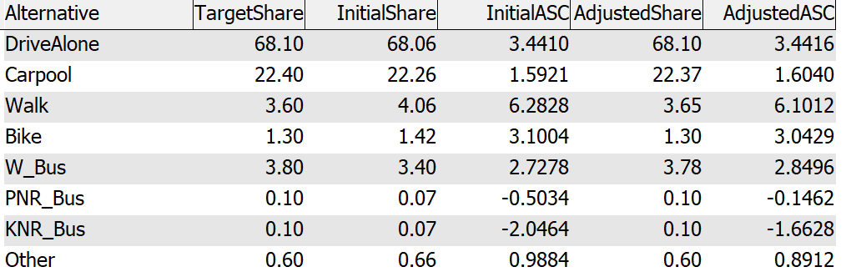

### Work Tour Frequency

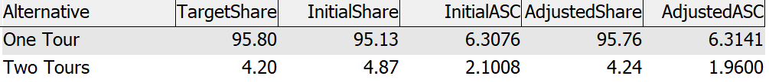

## Mandatory Stops

### University Stops Duration

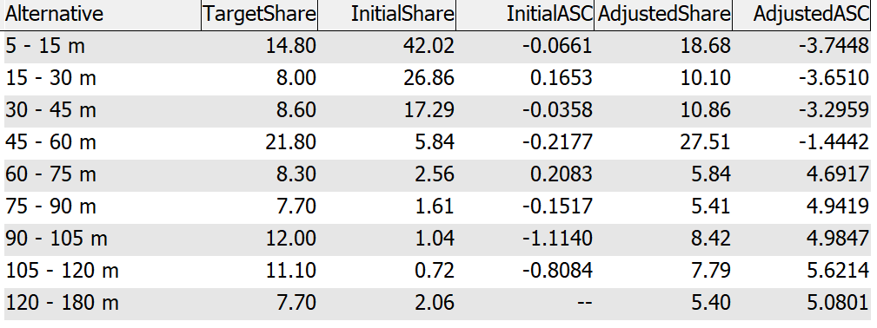

### University Stops Frequency

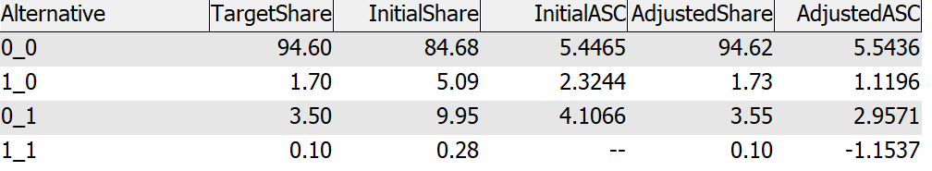

### Work Stops Duration

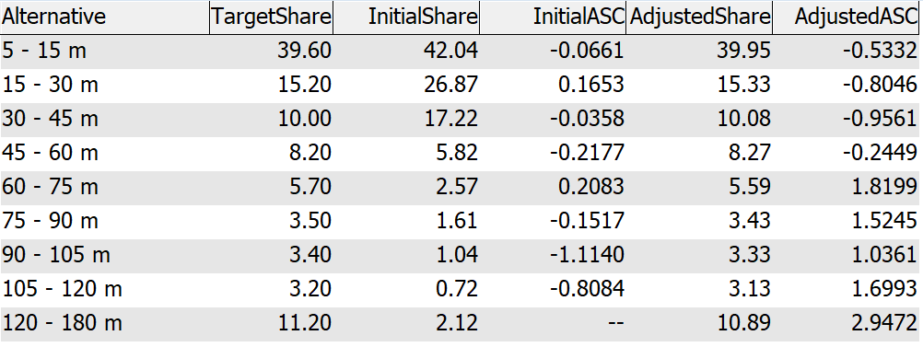

### Work Stops Frequency

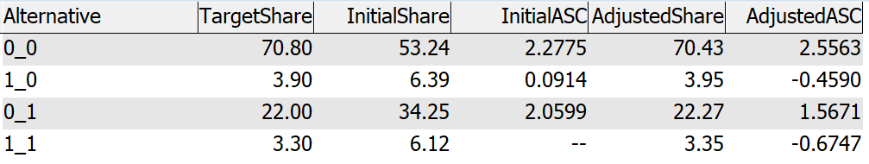

## Subtours

### Subtour Duration

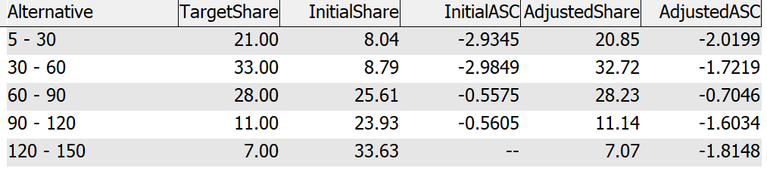

### Subtour Frequency

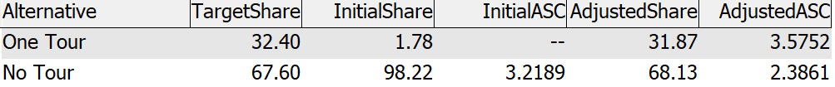

### Subtour Mode

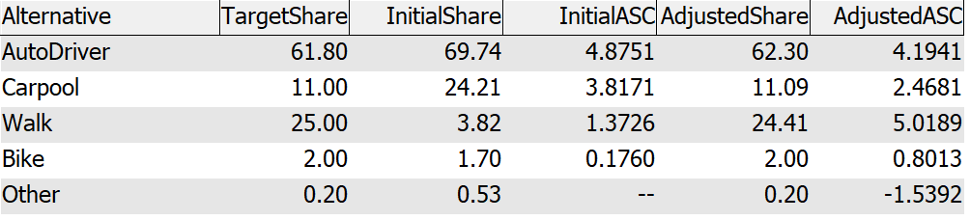

### Subtour Start

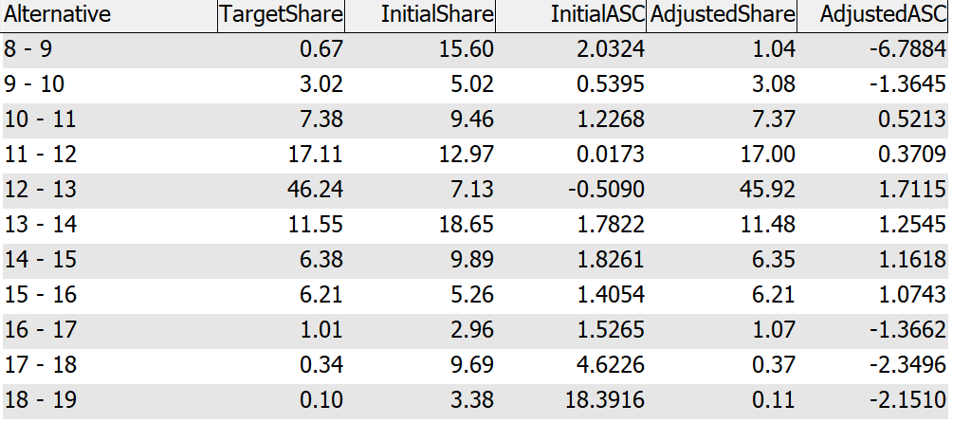

## Joint Tours

### Joint Tours Composition (Other)

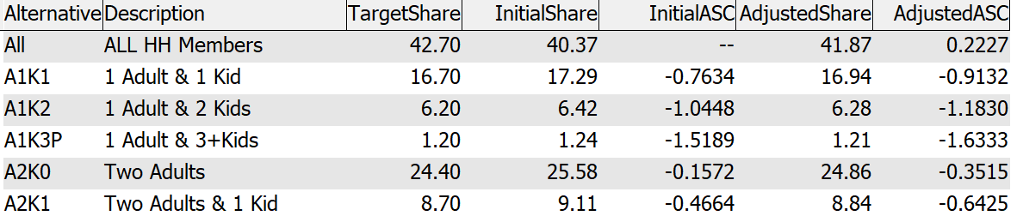

### Joint Tours Composition (Shop)

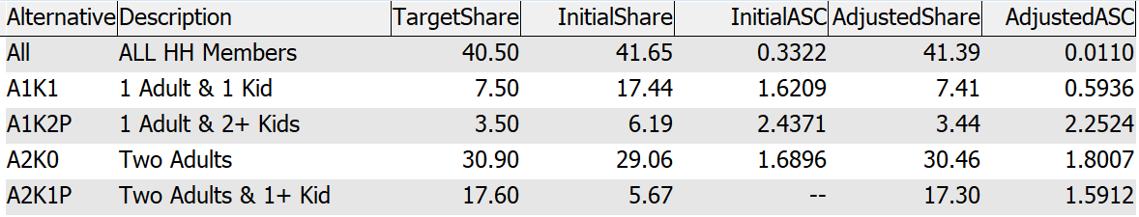

### Joint Tours Duration (Other)

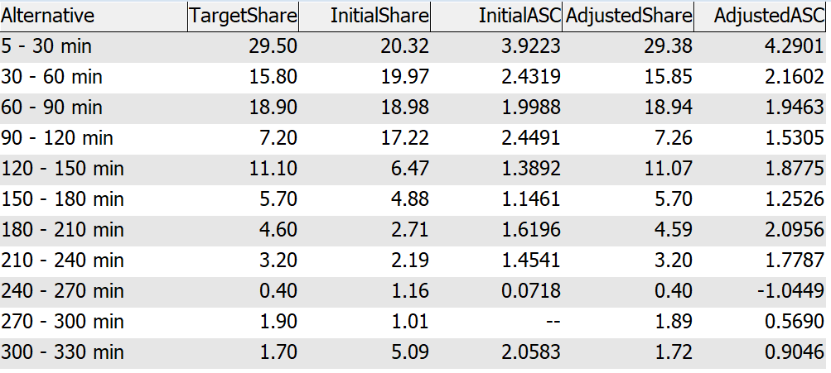

### Joint Tours Duration (Shop)

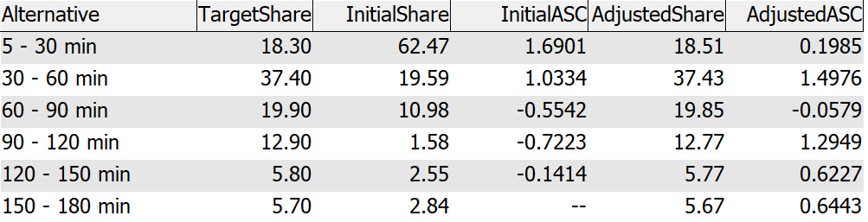

### Joint Tours Frequency

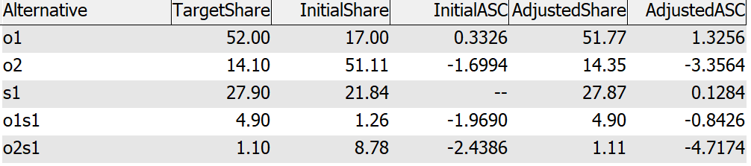

### Joint Tours Mode Choice (Other)

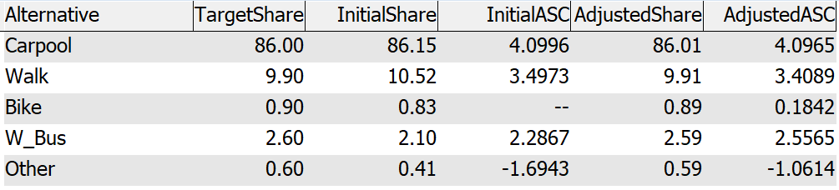

### Joint Tours Mode Choice (Shop)

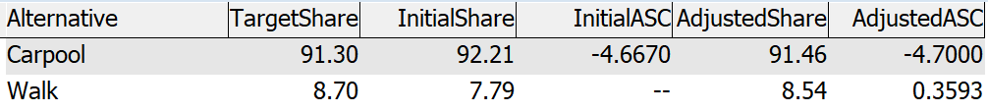

### Joint Tours Participation Adult Other

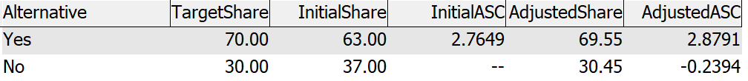

### Joint Tours Participation Adult Shop

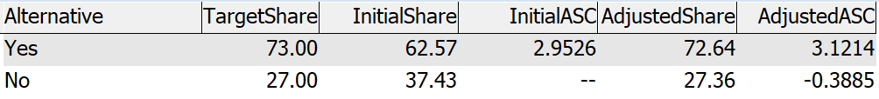

### Joint Tours Participation Child Other

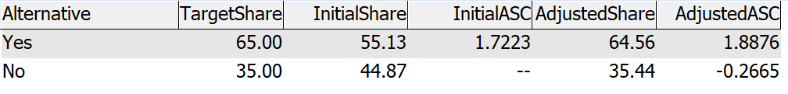

### Joint Tours Participation Child Shop

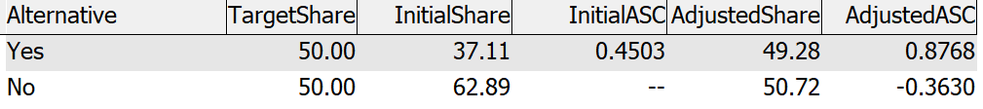

### Joint Tours Start Time Other

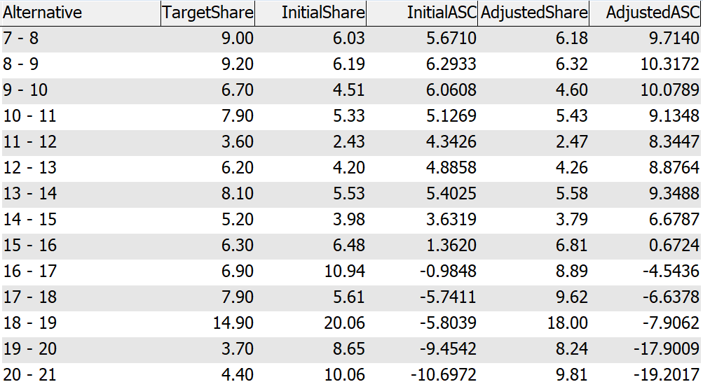

### Joint Tours Start Time Shop

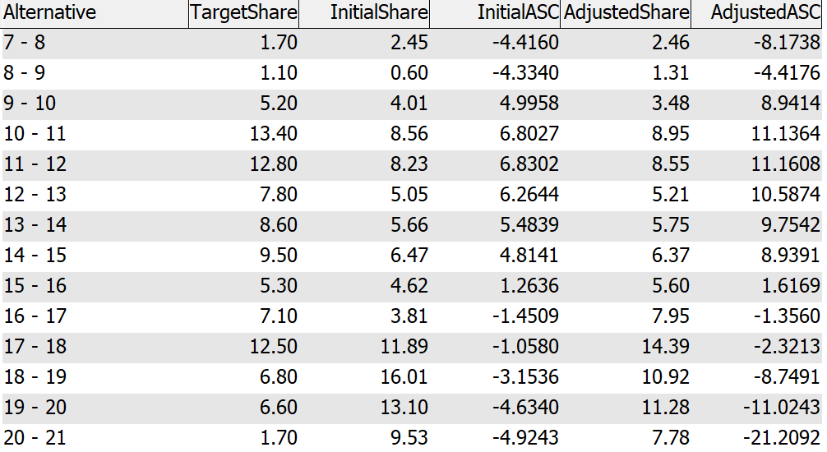

# Appendix B: Highway Validation

This section shows model performance compared to traffic counts.

|  |  |  |  |  |  |
| --- | --- | --- | --- | --- | --- |
| **HCMType** | **N** | **TotalCount** | **TotalVolume** | **PctDiff** | **PRMSE** |
| Arterial | 94 | 1,772,309 | 1,633,227 | -8 | 38 |
| Collector | 200 | 1,246,954 | 1,007,983 | -19 | 58 |
| Freeway | 70 | 7,749,527 | 7,713,979 | 0 | 15 |
| Local | 23 | 228,320 | 116,053 | -49 | 119 |
| MLHighway | 24 | 743,600 | 769,223 | 3 | 26 |
| MajorArterial | 197 | 4,728,092 | 4,660,640 | -1 | 37 |
| MajorCollector | 105 | 1,249,846 | 980,349 | -22 | 72 |
| Ramp | 136 | 1,614,433 | 1,666,324 | 3 | 40 |
| All | 849 | 19,333,081 | 18,547,778 | -4 | 36 |

|  |  |  |  |  |  |
| --- | --- | --- | --- | --- | --- |
| **VolumeGroup** | **N** | **TotalCount** | **TotalVolume** | **PctDiff** | **PRMSE** |
| 10000 | 347 | 1,900,071 | 1,788,537 | -6 | 62 |
| 25000 | 310 | 4,979,807 | 4,593,007 | -8 | 43 |
| 50000 | 118 | 4,028,098 | 3,925,403 | -3 | 33 |
| 100000 | 36 | 2,434,302 | 2,337,865 | -4 | 24 |
| 100000+ | 38 | 5,990,803 | 5,902,967 | -1 | 12 |
| All | 849 | 19,333,081 | 18,547,778 | -4 | 36 |

|  |  |  |  |  |  |
| --- | --- | --- | --- | --- | --- |
| **Screenline** | **N** | **TotalCount** | **TotalVolume** | **PctDiff** | **PRMSE** |
| 1 | 2 | 223,948 | 173,644 | -22 | 28 |
| 4 | 3 | 224,000 | 264,870 | 18 | 18 |
| 5 | 4 | 423,867 | 448,763 | 6 | 13 |
| 6 | 1 | 175,000 | 160,274 | -8 | 8 |
| 10 | 3 | 160,101 | 157,855 | -1 | 11 |
| 21 | 8 | 946,502 | 1,021,072 | 8 | 15 |